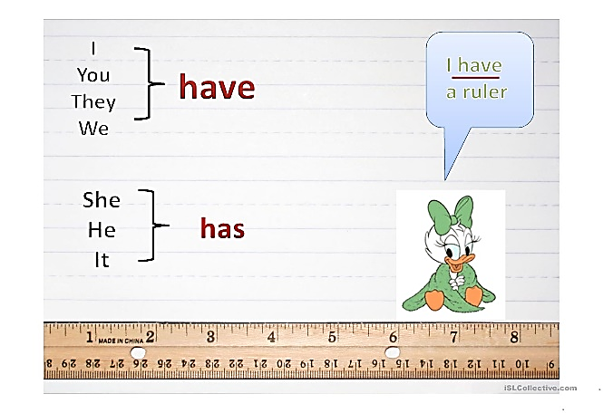POSSESSION

Para expresar posesión en inglés podemos:

* Usar el verbo ‘have’*

I **have** a new computer.

Sheila **has** a very good job at Cisco Systems.

Luca and Leo **have** the latest version of Call of duty.

* en Inglés británico suele usarse ‘have got’ en vez de have, pero tiene el mismo significado:

I **have got** a new computer.

Sheila **has got** a very good job at Cisco Systems.

Luca and Leo **have got** the latest version of Call of duty.

* Usar possessive adjectives o adjetivos posesivos: my, his, her, its, our, your y their

**My** contact number is 754 666721.

Sylvia is the IT team leader. **Her** job is to help the team

Pat and Mike are 2D artists and **their** area is concept art.

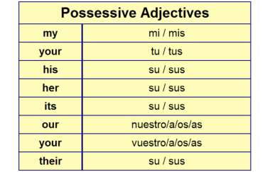

* Usar sustantivos posesivos (sustantivo + ‘s):

|  |  |
| --- | --- |
| **SUSTANTIVOS POSESIVOS**  Gaming on a 25 YEAR OLD Laptop!!**La regla general es sustantivo + ’ + s**  **Joe + ‘ + s**  **Joe’s laptop is very old.** | |
| * Si el sustantivo termina en ‘s’   como en Frances | → sustantivo + ‘  Frances’ office is in Miami. |
| * Si el sustantivo es plural | Recovering from Report Card Shock - TulsaKids Magazine  → sustantivo + ‘  The students’ marks are low. |
| * Si hay 2 o más sujetos | → sujeto + sujeto + ‘s  Sara and Nick’s house |
| * Si hay 2 o más sujetos y 2 o más objetos poseídos | → sujeto + ‘s + sujeto + ‘s  Pedro’s and Luca’s houses are identical  two men leaning out of adjoining chalet windows (digital composite) - neighbours talking over fence fotografías e imágenes de stock |

Los sustantivos posesivos señalan quién o qué tiene algo.

Por ejemplo:

la computadora **de** John

John’s computer is not very modern.

 Los **sustantivos en singular** forman la posesión agregando un apóstrofo y luego una **s:**

Mario**’s** cap is red.



She’s Crash Bandicoot’s sister.

Los **sustantivos en plural** solo agregan el apóstrofo:

The game **artists’** job was fantastic.

These **computers’** RAM is not very large.

 Los nombres terminados en s solo agregan el apóstrofo:

**Kratos’** tattoo is red.



**Nicolas’** marks at school are very low.

EXERCISES:

1. Complete each sentence with the possessive form of the noun in brackets.

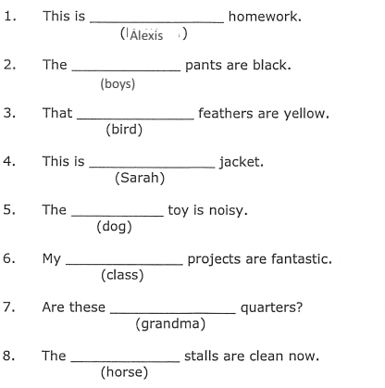

2. Choose the best option.

1. a. That is Bobs’ car. b. That is Bob’s car. c. That is Bobs car.

2. a. Are you going to Dan’s and Suzie’s party? b. Are you going to Dans and Suzies party?

c. Are you going to dan and Suzie’s party?

3. a. Is this Louis’ laptop? b. Is this Luis’s laptop? c. Is this Loui’s laptop?

4. That’s my sisters’ bedroom**.** How many girls sleep in this room?

a. two or more b. one c. none

5.a. Istanbul is Turkey’s biggest city. b. Istanbul is the biggest city of Turkey.

c. Istanbul is Turkeys’ biggest city.

3. Write the missing words in sentence B so that it means the same as sentence A.

1. **A** The biggest city in Japan is Tokyo.  
    **B** Tokyois ……………………. biggest city.

2. **A** The rain last week was really heavy.  
    **B** Last ………………….. rain was really heavy.

3. **A** That dog belongs to Will.  
    **B** That is …………………….. dog.

4. **A** Maria decided to move to Brazil.  
    **B** ……………………….. decision is to move to Brazil.