THE PAST CONTINUOUS WITH WHEN AND WHILE

**1. Look at the sentences below and say which was the action in progress and which one interrupted it:**

1. The program **was running** when the computer crashed.

Action in progress:

Action that interrupted it:

1. The screen went black while the programmers **were working** on the database.

Action in progress:

Action that interrupted it:

1. I **was shopping** online when my keyboard froze and my screen got black.

Action in progress:

Action that interrupted it:

**2. Complete the sentences with a subject and the correct form of the verbs in brackets.**

**Example:** I was downloading a file when … (the screen / go black)

I was downloading a file when the screen went black.

a. While the program was running, … (it / freeze)

b. My mum was watching TV when… (it /stop working)

c. While I was doing the English homework, … (my dog / sleep ) on the sofa.

d. While the teacher was teaching, … (her mobile / ring)

e. When … (the lights / go out), I was watching TV.

f. We broke a window while … (we / play) football.

g. While … (they /do) the exam, the lights went out.

h. When… (he /have) the accident, he was driving too fast.

i. We were working on the user interface while … (Jane / write code).

**3. Choose the correct options. Remember about short and long actions**  
1 I *do / was doing* the English homework when I *heard / was hearing* the car crash.  
2 When the teacher *said / was saying* ‘Stop!’, I *tried / was trying* to finish the last question.  
3 Tim *print/ was printing documents* when his boss *called / was calling* him.  
4 I *looked / was looking* for a file on my memory stick when I *noticed / was noticing* there was a virus.  
5 Ron *found / was finding* a really interesting games website while he looked / was looking for information for his homework.

COMPARATIVES AND SUPERLATIVES

**1. Complete the table with the comparative and superlative forms of the adjectives in the first column.**

|  |  |  |
| --- | --- | --- |
| **adjective** | **comparative** | **Superlative** |
| **light** | **lighter than** | **the lightest** |
| **bad** |  |  |
| **convenient** |  |  |
| **wide** |  |  |
| **heavy** |  |  |
| **durable** |  |  |
| **efficient** |  |  |
| **good** |  |  |
| **easy** |  |  |
| **difficult** |  |  |
| **cheap** |  |  |
| **small** |  |  |

**2. Choose 4 adjectives from the list to write two comparative and two superlative sentences. Compare the following web browsers: Google Chrome, Internet Explorer and Microsoft Edge.**

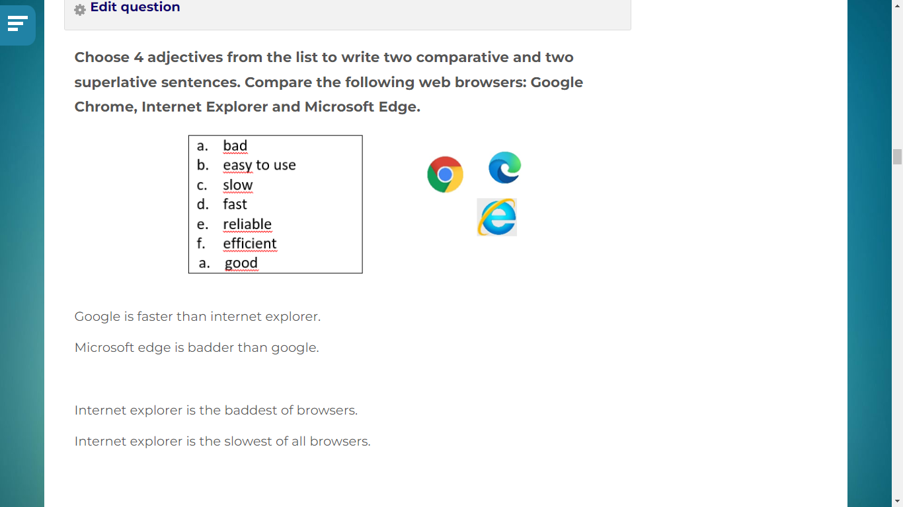

4. 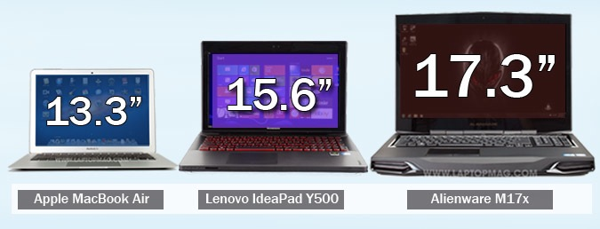Look at the picture and **answer the questions. Use complete sentences to answer WH questions and short answers for**

**$150 - 1,4 kg $999 – 2 kg $1679 – 2,8 kg**

1. Which laptops are lighter than the Alienware?

2. Which one isn’t cheaper than the Lenovo IdeaPad?

3. Which one has the biggest screen?

4. Which one is the least expensive?

5. Is the Lenovo the heaviest of the three laptops?