THE PAST SIMPLE PRACTICE

1) Complete the text with the correct form of the verbs in brackets.

Last week, we ___ (be) at an international IT conference. It ___ (be) in Silicon Valley. The keynote speaker ___ (be) Sheryl Sandberg, The CEO of Meta. She ___ (give) a presentation on women in technology. Apple ___ (present) its new accessories for iPhone. They ___ (be) amazing! We ___ (meet) other developers and ___ (talk) about the new gadgets.

2) Now make the following sentences negative.

1. Last week we were at a cyber security conference.
2. The international conference was in Colorado.
3. The keynote speaker was Mark Zuckerberg.
4. The keynote speaker gave a presentation on the future of AI.
5. Apple presented its new MacBook Air.
6. We meet Sheryl Sandberg.

3) Now make questions about the international IT conference

1. Where _______________________________? (be)

We were at an international IT conference

1. Where_________________________________? (be)

It was in Silicon Valley

1. What_________________________________? (do)

She gave a presentation on women in technology

1. What_________________________________? (present)

Apple presented its new accessories for iPhone

1. Who__________________________________? (meet)

We met other developers.

**4) Read the following text and answer the questions.**

Last Saturday, our team attended a workshop on game development. The speaker explained different coding techniques. During the break, we meet other developers and discussed our projects. After the workshop, we tried some of the new techniques we learnt during the session. Everyone felt very excited about using these skills in our next project. The whole day was very productive!

1. What did they do last Saturday?
2. What was the workshop about?
3. What did they learn?
4. Did they meet other developers?
5. Did they try the new techniques?
6. Was the day productive?

**5) Circle the correct answer for each sentence**

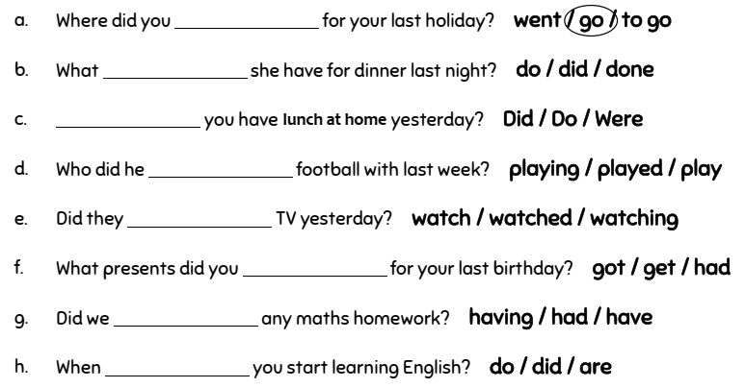

**6) Fin and correct the mistakes in each sentence**

