REVISION EXERCISES

**1. Write each verb with the correct -*s*, -*es*, or -*ies* ending.**

|  |  |
| --- | --- |
| 1. study  2. brush  3. process  4. play  5. explore  6. edit  7. copy | 8. help  9. miss 10. fly  11. fix  12. watch  13. debug  14. test |

**2. Underline the correct form of the verb to complete each sentence**.

1. A video game developer write / writes / **writes** code for games.  
2. Frank study / studies / studys English at university  
3. A system maintenance officer **keep /keeps** **/ keepies** the systems going.  
4. Video game designers design / designs / designes games for different formats.

5. A game development team usually **have / has** **/ haves** a lead designer. 7. Lead designers **coordinate /coordinats / coordinates**  the work of the other designers in the team.   
6. We code / **codes /** codies in C++.  
7. Our office close / closes / closies at 7:00 p.m.  
8. Shetake /**takes /** takies classes at the business school.10. I start / starts / startes work at 8:00 a.m. every morning.

**3. Make these sentences negative.**

1. My brother **has** a new job.

2. I usually **walk** to work.

3. Mike **fixes** software errors.

4. Our teacher **does** experiments in class

5. My friend and I **go** to the gym in the morning

6. You and tour classmates **have** an English class on Sunday.

7. Ella **teaches** object-oriented programming at university.

8. Franco **codes** in C++.

**3. Complete each sentence with the correct form of the verb in parentheses**

1. A game programmer (develop) video games software.  
2. Computer programmers (write) software.  
3. Photographers (take) photos.  
4. A 3D artist (produce) 3D models and animation.  
5. Art directors (manage) the art team.  
6. Sound engineers (be) responsible for sound effects.   
7. A level designer (create) levels, missions or challenges for video games.   
8. A writer (write) books.

9. The new printer (be) in my office.

**b. READING COMPREHENSION AND GRAMMAR**

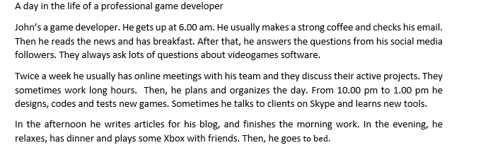

**1. Read the list of verbs in the chart. Who does each action? Check (✓) the correct column.**

|  |  |  |  |
| --- | --- | --- | --- |
| Verbs | John | His social media followers | John and his team |
| Makes |  |  |  |
| reads |  |  |  |
| Answers |  |  |  |
| ask |  |  |  |
| has |  |  |  |
| discuss |  |  |  |
| work |  |  |  |
| designs, codes and tests |  |  |  |

**2. Read again and complete the table**

|  |  |  |
| --- | --- | --- |
| Things John does in the morning | Things John does in the afternoon | Things John does in the evening |
| Gets up  Makes a strong coffee | Writes articles for his blog | Relaxes |

1. **Are these sentences about John true or false? Correct the false sentences.**
2. John gets up early.
3. He never drinks coffee.
4. His social media followers rarely ask him questions.
5. John has online meetings with his team twice a week.
6. He sometimes talks to clients on Zoom.
7. **Make 2 yes/no and 2WH questions about John.**
8. **Write a paragraph about Ted Burner. Use the information below and the following verbs:** be – work – get up – have a shower - have breakfast – check mail – leave home - start work – finish – work – have lunch – go home and relax m



Name : Ted Burner

Job: Engineer

Work place: Techint

Home routine: 7 am, get up – then shower – breakfast – check mail - leave home

Work Schedule: from 9 am to 5pm - from Monday to Friday

Lunch: at a cafe

After work: go home and relax