**DESCRIBING HOME AND WORK/ STUDY ROUTINES**

Esta clase está orientada a practicar el presente simple en todas sus formas y a lograr que ustedes produzcan un texto escrito oral en el que hablen de ustedes mismos.

1. **Read and answer the questions about Amina’s day.**

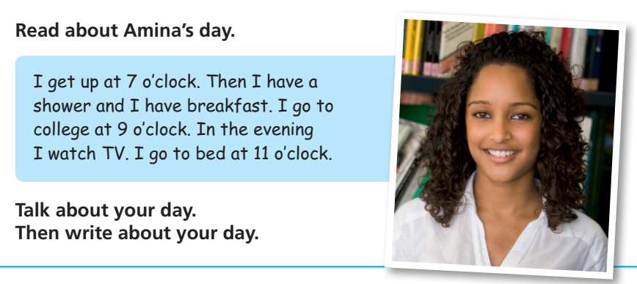

1. What time does she get up?
2. Does she have breakfast?
3. Is she a student?
4. Where does she go at 9 o’clock?
5. What does she do in the evening?
6. What does she do at 11 o’clock?

**2. Read about Carla’s day and correct the sentences turning them into the negative.**

Carla is a computer programmer. She works for a software publisher company, but she **does not work** in California, she works in New York. She and her colleagues have a very busy schedule. From 8 am to 9 am they have team meetings and after that, their workday begins.

They **do not do** the same thing every day. Sometimes, they write code and sometimes they test code or meet clients. They **do not work** all the time. They usually have 2 breaks for lunch and coffee. Their work **does not end** until 7 pm.

After work, Carla often goes for a walk, has dinner and watches TV, but she **does not go to bed** late because she’s always too tired.

1. Carla is a web developer.
2. She and her colleagues have team meetings in the evening.
3. They do the same thing every day.
4. Their work ends after 8 pm.
5. After work Carla goes to the gym.
6. She always goes to bed late.
7. **Watch the video Sara’s day**: <https://youtu.be/xlDj5aH3Cco> and...
8. **Write the following actions in the correct column:**

gets up – waits for the train – talks on the phone – has lunch – writes emails – has a shower has a cup of coffee – looks at her phone – cooks dinner – goes to bed – has meetings

|  |  |  |  |
| --- | --- | --- | --- |
| Home (casa) | Station | Company | Café |
|  |  |  |  |

1. **Put Sara’s activities in the correct order**
2. She has a cup of coffee.
3. She cooks dinner.
4. Sara talks on the phone, writes emails and has meetings.
5. She goes to bed.
6. She has lunch in a café.
7. Sara wakes up early.
8. She walks to the station.
9. After work, she goes home.
10. **Make questions about Sara’s day:**

2 questions with ‘When’

2 questions with ‘What’

1 question with ‘When’

3 yes/no questions.

4. Ahora sí llegamos al texto que servirá de modelo para que ustedes describan su propia rutina:

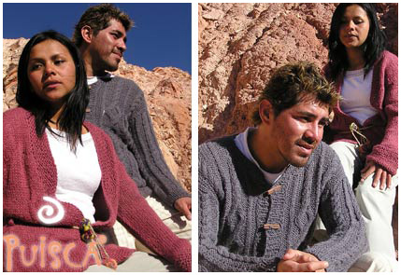**My daily routine by Marcos Luna**

I’m Marcos Luna. I’m 21 a**nd** I live and study in San Salvador de Jujuy. I live in a small house with my parents **and** my two sisters. I study programming in our local university. On week days, I usually get up at 7 o’clock. **Then** I have a shower and I have breakfast. I go to university by bus **because** it’s three kilometers from my house. I often have lunch at university **because** I have classes in the morning **and** in the afternoon. **After** class, I go home **and** I play computer games **or** play the guitar **and** study for a couple of hours. At weekends I play rugby **but** I don’t go out go out much **because** I’m always tired after the game.

**a. Read again and** **pay attention to the following linking words. Write their Spanish meanings**

**And:**

**After:**

**Because:**

**But:**

**Or:**

**Then:**

**b. What does Marco do at these times? Put his activities under the correct headings**

|  |  |  |  |
| --- | --- | --- | --- |
| **In the morning** | **In the afternoon** | **In the evening** | **At weekends** |
| **gets up at 7 o’clock** |  |  |  |

**Now answer the following questions about Marco. Be careful with questions with the verb “be” and questions with other verbs.**

1. What’s his name?
2. How old is he?
3. Where does he live and study?
4. Does he live in a flat?
5. Who does he live **with**?
6. Why does he take the bus to university?
7. When does he have classes?
8. Where does he have lunch?
9. What does he do after class?
10. What sport does he play?
11. Why doesn’t he go out much?

**Now, write about your daily routine. Use the text about Marco and the questions as a guide.**