**THE PRESENT SIMPLE: REVISION**

**1. Write the he /she / it form of the following verbs.**

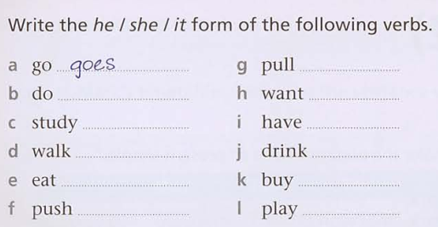

**2. Put the words in order to make a sentence**

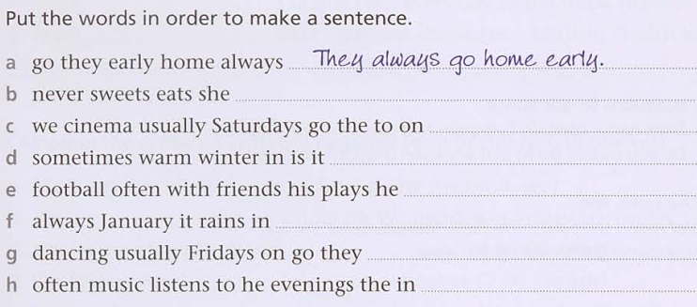

**3. Look at Mark’s timetable. Complete the sentences with the affirmative form of the verb in brackets**

