REVISION

ALPHABET AND SPELLING

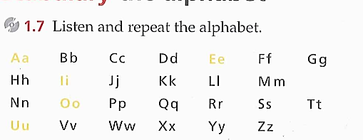1.

2. 