**REVISION**

1. **Complete the sentences with the words in the chart.** (Cada palabra se puede repetir una o más veces)
2. **Match the sentences to the pictures.**

|  |  |  |
| --- | --- | --- |
| Subject pronouns | Verb Be | Possessive adjectives |
| I  he  they  we | am/ ‘m  is / ‘s  are / ‘re | my  his  her  its  their  our |

1. Software development …… 1 the process of designing, coding, testing and maintaining software. …… 2 stages are: research, planning and design, execution, testing and maintenance and support.
2. There …… 3 many types of software developers. → there is y there are = hay (singular o plural)
3. Leo and Sam’ …… 4 front-end developers. …… 5 job’ …… 6 to design the user interface.
4. Hello! …… 7 ’m Julia. I' …… 8 a back-end developer. …… 9 job is about server-side logic and databases.
5. This …… 10 Amir. …… 11’s a software tester. …… 12 job is to check the code.
6. Diana. …… 13 a UX designer. …… 14 responsibility …… 15 to optimize the user-software interaction.
7. Carlos and I …… 16 software engineers. …… 17are the web applications team leaders.

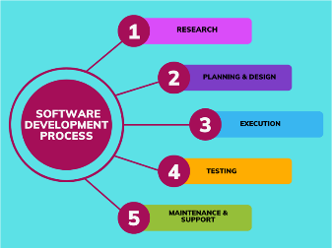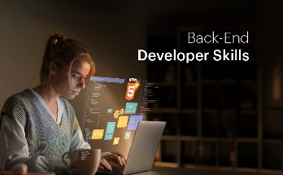

1. 2.

**3. 4. 5.**

**c.1 Read the team introduction and correct the wrong verbs, subject pronouns or possessive adjectives**. Be careful, **two words are correct**.

Hi! I’**re1** Diego and I’m a computer programmer. **My2** job is to write and test code for websites. This is Elena. **He**3 designs user interfaces and makes them easy to use. And this **is4** Lucas. He’s in the system maintenance team and **your5** job is to debug programs and fix errors. Finally, there’s Mia and Sam. **Our6** job is to manage databases and keep all the information secure. We all work for Soft Solutions, a software company in Canada. **Their7** offices **is8** in Montreal.

1 **‘m** 2 …✓… 3 … 4 … 5 … 6 … 7 … 8 …

✓

**d. Read** **the game art team introduction and** **match the questions with their answers**

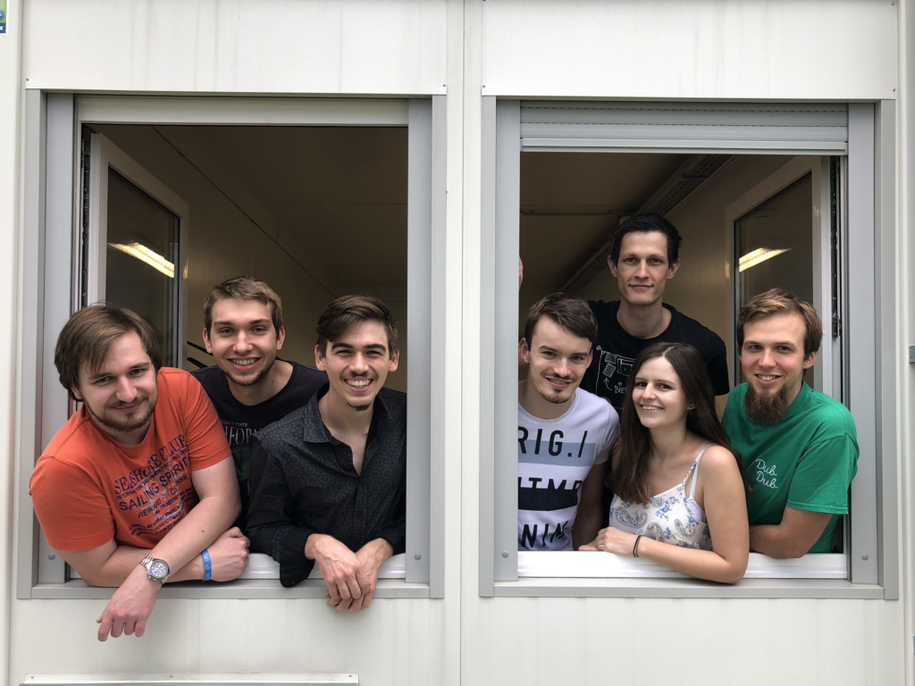

Hi! I’m Marco1, the sound art team leader2 and this is John, María and Juan. We are all sound artists. John and María3 are sound engineers and they are in the FX area4. Juan is a music expert5 and his area is music.

We work for E-Games Studio, a small game development company6 in Melbourne, Australia7.

|  |  |
| --- | --- |
| 1. Who is he? 2. What’s his job? 3. Are they 3D artists? 4. Are they sound artists? 5. Who are the sound engineers? 6. What’s their area?(The area of the sound engineers) 7. Is Juan a sound engineer? 8. Where is their company? | 1. Yes, they are 2. No, he isn’t. 3. He’s Marco. 4. He’s the sound art team leader. 5. It’s in Melbourne, Australia. 6. Their area is FX. 7. No, they aren’t 8. John and María are. |

**e. Make questions for these answers:**

1. Who ………………………………………………………………….?

The IT team members are Sylvia, Isabell, Andrew, Carla and Tom?

2. Are ……..…………………………………………………………….?

Hi! **My** name**’s** Sylvia. **I’m** the IT team leader, and this is Isabelle, Andrew, Carla and Tom. **We’ re** all IT professionals. Isabelle**’s** a database administrator and **she’s** in the data analysis area. Andrew**’s** an IT support officer and **his** area is technical support. Carla and Tom **are** data analysts, **their** area is data processing. **We** work for an IT services company in Northern Ireland. **Our** offices **are** in Belfast.

Yes, they are.

3. ……………. Isabelle…………………………………………………?

Yes, she is.

4. What…………………………………………………………………..?

Her area is data analysis.

5. Who……………………………………………………………………?

Andrew is.

6. Where…………………………………………………………………...?

They are in Belfast, Northern Ireland.

**f. Make questions for the answers below**

1. ___________________________________________

He’s from Canada.

b. ___________________________________________

My name’s Laura.

1. ___________________________________________

Their company is in Australia.

1. ___________________________________________

They are web designers.

1. ___________________________________________

The English class is on Monday.* (*on Monday: los lunes)

**g. You are at the reception desk of a software developers conference in Berlin[1]:**

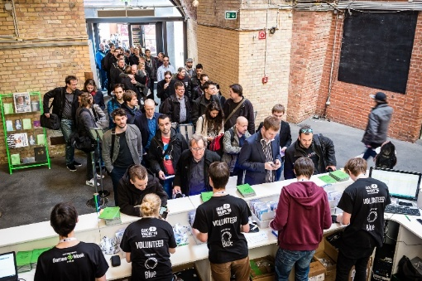

1. Invent an identity: name, job, company, phone number.
2. Write a conversation between you and the receptionist asking and giving personal information. Use the following dialogue as a model[2]:

MODEL: YOUR CONVERSATION:

R: Good morning. What’s your name, please?

R: Good morning. What’s your name, please?

L: Hi. My name’s Schultz.

R: Can you spell that?

L: Yes. S-C-H-U-L-T-Z: Shultz.

R: What’s your first name?

L: Liam: L-I-A-M.

R: Thank you. What’s your job?

L: I’m a photographer. I’m from *Today* magazine.

R: OK. Sign here, please[3].

L: OK. Thanks. Bye.

R: Goodbye

R = Receptionist - L = Liam

1. Estás en la recepción de una conferencia internacional de desarrolladores de software. 1. Inventá una identidad: nombre, trabajo, empresa, N° de teléfono. 2.Escribí una conversación entre vos y la recepcionista pidiendo y dando información personal. Usá el siguiente diálogo como modelo:
2. Usá el siguiente diálogo como modelo
3. ‘Firme acá por favor.’