INGLÉS V
WEBSITES
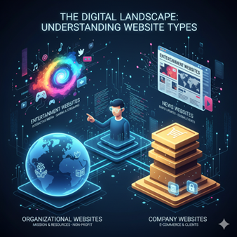
Website purpose
- Which websites do you use in your work and study? Make a list and share it with a partner. Do you use the same sites?

2. Reading: Read the following text and answer the questions bellow
The Digital Landscape: Understanding Website Types
In the modern tech industry, websites are categorized based on their primary function and target audience. Organisational websites, typically used by non-profits or NGOs, focus on promoting a mission and providing resources rather than selling a product. In contrast, company websites serve as the digital storefront for businesses. For a programmer analyst, these sites are often complex, requiring secure integrations for e-commerce, customer portals, and detailed product databases to convert visitors into clients.
Entertainment websites are designed to keep users occupied through interactive media, streaming, or gaming . They are designed to be engaging and easy to navigate. Meanwhile, news websites act as digital archives of current events. These platforms must be built for rapid updates and high readability, ensuring that global audiences can access breaking stories across multiple devices. Understanding these distinctions is essential for developers when choosing the right frameworks and databases for a project.
NGOs: Non- Governamental Organisations
1. Why do people visit organisational websites?
2. Why do people visit company websites?
3. Why do people visit entertainment websites?
4. Why do people visit news websites?

- Complete these sentences about the purpose of websites with the words in the box.
Offer practise present promote read sell share

- The purpose of Nationalgeographic.com is to ………………. information on topics.
- People visit CNN.com to ……………………international news.
- Some websites want to ………………… a service.
- Companies use Amazon.com to ………………….. their products.
- Thegreenshoppingguide.co.uk wants to …………………environmentally friendly shopping.
- Students visit Math.com to ……………………..their maths.
- English teachers join eltforum.com to ……………………teaching resources.
WH- Questions Words
We use WHICH to ask about things. We can use with a noun. | Which website do you visit the most?  I usually visit YouTube and some programming websites.
We use WHAT to ask about things. | What do you usually do on those websites?  I watch videos and learn about programming.
We use WHEN to ask the reason for something. | When do you usually visit these websites?  I usually visit them in the evening after classes.
We use WHY to ask about time. | Why do you like those websites?  (Because) they are interesting and useful for learning.

- Go around the class and ask three students to name the websites the y visit and use at home. Write down a website for each of the four headings 1-4 in the table.

Interviewee name | Interviewee uses these websites to:
Interviewee name | - entertain | - get news | - research/study | - shop

- Present the information you collected to the group. Which are the most popular websites for each heading?

- Listening
Listen to Sarah and George. Complete this dialogue.
Sarah: George, I (1) ……………………some information about our website.
George: OK, what do you need to (2) …………………..?
Sarah: Well, I need some information about website (3) ………………., you know, external visits to our website.
George: OK.
Sarah: (4) ……………… you do a report for me?
George: Sure. (5) ……………… do you need it by?
Sarah: Er, tomorrow morning, I'm (6) ………………. . It's for the finance director.
George: OK, what do you need to know (7) ………………….?
Sarah: Well, the (8) ………………… of visitors to our website last month, their movements and actions on the website, and where they're from.
George: OK, I (9) ………………….. do that.
Sarah: Thanks very (10) ……………… indeed.

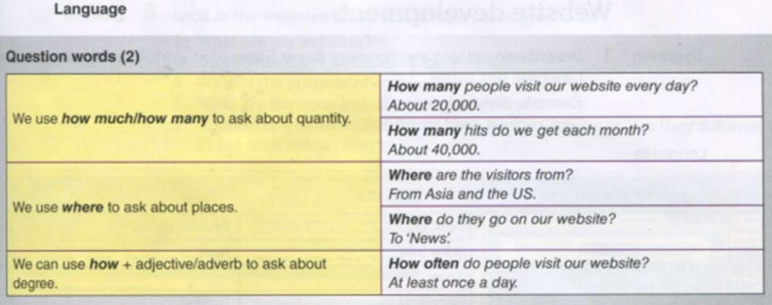
- Write questions for the following answers.

- …………………………………………………………………………………………………………?
I spend a lot of time with social media.
- …………………………………………………………………………………………………………?
Instagram has over 2 billion monthly active users.
- …………………………………………………………………………………………………………?
Last year, I studied two hours a day when I had an exam.
- …………………………………………………………………………………………………………?
In five years, I see myself as an important part of this organization.
- …………………………………………………………………………………………………………?
I paid u$s 600 for my computer.
- …………………………………………………………………………………………………………?
The project's findings were unveiled at the 2023 Workshop on Usable Security.
- ………………………………………………………………………………………………………?
AI is revolutionising engineering design practices by exploring real-world implementations of these technologies
- …………………………………………………………………………………………………………?
Paul has 3 different email account.

WEBISTE DEVELOPMENT
LANGUAGE
Describing steps in a process

Reading 2. Complete this text with the words in the box
We use first, next, then, after that (etc.) to describe the order of actions. | First, do.... | To start, do ....
 | After that,.... | Next,....
 | Then, … .
 | Secondly,.... | Thirdly, ….
 | Finally,.... | To finish,....

The steps in website development
(i) ………………, discuss with the customer their requirements and the target audience. Find out what features and number of pages they want on their site. (2) …………….., analyse the information from the customer . (3) ………………, create a website specification. (4) …………………… design and develop the website. (5)……………. , assign a specialist to write the website content. (6) ………………... give the project to programmers for HTML coding. (7) …………….., test the website. After you publish the website, update and maintain it on an ongoing basis. Monitor customer use.

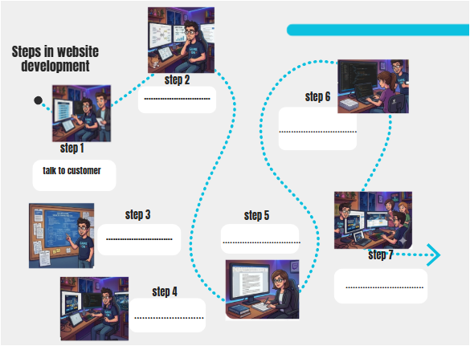

Speaking
- Describe the website development process to another pair in your own words.
Reading
- Look at the websites below and answer these questions.
- What are the websites?
- Do you use these websites? Why/Why not?
- What is the purpose of each website: sell, inform, share, educate?
- What are the main features of each website?
- Think of two more websites that have the same purpose. Are they different to the ones below? Why?
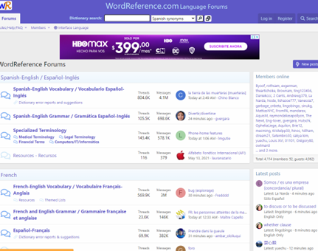
Writing
- You are the owner of a company that needs a new website. Make a list of things that you need/would like for your website. Answer the following questions.
• What is the name of your company?
• What is the business type?
• What is the purpose of your website?
Speaking
- Work in pairs: .
- Student A: Website developer
- Student B: Customer who wants a website for their company.
Ask and answer questions about website requirements. Swap roles.
Example: A: What is the name of your company?
B: It's called/Its name is ... .

The best websites
Vocabulary
What are your favourite websites? Why? Use the words in the box to describe them.
beautiful well-designed easy-to-use/navigate clear reliable useful informative fun funny exciting interesting

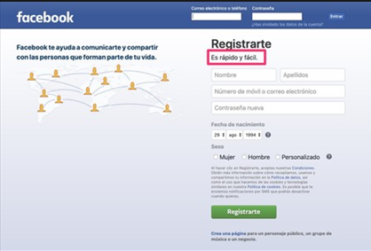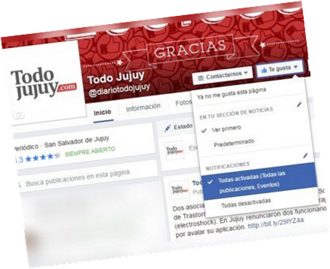
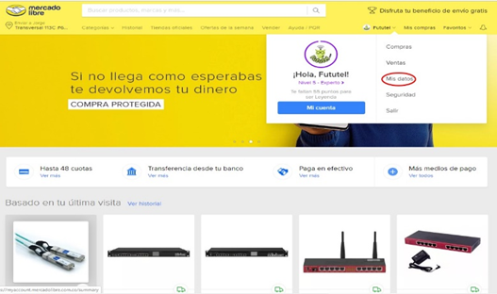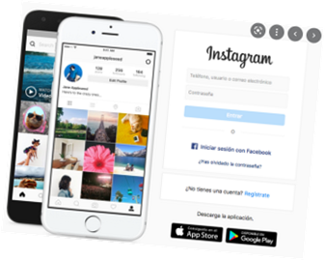

Language
Describing things
There's/There is/There isn't | There's a lot of information on this website.
There are/aren't | There aren't many photos on this website.
Has | The website has good graphics.
Have | Most websites have a lot of features.

Writing
2. Write about the things you like and dislike about different websites.
Example: I really like the look of the TodoJujuy website. It has ....
Business matters
Reading
You are a website designer. Read the information about Learning Now Ltd. Answer these questions.
• What is the business type?
• What is the purpose of the website: sell, inform, share, educate?
• Who are the website users? Where are the website users?
• What are the features of the website?

Writing
- In pairs, write a proposal for Learning Now Ltd's website. Use your answers from 1 and the template below to help you.
