WEBSITES
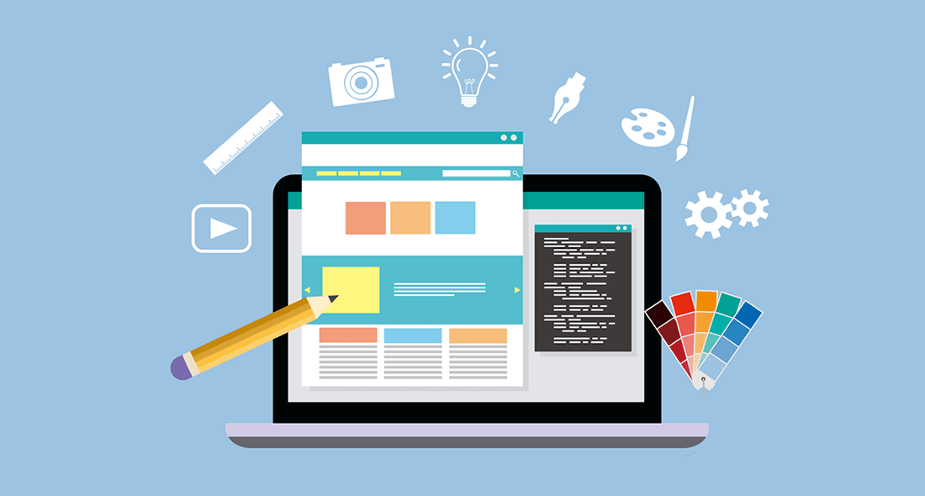
Website purpose
- Which websites do you use in your work and study? Make a list and share it with a partner. Do you use the same sites?

- Read this text about different types of website. Answer these questions.

TYPES OF WEBSITE - A GUIDE FOR WEBSITE DESIGNS
The purpose of an organisational website is to inform about an idea or event. Companies develop commercial websites to sell products or services. Entertainment websites are designed to entertain or provide fun activities. People visit news websites to obtain information. The purpose of a personal website is to provide information about an individual. Social networking websites help people to exchange personal information. Educational websites aim to share knowledge and enable online learning.
1. Why do people visit organisational websites?
2. Why do people visit company websites?
3. Why do people visit entertainment websites?
4. Why do people visit news websites?

- Complete these sentences about the purpose of websites with the words in the box.
Offer practise present promote read sell share

- The purpose of Nationalgeographic.com is to ………………. information on topics.
- People visit CNN.com to ……………………international news.
- Some websites want to ………………… a service.
- Companies use Amazon.com to ………………….. their products.
- Thegreenshoppingguide.co.uk wants to …………………environmentally friendly shopping.
- Students visit Math.com to ……………………..their maths.
- English teachers join eltforum.com to ……………………teaching resources.
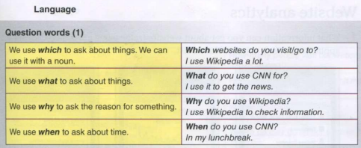

- Go around the class and ask three students to name the websites the y visit and use at home. Write down a website for each of the four headings 1-4 in the table.

Interviewee name | Interviewee uses these websites to:
Interviewee name | - entertain | - get news | - research/study | - shop

- Present the information you collected to the group. Which are the most popular websites for each heading?
Listening
- Listen to Sarah and George. Complete this dialogue.
Sarah: George, I (1) ……………………some information about our website.
George: OK, what do you need to (2) …………………..?
Sarah: Well, I need some information about website (3) ………………., you know, external visits to our website.
George: OK.
Sarah: (4) ……………… you do a report for me?
George: Sure. (5) ……………… do you need it by?
Sarah: Er, tomorrow morning, I'm (6) ………………. . It's for the finance director.
George: OK, what do you need to know (7) ………………….?
Sarah: Well, the (8) ………………… of visitors to our website last month, their movements and actions on the website, and where they're from.
George: OK, I (9) ………………….. do that.
Sarah: Thanks very (10) ……………… indeed.
- Match the website analysis tools 1-5 to the descriptions a-e.
1 traffic a) information about where the visitor s t o your site are from
2 meta tag b) invisible information (e.g. a hidden keyword) on a website
3 visitor map c) information about a user and the sites they browse
4 user profile d) increasing the number of visitors to your site
5 page optimisation e) the movement and actions of visitors to your site

- Write questions for the following answers.

- ………………………………………………………………………………………………………………………?
I spend a lot of time with social media.
- ………………………………………………………………………………………………………………………?
Instagram has over 2 billion monthly active users.
- ………………………………………………………………………………………………………………………?
Last year, I studied two hours a day when I had an exam.
- ………………………………………………………………………………………………………………………?
In five years, I see myself as an important part of this organization.
- ………………………………………………………………………………………………………………………?
I paid u$s 600 for my computer.
- ………………………………………………………………………………………………………………………?
Paul has 3 different email account.

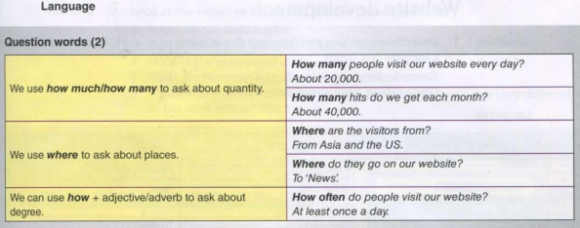
Website development
Language
Describing steps in a process
We use first, next, then, after that (etc.) to describe the order of actions. | First, do.... | To start, do ....
 | After that,.... | Next,....
 | Then, … .
 | Secondly,.... | Thirdly, ….
 | Finally,.... | To finish,....

Reading 2. Complete this text with the words in the box.
After that Finally First Next Secondly Then Thirdly
The steps in website development
(i) ………………, discuss with the customer their requirements and the target audience. Find out what features and number of pages they want on their site. (2) …………….., analyse the information from the customer . (3) ………………, create a website specification. (4) …………………… design and develop the website. (5)……………. , assign a specialist to write the website content. (6) ………………... give the project to programmers for HTML coding. (7) …………….., test the website. After you publish the website, update and maintain it on an ongoing basis. Monitor customer use.

3. Work in pairs. Complete the flowchart to show the website development process.
7
1 Talk to customer
9
4
3
2

5

Speaking
- Describe the website development process to another pair in your own words.
Reading
- Look at the websites below and answer these questions.
- What are the websites?
- Do you use these websites? Why/Why not?
- What is the purpose of each website: sell, inform, share, educate?
- What are the main features of each website?
- Think of two more websites that have the same purpose. Are they different to the ones below? Why?
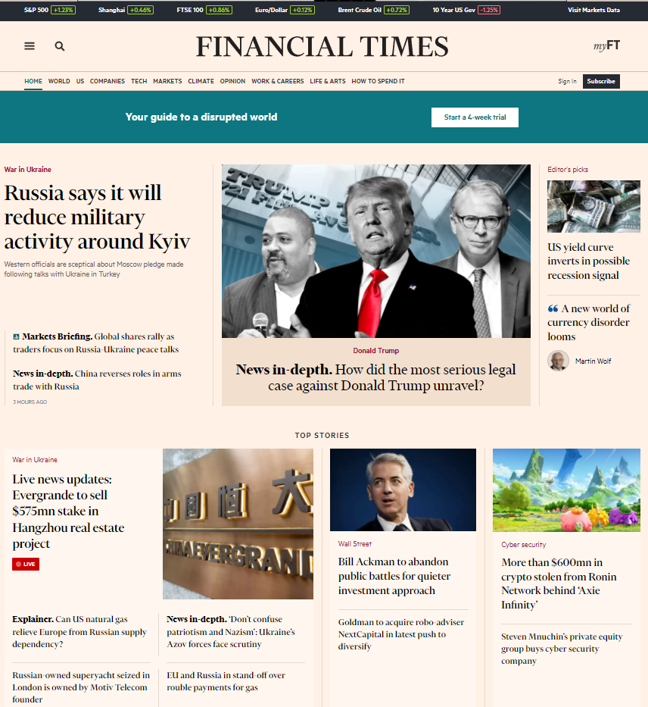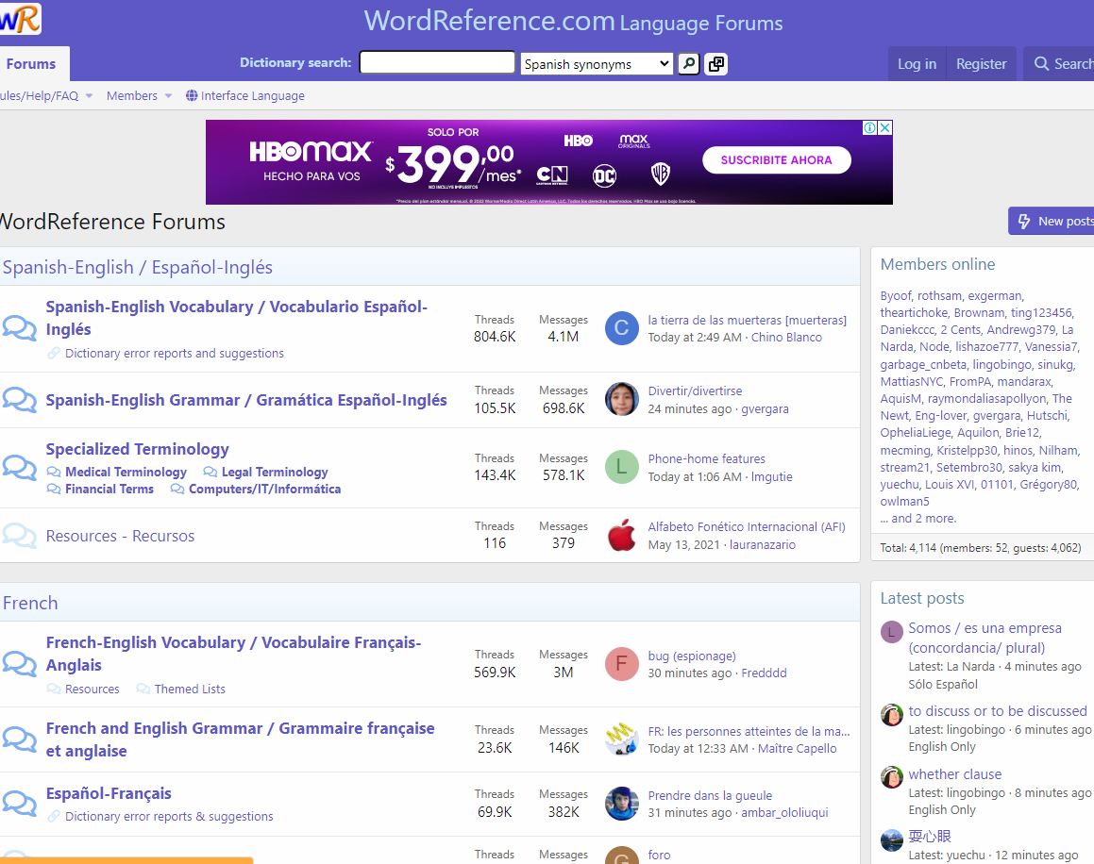
Writing
- You are the owner of a company that needs a new website. Make a list of things that you need/would like for your website. Answer the following questions.
• What is the name of your company?
• What is the business type?
• What is the purpose of your website?
Speaking
- Work in pairs. Student A is the website developer. Student B is the customer. Ask and answer questions about website requirements. Swap roles.
Example: A: What is the name of your company?
B: It's called/Its name is ... .

The best websites
Vocabulary
What are your favourite websites? Why? Use the words in the box to describe them.
beautiful well-designed easy-to-use/navigate clear reliable useful informative fun funny exciting interesting

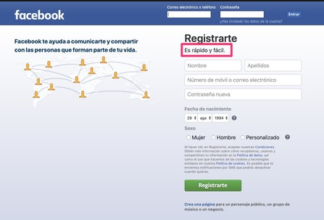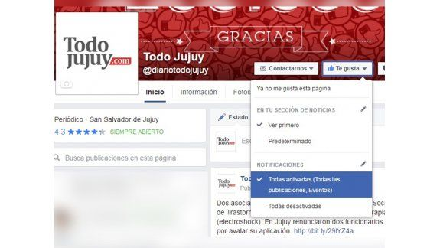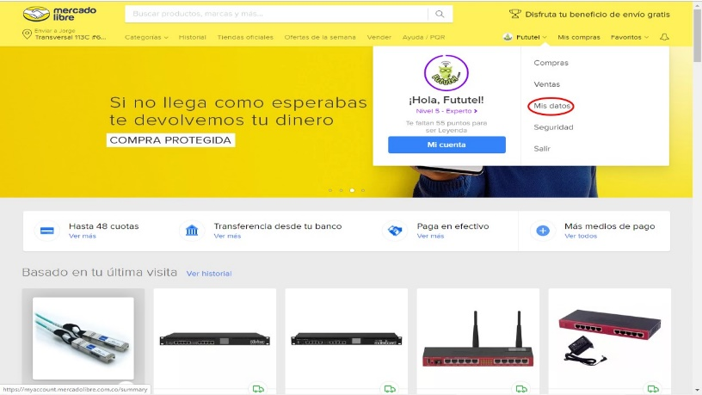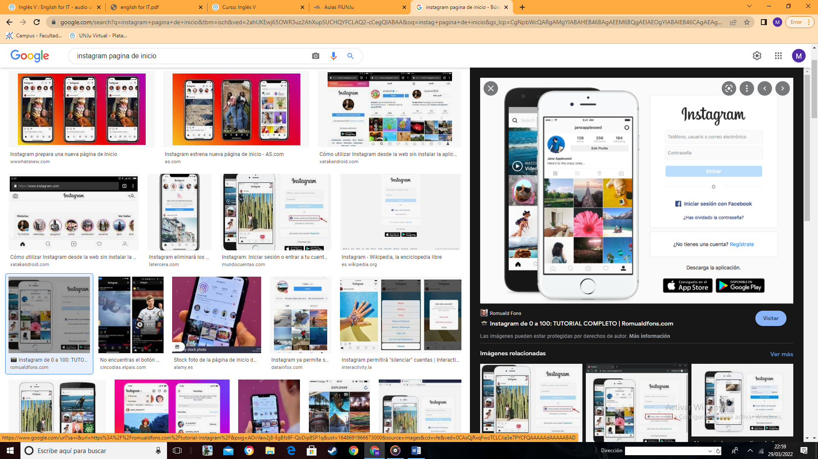

Language
Describing things
There's/There is/There isn't | There's a lot of information on this website.
There are/aren't | There aren't many photos on this website.
Has | The website has good graphics.
Have | Most websites have a lot of features.

Writing
2. Write about the things you like and dislike about different websites.
Example: I really like the look of the TodoJujuy website. It has ....

Business matters
Reading
- You are a website designer. Read the information about Learning Now Ltd. Answer these questions.
• What is the business type?
• What is the purpose of the website: sell, inform, share, educate?
• Who are the website users? Where are the website users?
• What are the features of the website?
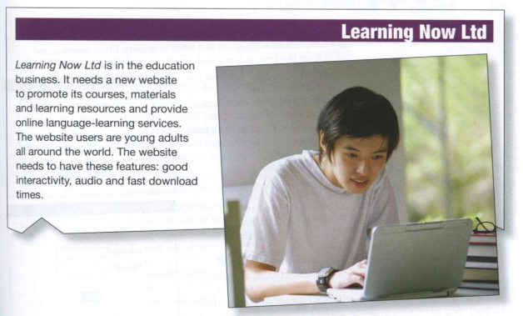

Writing
- In pairs, write a proposal for Learning Now Ltd's website. Use your answers from 1 and the template below to help you.
