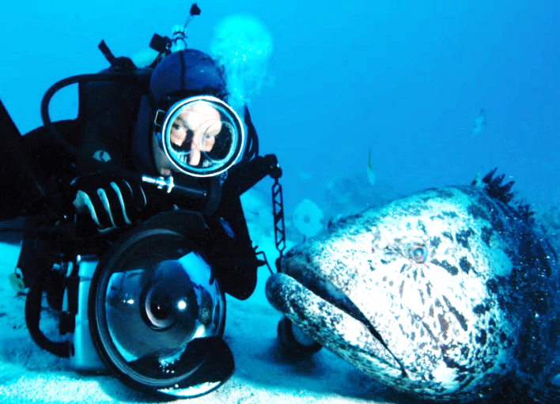
UNIT 1: HELLO!
- Look at the photo. Listen and tick ()
a Hi! My name’s Mike.
b Hello! I’m Mike.
c Hi! I’m Mike.
2. Listen and repeat
explorer - filmmaker - photographer - scientist – writer -
3. Write your name.
Hi! I’m ……………………………..…….
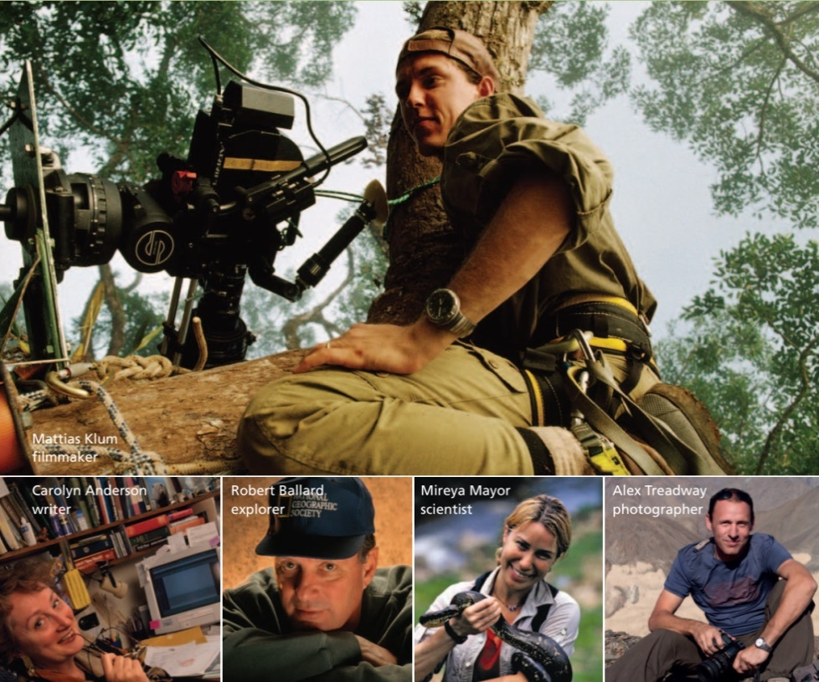
4. Look at the photos and listen to the people.
Hi. I’m Mattias. I’m a filmmaker
Hi. I’m Caroline. I’m a writer.
Hello. I’m Robert. I’m an explorer.
Hi. I’m Mireya. I’m a scientist.
Hello. I’m Alex. I’m a photographer

Mattias Klum
filmmaker

Carolyn Anderson Robert Ballard Mireya Mayor Alex Treadway
Writer explorer scientist photographer
6. Look at the photos. Write the jobs. 7. Talk⁶ to your classmates⁷
1 Hi. I’m Carolyn. I’m a ………………………….
2 Hello. I’m Alex. I’m a .………………………….
3 Hi. I’m Mireya. I’m a .………………………….
4 Hi. I’m Mattias. I’m a .………………………….
5 Hello. I’m Robert. I’m an . ………………………….
Hi. My name is Luis. I’m a student.
Hi. I’m Melisa. I’m a student.

8. Translate the following
I’m: …………………………………….
Hello. I’m Mattias: ……………………………………………….………………….
I’m a photographer: ………………………………………..………………………
Hi! My name’s Mike: …………………………………………………………………
Hi. I’m Melisa. I’m a student: ………………………………………………………………………….
9. Look at the grammar boxand the example. Then look at the jobs in exercise 2. Underline the first letter
EXAMPLE: explorer
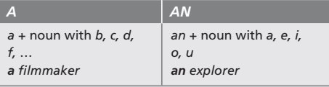
10. Complete the sentences with a or an. Then listen, check and repeat the sentences.
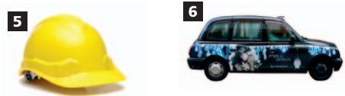
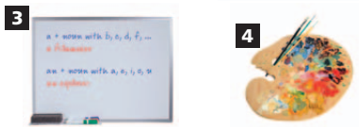
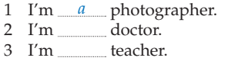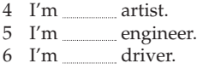
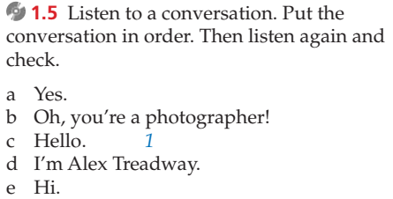
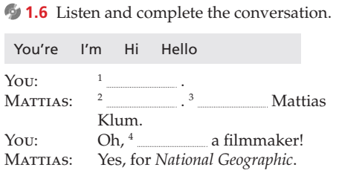

Look: mirá. ⁶talk: hablá
Listen: escuchá. ⁷classmates: compañeros
Tick: marcá con una tilde.
Repeat: repetí.
Write your name: escribí tu nombre.
Translate: traducí
The following: lo siguiente
Grammar box: tabla de gramática
Example: ejemplo
Jobs: trabajos
⁶ underline: subrayá
First letter: primera letra

