REVISION EXERCISES

MODALS

1. What do these modals express?
2. MUST:
3. MUSTN’T:
4. CAN:
5. CAN’T:
6. SHOULD – SHOULDN’T:
7. HAVE TO:
8. DON’T HAVE TO:
9. Read about the rules of computers use in his office and choose the best option.

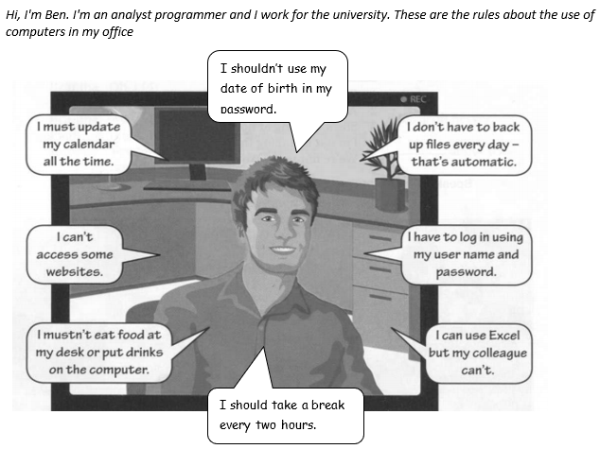

1. I **must** update my calendar all the time. → It is necessary / It is not necessary.
2. I **mustn’t** eat food at my desk or put drinks on the computer. → It is an ability / It is a prohibition.
3. I **don’t have to** back up files every day, it’s automatic. → It’s a prohibition / It is not necessary.
4. I **have to** log in using my user name and password. → It is an ability / It is necessary.
5. I **can** use Excel but my colleague **can’t**. → It is an ability / It is a good idea.
6. I **can’t** access some websites. → It is an obligation / It is a prohibition.
7. I **should** take a break every two hours. →It is an ability / It is a good idea.
8. I **shouldn’t** use my **date of birth in my password.** →It is necessary / It is not a good idea.

3. Read again and answer the questions.

1. What **mustn’t** Ben do?

………………………………………………………………………………………………………………………………………

1. **Can** he open any website? ………………………………………………………………………………………………………………………………………
2. What **should** Ben do every two hours?

………………………………………………………………………………………………………………………………………

1. What **shouldn’t** he do?

………………………………………………………………………………………………………………………………………

1. Does he have to back up files every day? Why? …………………………………………………………………………………………………………………………………….
2. Can his colleague use Excel? …………………………………………………………………………………………………………………………………….

4. Complete these rules in the English classroom. Use must / mustn’t, should / shouldn’t, can/ can’t, have to / don’t have to.

1. You ……………… listen carefully. ✓
2. You ……………… use your mobiles phones without permission. X
3. You ……………… leave the class before it finishes. X
4. You ……………… ask for help when you need it. ✓
5. You ………………. to buy an English text book. You can download your notes from the virtual classroom. X
6. You ……………….to arrive to class in time. ✓
7. You ………………. attend tutoring classes. ✓
8. You ……………….miss classes. X
9. You ………………. eat or drink in class ✓(you have permission), but you ……………….. drop litter on the floor.

THE FUTURE WITH WILL

1. Read the text and mark the statements T (true) or F (false). Correct the false ones.

In the future, computer programming will be even more important than it is today. Developers will write code much faster, and AI will help programmers solve complex problems. Programming languages will become easier to learn, and more people will be able to create their own software.

Bugs won’t be a problem, because new tools will help find and fix code errors automatically. Programmers won’t spend hours writing code manually. Instead, they will use voice commands to code, and AI will finish the rest of the work.

Soon, we will see new programming languages that will help us work on projects faster and with fewer mistakes.

1. Computer programming won’t be more important in the future than it is now.
2. Writing code will be much faster.
3. Programmers will solve complex problems with the help of AI.
4. It won’t be very easy to learn programming languages.
5. Bugs will be a serious problem.
6. Voice commands will help programmers to code faster.
7. New programming languages will help us to work faster and more efficiently.

2. What do you think? Write sentences with will to make predictions about the future. Use: I think/ I don’t think – Probably (+) / (-) – Definitely (+) / (-)

a. people - drive normal cars / flying cars

b. robots – do the household jobs / not do the household jobs

c. people – live on the moon / on Mars

d. we - download information on our computers / into our heads

e. your microwave - talk to you / not talk to you.

f. people – speak only English / three or four languages.