**THE PAST CONTINUOUS WITH WHEN AND WHILE - CONSOLIDACIÓN**

**A. Underline the best option**

**1** I *was losing* / *lost* my mobile phone while I *was jogging* / *jogged* in the park.

**2** Jason *was going* / *went* to the supermarket when I *was seeing* / *saw* him.

**3** Lucy *was having* / *had* lunch when her boyfriend *was calling* / *called* her.

**4** My friends *were arriving* / *arrived* while I *was having* / *had* a shower.

**5** Nick *was cooking* / *cooked* when the telephone *was ringing* / *rang*.

**6** Robert *was driving* / *drove* to work, when the police *were stopping* / *stopped* him.

**7** Tony and Dan *were playing* / *played* tennis when it *was starting* / *started* to rain.

**8** When Ted *was leaving* / *left* home this morning, I *was sleeping* / *slept.*

**9** Tricia *was living* / *lived* in London when she *was meeting* / *met* her future husband.

**10** We *were seeing* / *saw* Mark while we *were shopping* / *shopped* in town.

**B. Complete with the correct past simple or past continuous form of the verbs in brackets.**

**1** Dad ________________ (wash) the car when his boss ________________ (call) him.

**2** Who ________________ (you / talk) to when I________________ (see) you in the school canteen?

**3** Susan ________________ (listen) to music when she ________________ (receive) an SMS from Jake.

**4** We ________________ (cross) the road when the accident ________________ (happen).

**5** I ________________ (wear) a warm jacket because it ________________ (be) very cold.

**6** The students ________________ (do) a test when the bell ________________ (ring).

**7** We ________________ (listen) to the news when they ________________ (interrupt) the programme.

**8** What ________________ (the children / do) when dad ________________ (arrive) home?

**9** I ________________ (eat) a pizza when I ________________ (drop) some tomato on my shirt.

**10** Alan ________________ (have) dinner when someone ________________ (knock) at the door.

**C. Use the prompts to write complete sentences**

**1** Sam and Meg / meet / while / study / Boston

**2** what / the students / do / when / teacher / arrive / ?

**3** I / play / computer games / when / you / call

**4** when / we / arrive / restaurant / our friends / already eat

**5** David / hurt / leg / while / play / rugby

**6** Betty / fi nd / old photograph / her family / while / she / do / housework

**7** Nick / walk / park / when / he / fi nd / wallet

**8** I / surf / Internet / when / computer / stop working

**9** who / you / see / while / you / do the shopping / ?

**10** it / not rain / when / we / leave / home / this morning

**D. Match a phrase from column A with one from column B. Then, write sentences with past simple and past continuous and when or while as in the example.**

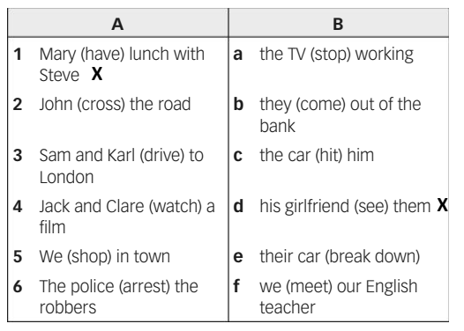

**Mary was having lunch with Steve when his girlfriend saw them.**