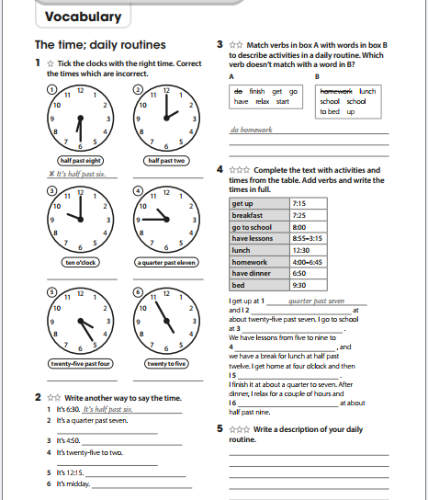TELLING THE TIME – THE SIMPLE PRESENT

PRESENT SIMPLE EXERCISES:

