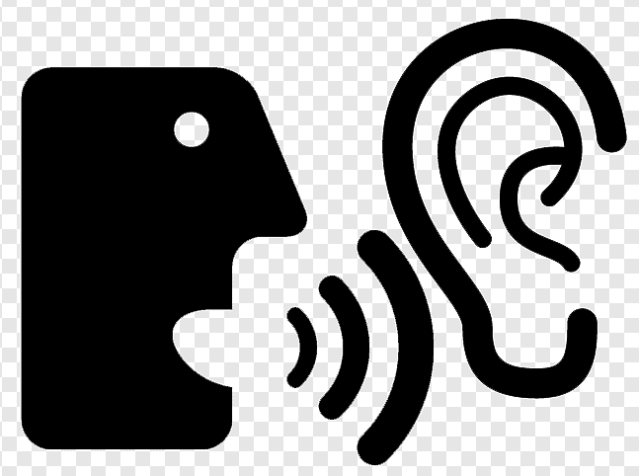 LISTENING
E-commerce and online banking
- Listen to two extracts from a monthly podcast called Money Matters. What is each speaker talking about?
Speaker 1 ________________________________________________
Speaker 2 ________________________________________________
- Listen again and make notes under these headings.
Speaker 1
Things people buy online

Steps for buying online

Precautions

Speaker 2
Things you can do with online banking

Biggest issues with online banking

Precautions

C. Write sentences giving advice of how to prevent some of these frauds.

