PRESENT SIMPLE – REVISION
1. Mark the following questions if they are correct or X if they are not. Correct the wrong questions.
a. Do John go to school every day? X Does John go to school every day?
b. Do Sophia and Peter go to college in the morning?
c. Does she like her job?
d. What time does you start work?
e. Does Hellen and Harry create usernames and passwords?
f. Where do he study?
g. When does she have online meetings?
h. Do your friends play rugby on weekends?

2. Write a paragraph about Juan. Use the following verbs: be – work – start work – finish – work from+ day + to + day – love – do sport – watch TV - relax
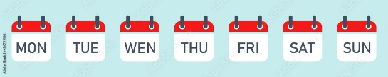

Work Schedule:

Workplace: Dell
From: Houston, Texas 8.30 am – 4.00 pm

Work days: Monday to Friday
Feelings about his job: ️

Name: Juan – Occupation: software developer

Free time activities: do sports, watch TV and relax
Juan is from Houston Texas and he is a software developer…

3. Now make yes/no and WH questions about Juan:
Example: Where is Juan from?

4. Make questions about the information in each sentence. Use the given wh word.
a. I live in Boston. Where ………………………..……………………………………………..……………………………….?
b. The English class starts at 8.00 am. What time……………………………………………………………………………?
c. Richard does sport at weekends. When ……………………………………………………………………………………….?
d. We have team meetings three times a week. How often……………………………………………………………..?
e. They train every day. They want to win the game. Why…………………………………………….………………….?
f. She designs and develops computer games. What…………………………………………………………………………?
g. He’s a database administrator. What……………………………………………………………………………………………..?
h. Mel and Abby work in building 3. Where………………………………………………………………………………………..?

