REVISION 2

a. Complete the sentences with these words:
I’m you’re he’s he’s she’s she’s it’s it’s
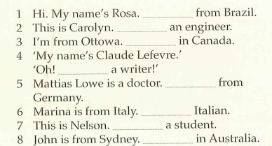

b. Circle the best option
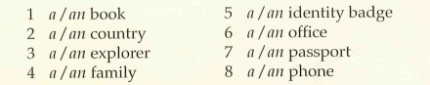

c. Complete the conversation with a-d:
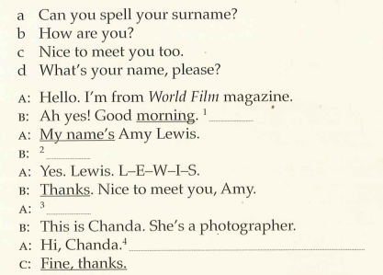

d. Put the words in the correct order to make negative sentences:
1. isn’t / secretary / Silvia / a.
2. network administrators / Mark and Latika / aren’t.
3. office / in / isn’t / their / building 2.
4. a / isn’t / Andrew/ database analyst,
5. they /in / the software development team/ aren’t

e. Make 2 negative sentences about yourself.

f. Read the text and answer the questions.
Hi, I’m Andrew. I’m an IT support officer in the IT team at university. In this photo, I’m not in building 8, I’m in building 5 with Jenny. She isn’t a database analyst, she’s an IT teacher. We aren’t in her office, we are in the computer room. The computers in the room aren’t very modern. We are updating software.

- Is Andrew a teacher?
- Is he in the IT team at university?
- Are Andrew and Jenny in building 8?
- Are they in the computer room?
- Is Jenny an English teacher?
- Are the computers modern?
g. Write two yes/no questions to ask to your teacher or partner:
Example: Are you from Salta?

h. Read the IT support team introduction and answer these questions:
Hi! I’m Sylvia. I’m a network administrator. This is Isabelle. She’s a network architect. And this is Andrew. He’s an IT support officer. Finally, this is Mark and this is Latika. They’re database analysts. Their area is data processing
We’re all in the IT team at university. Our offices are in building 8.

- Who is the network administrator?
- What is Andrew’s job?
- Who are the database analysts?
- What team are they in?
- Where are their offices?
- What is the name of the network architect?
i. Answer these personal questions:
a. What’s your surname?
b. What’s your phone number?
c. Are you from San Salvador de Jujuy?
d. What’s your favourite football team?
e. Who is your database teacher?
f. Is Mr. Vega your English teacher?

