REVISION 1

- Complete the sentences with the words in the chart.
- Match the sentences to the pictures.
Subject pronouns | Verb Be | Possessive adjectives
I  He  They | ‘m (x 2)  Is (x 4)  ‘s (x 2)  Are | My  His (x 2)  Her  Their

- Game development …¹ the process of creating a game.
- There … ² several members in a game development team.
- These are Monica, Luis and Juan. …³ are game designers. …⁴ job …⁵ to design the gameplay.
- Hi. I …⁶ Mia. …^{7 ‘}m a sound engineer. I…⁸ responsible for sound effects and sound positioning.
- This …⁹ Neil. …¹⁰ ‘s a level designer. …¹¹job is to create levels, challenges or missions for video games.
- This …¹² Lina. She …¹³ a game artist. …¹⁴ area is video game art.
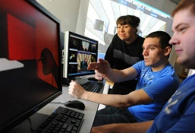
- This …¹⁵ Sean. He …¹⁶ a game programmer. …¹⁷ job is to develop the game codebase.
1 2 4

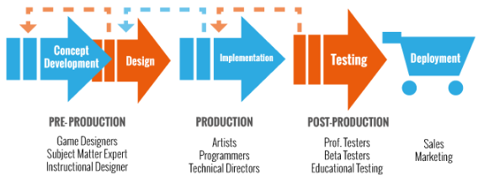
5

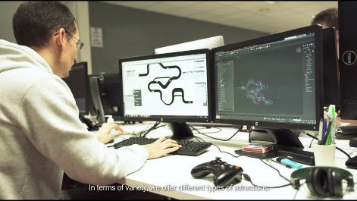
6 7

c. You are at the reception desk of a game developers conference in Berlin:
1. Invent an identity: name, job, company, phone number.
2. Write a conversation between you and the receptionist asking and giving personal information. Use the following dialogue as a model:
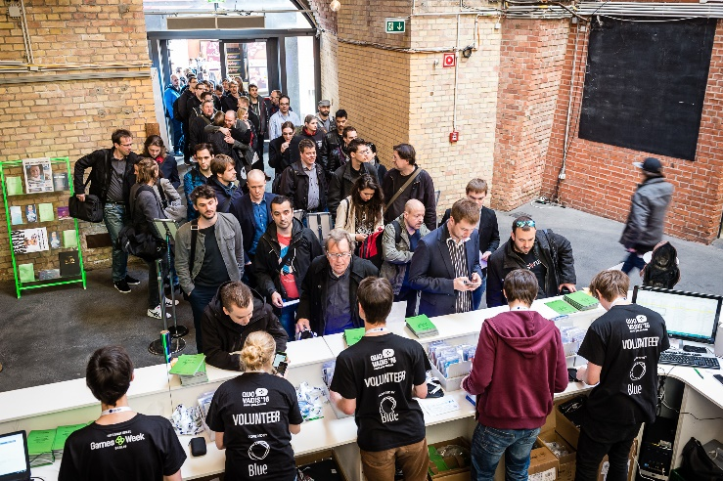
R: Good morning. What’s your name, please?
L: Hi. My name’s Schultz.
R: Can you spell that?
L: Yes. S-C-H-U-L-T-Z: Shultz.
R: What’s your first name?
L: Liam: L-I-A-M.
R: Thank you. What’s your job?
L: I’m a photographer. I’m from Today magazine.
R: OK. Sign here, please.
L: OK. Thanks. Bye.
R: Goodbye.

Base de código.
Estás en la recepción de una conferencia internacional de desarrolladores de videojuegos. 1. Inventá una identidad: nombre, trabajo, empresa, N° de teléfono. 2.Escribí una conversación entre vos y la recepcionista pidiendo y dando información personal. Usá el siguiente diálogo como modelo:
‘Firme acá por favor.’

