COMPARATIVE AND SUPERLATIVE FORMS EXERCISES
- Complete the table with the comparative and superlative form of the adjectives
ADJECTIVE | COMPARATIVE | SUPERLATIVE
bad
big
cheap
durable
easy
efficient
fast
good
heavy
light
modern
new
old
reliable
slow
small
thin
versatile

2.a. Look at the chart comparing three laptop computers. Then complete the sentences with the comparative form of the adjectives in parenthesis.
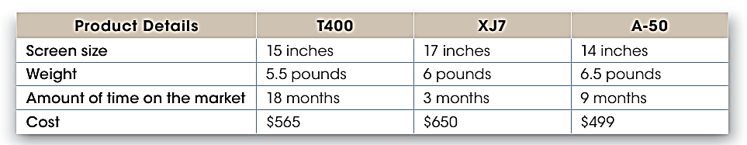
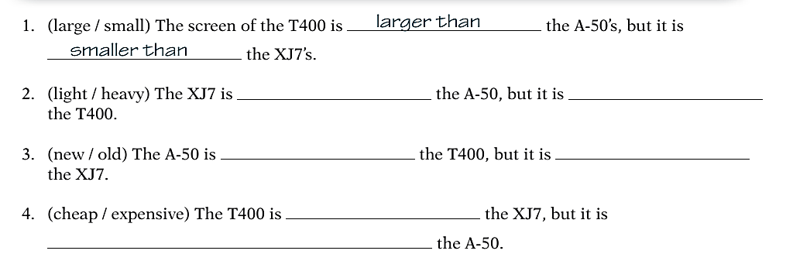
2.b. Now, write superlative sentences about the laptop computers.

3. Make comparative and superlative sentences about the three web browsers: Microsoft Edge, Google Chrome and Internet explorer.
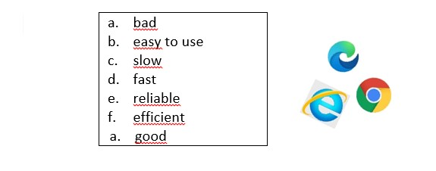

4.a. Make comparative sentences about these devices. Use: heavy; good memory capacity; expensive – durable.

laptop iPad Galaxy Fold
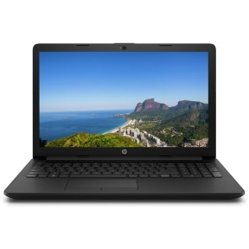
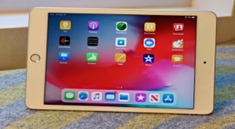

4.b. Now, make superlative sentences about the devices. Use: efficient; bad; easy to use; good definition.

