COMPARATIVE AND SUPERLATIVE FORMS EXERCISES
- Complete the table with the comparative and superlative form of the adjectives
ADJECTIVE | COMPARATIVE | SUPERLATIVE
bad | worse | The worst
big | bigger | The Biggest
cheap | cheaper | The cheapest
durable | More/less durable | The most/least durable
easy | Easier | The easiest
efficient | More/less efficient | The most/least efficient
fast | faster | The fastest
good | better | The best
heavy | heavier | The heaviest
light | lighter | The lightest
modern | More/less modern | The most/least modern
new | newer | The newest
old | older | The oldest
reliable | More/less reliable | The most/least reliable
slow | slower | The slowest
small | smaller | The smallest
thin | thinner | The thinnest
versatile | More/less versatile | The most/least versatile

2.a. Look at the chart comparing three laptop computers. Then complete the sentences with the comparative form of the adjectives in parenthesis.
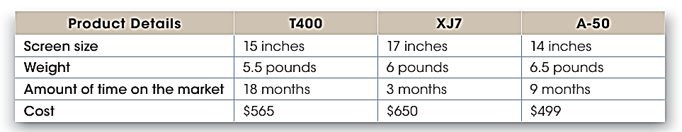
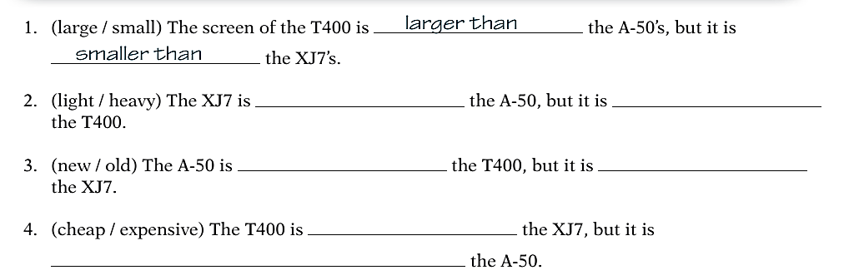
More expensive than
Cheaper than
Older than
Newer than
Heavier than
Lighter than

2.b. Now, write superlative sentences about the laptop computers.
-The A-50 is the cheapest in the shop and it has the smallest screen
-The A-50 is the heaviest of the three laptop computer.
- The XJ7 is the most expensive of the three laptop computer.
3. Make comparative and superlative sentences about the three web browsers: Microsoft Edge, Google Chrome and Internet explorer.
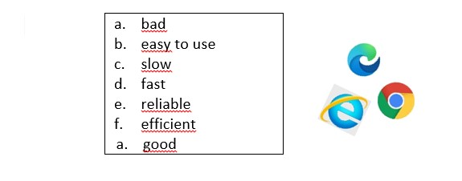
-Microsoft Edge is worse than Google Chrome.
-Internet Explorer is the slowest of the three web browsers, however, it is the easiest to use.
-Microsoft Edge is better than Internet Explorer, but Google Chrome is the best.
- Google Chrome is the easiest to use of the three browsers.
-Google Chrome is faster than Internet Explorer.
-Microsoft Edge is more reliable than Internet Explorer.
-Microsoft Edge is more efficient than Internet explorer, but The Google Chrome is the most efficient of the three.
4.a. Make comparative sentences about these devices. Use: heavy; good memory capacity; expensive – durable.

laptop iPad Galaxy Fold
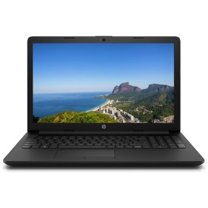
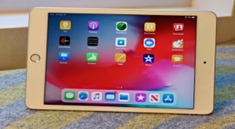

- A Galaxy Fold is more expensive than an iPad.
-The Galaxy Fold is cheaper than the laptop, but the laptop`s good memory capacity is better.
-The Laptop is heavier than a Galaxy Fold.
4.b. Now, make superlative sentences about the devices. Use: efficient; bad; easy to use; good definition.
-A Galaxy Fold is the easiest to use of the mobile.
- A Galaxy Fold is the most efficient of the mobile.
- The Laptop Samsung is the worst of the computer laptop.
The iPad is the most modern mobile at good definition.

