COMPARING SOFTWARE
SUPERLATIVE ADJECTIVES

Ya vimos que el grado comparativo se usa generalmente para establecer una comparación entre dos objetos (también lo usamos de la misma manera para comparar personas, lugares, animales, etc.) Comparamos una cualidad de “A” con la misma cualidad de “B”. El precio de una laptop Lenovo con el de una Alienware. O el precio de una laptop Apple MacBook con el de la Lenovo, etc.
Ahora nos vamos a ocupar del grado superlativo, el grado máximo de una cualidad, cuando destacamos una cosa por encima de toda una categoría.
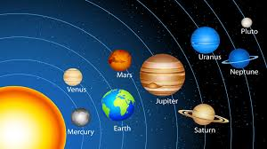
Jupiter is the largestst planet in the Solar System.→ en la categoría ‘Sistema Solar’, Júpiter es el el planeta más grande.

My grandma is the oldest person in my family. → en la categoría ‘mi familia’, mi abuela es la mayor.
1. Look at this PowerPoint presentation to learn about the superlative form of the adjectives.
2. Look!
We generally use comparative adjectives to compare two people or things. But when we compare one person or thing with a group of other people or things, we use superlative adjectives:
Web browsers
Firefox
Internet Explorer
Google chrome

Google Chrome is the fastest of the three browsers

3. Let’s study the rules:
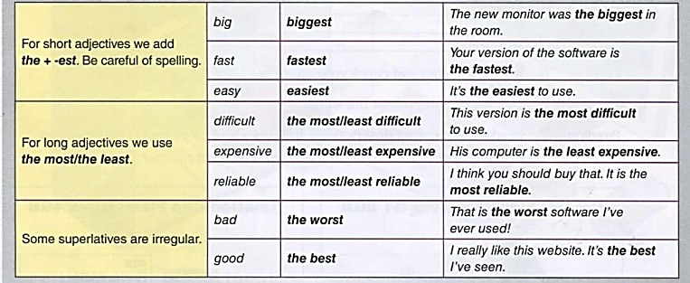

4. Can you think of more examples to add to the list?
………………………………………………………………………………………………………………………………………………………………………………………………………………………………………………………………………………………………………………………………………………………………………………………………………………………………………………………………………………………
5. ►15 Two colleagues are discussing photo imaging software. Listen to the dialogue and fill in the gaps with words from the box.
the best (x2) – best – the most – most expensive - correction – fastest – cheapest - compression – effects –burning

Tim: What do you think about these three photo imaging packaging?
Simone: It's a difficult choice. All three are very good but they have different strengths
Tim: I agree.
Simone: Serif Image Plus has (1) ______image (2) ___________.
Tim: OK
Simone: But Magic Extreme has the (3) _______ processing of images.
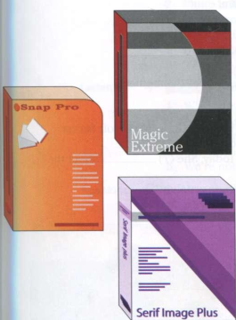
Tim:You're right. Also, Serif has (4)_________ special (5)_______________. But what about Snap Pro?
Simone: Well it has the (6) ___________dubbing options.
Tim: And Snap Pro is the best for (7) _____________ photos.
Simone:I'm not sure Serif has (8)________ efficient (9)__________.
Tim: Which is the (10) __________ __________________?
Simone: Oh, Serif Image Plus.
Tim: And the (11)______________?
Simone: Snap Pro.
Tim: Let’s get Snap Pro then.
Simone: I’m still not sure!
EXERCISES:
1. Write the superlative forms of the following adjectives or adjective phrases
- easy to use ………………………………………………………….
- reliable ………………………………………………………….
- heavy ………………………………………………………….
- cheap ………………………………………………………….
- convenient ………………………………………………………….
- good image correction ………………………………………………………….
- difficult to use ………………………………………………………….
- bad definition ………………………………………………………….
- fast ………………………………………………………….
- slow ………………………………………………………….
- expensive ………………………………………………………….
- new ………………………………………………………….
2. Choose three adjectives and three adjective phrases and use them to write comparative and superlative sentences about software and devices.

3. Finally, look at the following application programs. Can you write 6 (six) sentences using superlative forms? Compare them in terms of efficiency, reliability, speed, quality, etc.?
Office suites | Web browsers | Media players
Microsoft Office  LibreOffice  iWork | Firefox  Internet Explorer  Google chrome | Windows media player  VLC media player  Real player

Examples:
Firefox is faster than Internet Explorer but Google Chrome is the fastest of the three browsers.
Windows media Player is the most efficient media player.

