COMPARATIVE FORMS - EXERCISES
1. Make comparative sentences
1. data structure/ interesting/ English ________________________________________________________
2. airplanes / fast/ trains
________________________________________________________
3. algebra/ difficult/ geometry
________________________________________________________
4. Batman / popular/ Superman
________________________________________________________
5. Linux/ good / Windows
________________________________________________________
6. mornings / warm/ nights
________________________________________________________
7. Google Chrome /reliable/ Internet Explorer
________________________________________________________
8. a last generation mobile/ expensive/a tablet ________________________________________________________
9. France/ beautiful/ Switzerland
________________________________________________________
10. my old laptop/ reliable /my new one _______________________________________________________

2a. Irregular adjectives: complete the table.
Some comparatives are irregular. | Bad  malo
Good
bueno

2b. Make sentences with the comparatives of good and bad

3. Look at the following list of media player software and write comparative sentences about them. Use the adjectives in the box
MEDIA PLAYER SOFTWARE
VLC media player
Real Player
Windows Media Player
GomPlayer

easy / difficult to use – good – efficient – bad - popular - versatile

4. Make comparative sentences:
expensive – small – cheap – light – heavy - good/bad definition – good/bad memory capacity
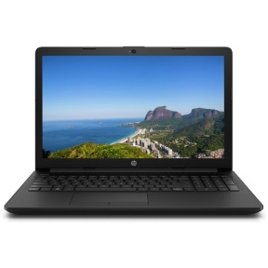
laptop iPad Galaxy Fold
