COMPARATIVE ADJECTIVES

Hasta ahora hemos venido trabajando principalmente con nombres propios, pronombres, sustantivos y fundamentalmente, con verbos.

Ahora nos vamos a detener en los adjetivos y las formas que toman en los distintos modos de comparar cosas, personas, lugares, etc.

1. Look at this [PowerPoint presentation](https://virtual.unju.edu.ar/mod/resource/view.php?id=346763) to learn about the comparative form of the adjectives.
2. Now, listen to two colleagues talking about two laptops and complete the dialogue. Use the comparative adjectives below.

**cheaper - better(x2) – smaller (x2) –bigger - lighter**

|  |  |
| --- | --- |
| Bob  Daisy  Bob  Daisy  Bob  Daisy  Bob  Daisy  Bob | What do you think? Which laptop is **………………………..**for the sales team?  I’m not sure. This computer has a ……………………………memory and I think it has a…………………………… processor.  And the other one?  Well, it is ……………………………  And ……………………………  Yes, you are right, **lighter** and **………………………**  But the **bigger** one is ……………………………  So, what is your decision?  I’m not sure. Let’s go for a coffee and discuss this again. |

**VOCABULARY:**

|  |  |
| --- | --- |
| **big:** grande  **cheap:** económico/ barato  **expensive:** costoso /caro  **good – better: bueno – mejor**  **“ = inch=** [**inches**](https://www.youtube.com/watch?v=v8yu9nAd1Kk)**:** pulgadas | **light: liviano**  **price:** costo / precio  **sales team: equipo de ventas**  **screen size**: tamaño de la pantalla -  **small:** pequeño |

**RECORDEMOS**

COMPARATIVES: We use comparative adjectives to compare two people, things, places, etc.

Study the following table:

|  |  |  |  |
| --- | --- | --- | --- |
| For short adjectives we add **–er (than)**. Be careful with spelling. | big | bigger | The new monitor is **bigger than** the old monitor. |
| fast | faster | Your processor is **faster than** mine |
| easy | easier | This mobile is **easier** to use **than** that one. |

|  |  |  |  |
| --- | --- | --- | --- |
| For long adjectives we use **more/less (than)** | difficult | more/ less  difficult | This version is **more** difficult to use **than** the old version. |
| expensive | more/ less  expensive | My computer is **less** expensive **than** yours |
| reliable | more/ less  reliable | You should buy that CPU. It is **more** reliable **than** the one you have. |

**¡MUY IMPORTANTE! ALGUNAS FORMAS COMPARATIVAS SON IRREGULARES:**

|  |  |  |  |
| --- | --- | --- | --- |
| Some comparatives are **irregular.** | Bad | worse | That screen resolution is much **worse than** before! |
| good | better | I really like this mouse. It’s much **better than** the old one. |

Note that we can use much before comparatives for emphasis.

Podemos usar ‘much’ antes del comparativo para enfatizar la diferencia, diciendo **mucho más:**

My Tablet is **much bigger** than my new mobile.

My new mobile is **much more expensive** than my tablet.

1. Look at the charts comparing three laptop computers.
2. Then complete the sentences with the comparative form of the adjectives in parentheses.
3. Use the example as a guide.

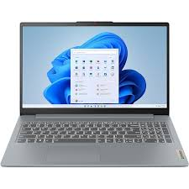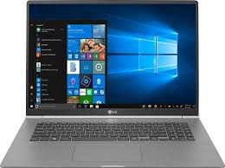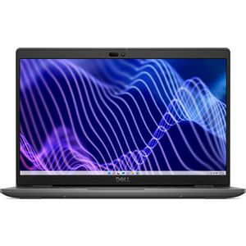

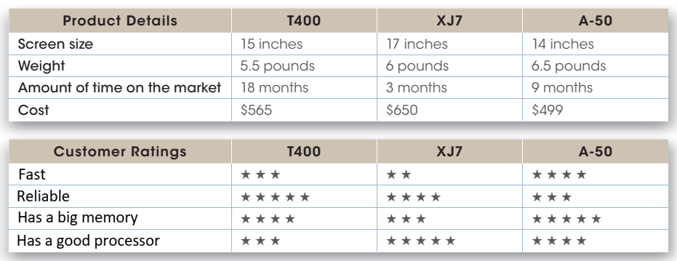 T400 XJ7 A-50

1. (large / small) The screen of the T400 is **larger than** the A-50’s, but it is **smaller** than the XJ7’s*.
2. (light / heavy) The XJ7 is ________________ the A-50, but it is ________________ the T400.
3. (new / old) The A-50 is ________________ the T400, but it is ________________ the XJ7.
4. (cheap / expensive) The T400 is ________________ the XJ7, but it is ________________ the A-50.
5. (fast / slow) The T400 is________________ the XJ7, but ________________ the A-50.
6. (reliable) The T400 is ________________ the XJ7 or the A-50.
7. (big) The A-50 has a ________________ memory _______ the T400 or the XJ7.
8. (good) The XJ7 has a ________________ processor _______ the T400 or the A-50.

* En el ejemplo, el apóstrofo + s, **‘s** indica posesión, que algo es de alguien. Su traducción es ‘de’: The screen of the T400 is larger than the A-50’s, but it is smaller than the XJ7’s*.

La pantalla de la T400 es más grande que la **de** la A-50**,** pero más pequeña que la **de** la XJ7.

**¡IMPORTANTE! No siempre es necesario usar ‘than’. Es posible omitirlo cuando la comparación se da por sentada:**

The T400 is a cheap laptop, but the A-50 is cheaper. →se sobrentiende que es “cheaper than the T400.”

The XJ7 is light, but the T400 is lighter. →se sobrentiende que es “lighter tan the XJ7”

**Exercises:**

1. **Write the comparative forms of these adjectives**

|  |  |  |  |
| --- | --- | --- | --- |
| Positive degree | Comparative degree | Positive degree | Comparative degree |
| 1. light 2. efficient 3. good 4. long 5. wide 6. heavy | lighter ((than) | g. fast  h. bad  i. dark  j. soft  k. hard  l. durable |  |

1. **Find the mistakes and correct them:**
2. My assignment was badder than I expected! I got a 3.
3. Are inkjet printers moreb ad than laser printers?
4. Your new mobile isn’t good than your old mobile.
5. Sheila is a gooder student than Martha.
6. Is Internet Explorer bad than Microsoft Edge?
7. My computer isn’t more good than your computer.

**C. Make comparative sentences about these game consoles. Use: cheap – good – convenient – modern – easy to use**

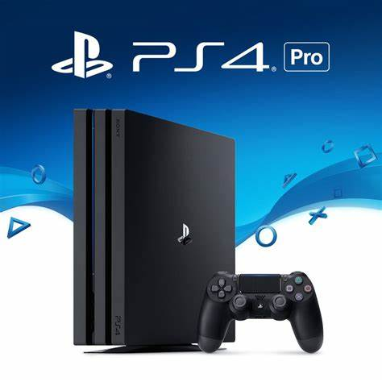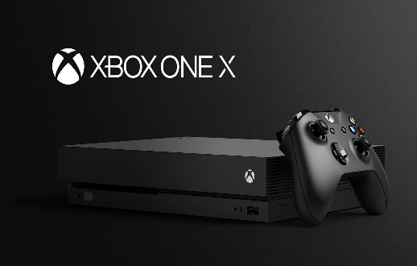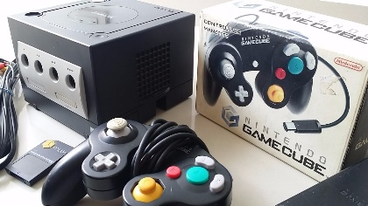

XBOX ONE X

Playstation 4

Nintendo GameCube

a. ………………………………………………………………………………………………………………………………………..

b. ………………………………………………………………………………………………………………………………………..

c. ………………………………………………………………………………………………………………………………………..

d. ………………………………………………………………………………………………………………………………………..

e. ………………………………………………………………………………………………………………………………………..

E. Compare your mobile with your classmate’s and write sentences.

EXAMPLE: My mobile is older than María’s (mobile)