COMPARATIVE ADJECTIVES

Hasta ahora hemos venido trabajando principalmente con nombres propios, pronombres, sustantivos y fundamentalmente, con verbos.
Ahora nos vamos a detener en los adjetivos y las formas que toman en los distintos modos de comparar cosas, personas, lugares, etc.

- Look at this PowerPoint presentation to learn about the comparative form of the adjectives.
- Now, listen to two colleagues talking about two laptops and complete the dialogue. Use the comparative adjectives below.
cheaper - better(x2) – smaller (x2) –bigger - lighter
Bob  Daisy  Bob  Daisy  Bob  Daisy  Bob  Daisy  Bob | What do you think? Which laptop is ………………………..for the sales team?  I’m not sure. This computer has a ……………………………memory and I think it has a…………………………… processor.  And the other one?  Well, it is ……………………………  And ……………………………  Yes, you are right, lighter and ………………………  But the bigger one is ……………………………  So, what is your decision?  I’m not sure. Let’s go for a coffee and discuss this again.
VOCABULARY:
big: grande  cheap: económico/ barato  expensive: costoso /caro  good – better: bueno – mejor  “ = inch= inches: pulgadas | light: liviano  price: costo / precio  sales team: equipo de ventas  screen size: tamaño de la pantalla -  small: pequeño

RECORDEMOS
COMPARATIVES: We use comparative adjectives to compare two people, things, places, etc.
Study the following table:

For short adjectives we add –er (than). Be careful with spelling. | big | bigger | The new monitor is bigger than the old monitor.
 | fast | faster | Your processor is faster than mine
 | easy | easier | This mobile is easier to use than that one.

For long adjectives we use more/less (than) | difficult | more/ less  difficult | This version is more difficult to use than the old version.
 | expensive | more/ less  expensive | My computer is less expensive than yours
 | reliable | more/ less  reliable | You should buy that CPU. It is more reliable than the one you have.

¡MUY IMPORTANTE! ALGUNAS FORMAS COMPARATIVAS SON IRREGULARES:
Some comparatives are irregular. | Bad | worse | That screen resolution is much worse than before!
 | good | better | I really like this mouse. It’s much better than the old one.

Note that we can use much before comparatives for emphasis.
Podemos usar ‘much’ antes del comparativo para enfatizar la diferencia, diciendo mucho más:
My Tablet is much bigger than my new mobile.
My new mobile is much more expensive than my tablet.

- Now, look at the three laptops below. What can you say about their screen size and their price?
- Try to complete the sentences with a comparative form or the name of one of the three laptops.
- Use the example as a guide.

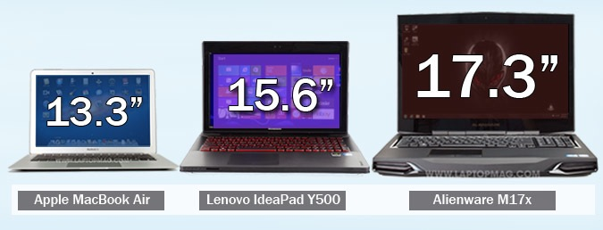

$150 $999 $1679

EXAMPLE: The Lenovo’s* screen is smaller than the Alienware’s* but it is bigger than the Apple MacBook’s*.
- The Apple MacBook is ……………………… …….. (cheap) the Lenovo and the ………………………… .
- The Lenovo is cheaper than the Alienware but it is ……… ……………………….. …………. (expensive) the ……………………………….. .
- The Alienware’s screen is …………………… ……… (big) the Apple MacBook’s and the …………………..’s
- The Apple MacBook is not ………… ………………………….. ………. (expensive) than the Lenovo and the Alienware.
- The Lenovo is less expensive than the Alienware and the Apple MacBook is ……………………..…….
……… the Lenovo.
* El apóstrofo + s: ‘s indica posesión, que algo es de alguien. Su traducción es ‘de’:
The Alienware’s screen = la pantalla de la Alienware. Para no volver a repetir la palabra pantalla, solamente se usa el apóstrofo s en the Apple MacBook’s, la idea es la misma: la pantalla de la Apple MacBook.
¡IMPORTANTE! No siempre es necesario usar ‘than’. Es posible omitirlo cuando la comparación se da por sentada:
The Lenovo is a cheap laptop but the Apple MacBook is cheaper. →se sobrentiende que es “cheaper than the Lenovo.”

The Lenovo’s screen is small but the Apple MacBook is smaller.

Exercises:
- Find the mistakes and correct them:
- My assignment was badder than I expected! I got a 3.
- Are inkjet printers more bad than laser printers?
- Your new mobile isn’t good than your old mobile.
- Sheila is a gooder student than Martha.
- Is Internet Explorer bad than Microsoft Edge?
- My computer isn’t more good than your computer.

B. Make the comparative form of these adjectives.
Example: long …longer…………

- light …………………………………
- efficient ………………………………
- good……………………………………
- long…………………………………
- wide…………………………………
- heavy…………………………………
- fast…………………………………
- bad…………………………………….
- dark …………………………………
- soft…………………………………
- hard…………………………………
- durable…………………………………

C. Read these product descriptions and make sentences using the comparative form of the above adjectives.
Example: The corsair is longer than the Imation but slimmer
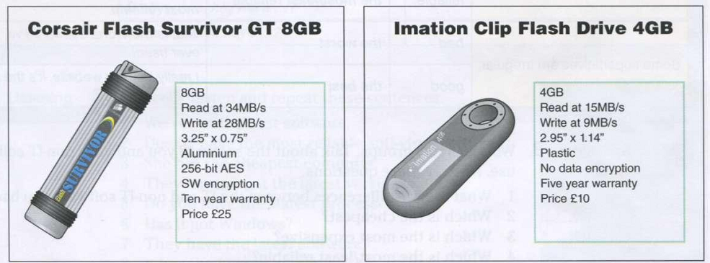

- ………………………………………………………………………………………………………………………………………………
- ………………………………………………………………………………………………………………………………………………
- ………………………………………………………………………………………………………………………………………………
- ………………………………………………………………………………………………………………………………………………
- ………………………………………………………………………………………………………………………………………………
- ………………………………………………………………………………………………………………………………………………
- ………………………………………………………………………………………………………………………………………………

D. Make comparative sentences about these game consoles. Use: cheap – good – convenient – modern – easy to use
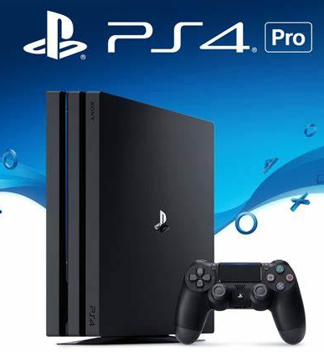
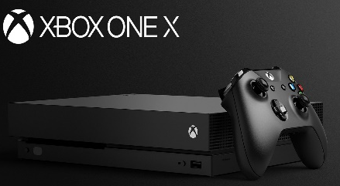
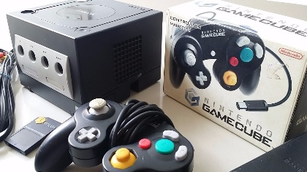

XBOX ONE X
Playstation 4
Nintendo GameCube

a. ………………………………………………………………………………………………………………………………………..
b. ………………………………………………………………………………………………………………………………………..
c. ………………………………………………………………………………………………………………………………………..
d. ………………………………………………………………………………………………………………………………………..
e. ………………………………………………………………………………………………………………………………………..
E. Compare your mobile with your classmate’s and write sentences.
EXAMPLE: My mobile is older than María’s (mobile)

