THE PROGRAM WAS RUNNING WHEN THE COMPUTER CRASSHED
THE PAST CONTINUOUS WITH WHEN AND WHILE


Can you think of a day in which you were trying to do something, but then something unexpected interrupted you?
Last Tuesday morning, while I was printing the tests, the power went out.
I was working on a project when my computer froze.
Si observamos los ejemplos escritos, podemos ver dos palabras en negritas: when y while. When quiere decir cuándo y while quiere decir mientras.

Es muy común que, cuando estamos hablando de eventos del pasado, combinemos el pasado simple y el pasado continuo, usando when y while. Por lo general, en estos casos hacemos referencia a algo que estaba pasando cuando sucedió otra cosa que lo interrumpió. Veamos:

1. Match the sentences to the pictures
- While Alan was updating the antivirus software, the power went out.
- The program was running when the computer crashed.
- The screen went black while the programmers were working on the database.
- Franco was shopping online when his keyboard froze and the screen went black.


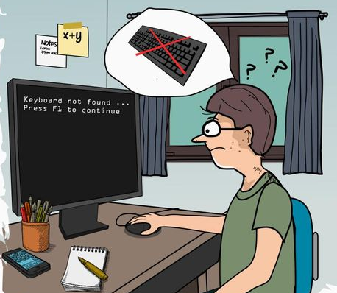

- b. c.

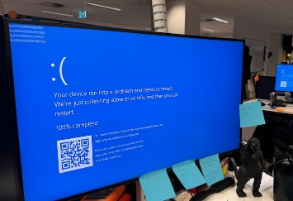
d.

2. Read the sentences again and choose the best option:
a. What was happening when the computer crashed?
I. the program was running. II. the computer was running III. the program was crashing

b. When did the screen go black?
I. while the database was working II. while the programmers were working

c. What happened while Alan was updating the software?
I. He updated the software. II. The lights went out. III. He went out.

d. When did the keyboard freeze and the screen go black?
I. While the screen froze. II. While he went black. III. While he was shopping online.

Volvamos ahora a las oraciones. Podemos ver que en todos los casos hay 2 tiempos verbales: el ……………………………………………….. y el ………………………………………………………..
- El ……………………………….……………………….. describe la acción que NO estaba terminada, la que estaba en proceso. Ejemplos: Alan was updating the software; the program was running; ……………………………………………; ……………………………………………………………
- Por otra parte, el ………………………………………………… describe las acciones que interrumpieron lo que estaba sucediendo. Ejemplos: the power went out; the compute rcrashed………………………………………………; …………………………………………………….
- También podemos ver que when acompaña al ……………………………………………….. y while acompaña al ……………………………………………………
- While también señala dos o más acciones que estaban en proceso simultáneamente, es decir dos o más acciones en pasado continuo: She was testing the app while I was debugging the antivirus software.

Como ya señalamos, es posible usar el pasado simple combinado con el pasado continuo.
→ The program was running →

the computer crashed

En la línea de tiempo podemos ver que la acción en proceso, The program was running, se estaba llevando a cabo, cuando fue interrumpida por la falla de la computadora, the computer crashed. También podemos ver, a partir del ejemplo, que es posible combinar estas dos acciones en una oración usando el conector ‘when’: The program was running when the computer crashed. En estas oraciones donde combinamos los dos tiempos verbales, generalmente when acompaña al pasado simple.

También es común usar while:

I was printing a document.

The lights went out
While I was printing a document, the lights went out.

Acá vemos una situación muy similar: una acción que estaba sucediendo y fue interrumpida por otra. La diferencia es que acá estamos describiendo estos eventos usando el conector while. Generalmente while acompaña al pasado continuo.

Otra cosa importante a tener en cuenta es que es posible invertir el orden de las acciones:
When the lights went out, I was printing a document.
I was printing the document when the lights went out.
While I was printing the document, the lights went out.
The lights went out while I was printing the document.

Cuando usamos los dos tiempos verbales, es muy importante tener en cuenta cuál de las dos acciones es la que requiere más tiempo, (por ejemplo: update the software; run a program; work; shop online; print a document; etc.); y cual la que es repentina y sucede en un instante, (por ejemplo: go black; freeze; crash; etc.) Usaremos el pasado simple para describir estas acciones más cortas y el pasado continuo para hablar de las acciones más largas que se estaban realizando.
3. Read and listen to Frank´s difficult day at work and choose the best option
Last Monday, my colleagues and I had / was having¹ a very difficult day at work. We had / was having² to finish an educational platform for the local university, but we faced some problems. I worked / was working³ on the user interface for the platform when the telephone rang / was ringing⁴. It was Carla. She needed / was needing⁵ help because her computer crashed / was crashing⁶ while she tested / was testing⁷ an app. I called / was calling⁸ the IT support office, but Jack wasn’t there because he installed / was installing⁹ a server in the conference room. Well, I gave / was giving¹⁰ Carla my laptop and continued working on my PC. I finished / was finishing¹¹ my work when the lights went out / were going out¹². They didn't come back / weren’t coming back¹³ until 8:00 p.m. We were lucky because we didn’t lose / weren’t losing¹⁴ our work. We stayed late in our offices and worked / were working¹⁵ very hard, but we finally finished the platform at around 11:30 p.m.

4. Now, decide what verbs are in the past simple and what verbs are in the past continuous and complete the table.

Past simple |  | PasT continuous
verb | meaning | verb | meaning
had | tuvimos | was working | estaba trabajando

5. Read the text again and answer these questions
1. What was Frank doing when the telephone rang?
2. Was Carla working on the user interface?
3. Who was installing a server in the conference room ?
4. What was happening when did the lights went out?
5. When did the lights come back?
5. Did they lose all their work?
6. Underline the correct option:
1 I was losing / lost my mobile phone while I was jogging / jogged in the park.
2 Jason was going / went to the supermarket when I was seeing / saw him.
3 Lucy was having / had lunch when her boyfriend was calling / called her.
4 My friends were arriving / arrived while I was having/ had a shower.
5 Nick was cooking / cooked when the telephone was ringing / rang.
6 Robert was driving / drove to work, when the police were stopping / stopped him.
7 Tony and Dan were playing / played tennis when it was starting / started to rain.
8 When Ted was leaving / left home this morning, I was sleeping / slept.
9 Tricia was living / lived in London when she was meeting / met her future husband.
10 We were seeing / saw Mark while we were shopping / shopped in town.
7. Fill in the blanks with the PAST SIMPLE or the PAST CONTINUOUS form of the verbs in brackets:
1. We ______________________ (play) Minecraft with Mary when the lights _______________________ (go out)
2. When the teacher _____________________(start) the Zoom class, many students ___________________ (sleep).
3. While she ___________________________ (print) the documents, the printer _________________ (get) disconnected.
5. My classmates _____________________ (do) the exam when I ________________ (enter) the classroom.
6. While we _______________ (work) on the game high concept, the system _________________ (crash)

