THE PROGRAM WAS RUNNING **WHEN** THE COMPUTER CRASSHED

THE PAST CONTINUOUS WITH WHEN AND WHILE

Can you think of a day in which you were trying to do something, but then something unexpected interrupted you?

Last Tuesday morning, **while** I was preparing the cat’s food, the lights went out.

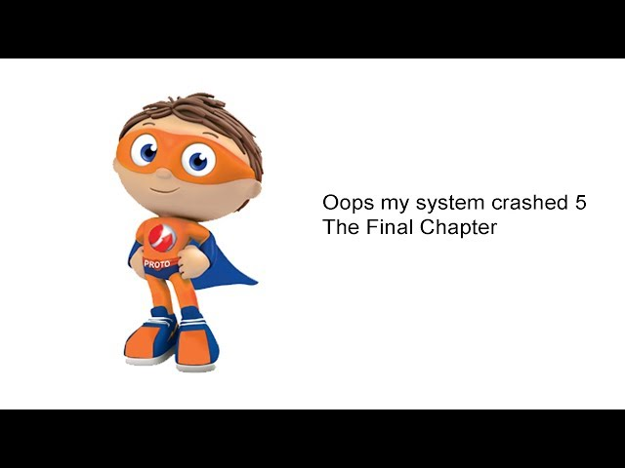I was working on a project **when** my computer froze.

**While** I was trying to do the English homework, …

I was playing a video-game **when**…

Si observamos los ejemplos escritos, podemos ver dos palabras en negritas: **when** y **while. When** quiere decir **cuándo** y **while** quiere decir **mientras.**

Es muy común que, cuando estamos hablando de eventos del pasado, combinemos el **pasado simple** y el **pasado continuo**, usando **when** y **while**. Por lo general, en estos casos hacemos referencia a algo que estaba pasando cuando sucedió otra cosa que lo interrumpió. Veamos:

**1. Match the sentences to the pictures**

1. **While** Alan **was updating** the antivirus software, the lights **went out.**
2. The program **was running when** the computer **crashed**.
3. The screen **went black** **while** the programmers **were working** on the database.
4. Franco **was shopping** online **when** his keyboard **froze** and the screen **went black**.

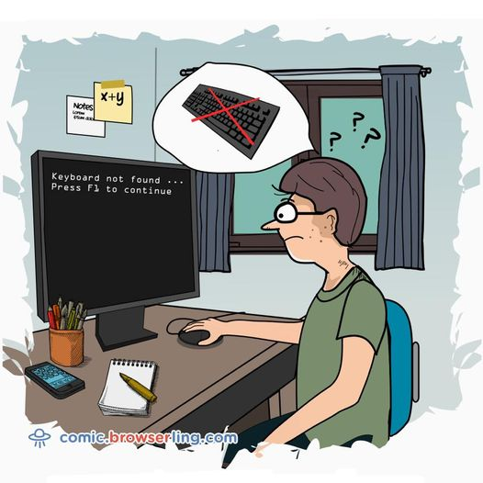



1. b. c.

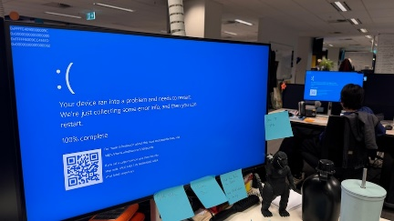

d.

**2. Read the sentences again and choose the best option:**

a. What **was happening** when the computer crashed?

I. the program was running. II. the computer was running III. the program was crashing

b. When did the screen go black?

I. while the database was working II. while the programmers were working

c. What **happened** while Alan was updating the software?

I. He updated the software. II. The lights went out. III. He went out.

d. When did the keyboard freeze and the screen go black?

I. While the screen froze. II. While he went black. III. While he was shopping online.

Volvamos ahora a las oraciones. Podemos ver que en todos los casos hay **2 tiempos verbales**: el ……………………………………………….. y el ………………………………………………………..

* El ……………………………….……………………….. describe la acción que NO estaba terminada, la que estaba sucediendo: Alan was updating the software; the program was running; ……………………………………………; ……………………………………………………………
* Por otra parte, el ………………………………………………… describe las acciones que interrumpieron la acción que estaba sucediendo: the lights went out; the computer crashed; …………………………………………………; ………………………………………………………….
* También podemos ver que **when** acompaña al ……………………………………………….. y **while** acompaña al ……………………………………………………
* **While** también señala dos o más acciones que estaban en proceso simultáneamente, es decir dos o más **acciones en pasado continuo**: She **was testing** the app **while** I **was debugging** the antivirus software.

👇

[Como ya señalamos, es posible usar el pasado simple combinado con el pasado continuo.](https://drive.google.com/file/d/1-yI4G6KE7U3jgY6M6Yj3lKqqYptgnikj/view?usp=sharing)

→ The program was running →

the computer crashed

En la línea de tiempo podemos ver que la acción en proceso, *The program* ***was running***, se estaba llevando a cabo, cuando fue interrumpida por la falla de la computadora, *the computer* ***crashed.*** También podemos ver, a partir del ejemplo, que es posible combinar estas dos acciones en una oración usando el conector ‘**when**’: The program was running **when** the computer crashed. En estas oraciones donde combinamos los dos tiempos verbales, generalmente **when** acompaña al **pasado simple**.

También es común usar **while:**

I was printing a document.

The lights went out

**While** I **was printing** a document, the lights **went out.**

Acá vemos una situación muy similar: una acción que estaba sucediendo y fue interrumpida por otra. La diferencia es que acá estamos describiendo estos eventos usando el conector **while**. Generalmente **while** acompaña al **pasado continuo.**

🤔 Otra cosa importante a tener en cuenta es que es posible invertir el orden de las acciones:

**When** the lights **went out**, I **was printing** a document.

I **was printing** the document **when** the lights **went out.**

**While** I **was printing** the document, the lights **went out**.

The lights **went out** **while** I **was printing** the document.

Cuando usamos los dos tiempos verbales, es muy importante tener en cuenta cuál de las dos acciones es la que requiere más tiempo, (por ejemplo: update the software; run a program; work; shop online; print a document; etc.); y cual la que es repentina y toma mucho menos tiempo en suceder, (por ejemplo: go black; freeze; crash; etc.) Usaremos el **pasado simple** para describir **estas acciones más cortas** y el **pasado continuo** para hablar de las **acciones más largas** que se estaban realizando.

**3. ▶ Read and listen to Frank´s difficult day at work and choose the best option**

Last Monday, my colleagues and I **had** / **was having1** a very difficult day at work. We **had** / **was having2** to finish an educational platform for the local university, but we faced some problems. I **worked / was working**3 on the user interface for the platform when the telephone **rang** / **was ringing4**. It was Carla. She **needed** / **was needing**5 help because her computer **crashed** **/ was crashing6** while **she tested / was testing7** an app. I **called / was calling8** the IT support office, but Jack wasn’t there because he installed / **was installing9** a server in the conference room. Well, I **gave / was giving10** Carla my laptop and continued working on my PC. I **finished / was finishing11** my work when the lights **went out / were going out12**. They **didn't come back / weren’t coming back13** until 8:00 p.m. We were lucky because we **didn’t lose / weren’t losing14** our work. We stayed late in our offices and **worked / were working15** very hard, but we finally finished the platform at around 11:30 p.m.

**4. Now, decide what verbs are in the past simple and what verbs are in the past continuous and complete the table.**

|  |  |  |  |
| --- | --- | --- | --- |
| Past simple | | PasT continuous | |
| verb | meaning | verb | meaning |
| had | tuvimos | was working | estaba trabajando |
|  |  |  |  |
|  |  |  |  |
|  |  |  |  |
|  |  |  |  |
|  |  |  |  |
|  |  |  |  |
|  |  |  |  |
|  |  |  |  |
|  |  |  |  |

**5. Read the text again and answer these questions**

1. **What was Frank doing** when the telephone rang?

2. Was Carla working on the user interface?

3. Who was installing a server in the conference room ?

4. **What was happening** when did the lights went out?

5. When did the lights come back?

5. Did they lose all their work?

**6. Underline the correct option:**

1 I *was losing* / *lost* my mobile phone while I *was jogging* / *jogged* in the park.  
2 Jason *was going* / *went* to the supermarket when I *was seeing* / *saw* him.  
3 Lucy *was having* / *had* lunch when her boyfriend *was calling* / *called* her.  
4 My friends *were arriving* / *arrived* while I *was having*/ *had* a shower.  
5 Nick *was cooking* / *cooked* when the telephone *was ringing* / *rang*.  
6 Robert *was driving* / *drove* to work, when the police *were stopping* / *stopped* him.  
7 Tony and Dan *were playing* / *played* tennis when it *was starting* / *started* to rain.  
8 When Ted *was leaving* / *left* home this morning, I *was sleeping* / *slept.*9 Tricia *was living* / *lived* in London when she *was meeting* / *met* her future husband.  
10 We *were seeing* / *saw* Mark while we *were shopping* / *shopped* in town.

**7. Fill in the blanks with the PAST SIMPLE or the PAST CONTINUOUS form of the verbs in brackets:**

1. While Carla and Mark ______________________ (test) the new software, the lights _______________________ (go out)

2. When the teacher _____________________(start) the Zoom class, many students ___________________ (sleep).

3. While she ___________________________ (print) the documents, the printer _________________ (get) disconnected.

5. My classmates _____________________ (do) the exam when I ________________ (enter) the classroom.

6. While we _______________ (work) on the new app, the system _________________ (crash)