EXERCISES
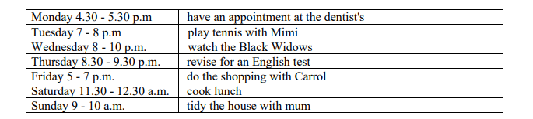
1. Look at Jane's diary. What was she doing at these times?

- On Monday at 5 p.m. she ........................................... an appointment at the dentist's.
- On Tuesday between 7 - 8 p.m. Jane and Mimi ........................................... tennis.
- On Wednesday at 9 o'clock she ........................................... the Black Widows.
- On Thursday from 8.30 to 9.30 she ........................................... for an English test.
- On Friday at 6 o'clock Jane and Carrol ........................................... the shopping.
- On Saturday between 11.30 and 12.30 she ........................................... lunch.
- On Sunday at 9.30 Jane and her mum ........................................... the house.

2. Complete with the past continuous form of the verb in brackets.

Server problem at the office
Yesterday morning, the IT department dealt with a big problem: the company's website was down. At 9:15, all the team members __________________ (look) for the cause. Ana ________________ (check) the server logs, and Martín and Lucía ___________________ (review) the latest code changes. At the same time, Diego _________________ (call) the hosting company.
The manager _______________ (not sit) in his office. He _________________ (walk) around the room and _________________ (ask) for updates. The clients ___________________ (send) angry emails, but nobody _________________ (answer) them.
Ana and Diego _________________ (not work) on the same task at that moment. Ana ____________ (test) a solution on a backup server, and Diego _________________ (wait) for a reply from the hosting company.
What ___________________ (the clients / say)? They ____________________ (complain) about the delay.

3. Look at the table. Correct the sentences: say what they weren't doing and what they were doing.
 | Sofía | Tomás and Iván
09:00 – 10:30 | write code | have a meeting
10:30 – 12:00 | test the app | fix bugs
12:00 – 13:00 | have lunch | review code
Look at the table. Correct the sentences: say what they weren't doing and what they were doing.
At ten o'clock …
Sofía was testing the app.
→ Sofía wasn't testing the app. She was writing code. (ejemplo resuelto)
At eleven o'clock …
1. Sofía was writing code.
2. Tomás and Iván were having a meeting.

At half past twelve …
3. Sofía was testing the app.
4. Tomás and Iván were fixing bugs.

4. The Robbery at NovaTech Arena
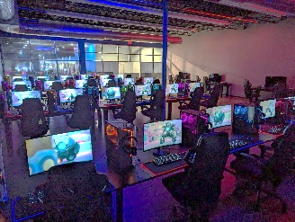
Last night there was a robbery at NovaTech Arena, a big gaming center. A very expensive prototype VR headset is missing from the Tech Room. The police want to know what everybody was doing at five past eight (8:05 p.m.).
Read the security camera reports. Then read the questions and answer them.
📹 Camera 1 – Main entrance
Omar, the security guard, was standing at the door. He was checking tickets on a tablet.
📹 Camera 2 – Reception
Ms Rivera, the manager, was standing behind the desk. She was talking on the phone and looking at her laptop.
📹 Camera 3 – Café
Julia and Fede were sitting at a table. They were eating burgers and watching a match on a phone.
📹 Camera 4 – Gaming Zone
Dani, a famous streamer, was playing a shooter game. He was streaming it live to his followers.
📹 Camera 5 – Corridor
Marta and Ben, the cleaning staff, were cleaning the floor. They were listening to music on their headphones.
📹 Camera 6 – Tech Room
The camera wasn't working at 8:05 p.m. There was no image.
Questions
- Was Omar watching a match?
- Who was talking on the phone?
- What were Julia and Fede doing?
- Were Marta and Ben cleaning the café?
- What was Dani doing?
- Where were Martha and Ben cleaning the floor?
- Were all the cameras working?
- Why were there no images of the Tech Room?

