TALKING ABOUT THE PAST – REVISION AND PRACTICE
1. Read anc complete the text with the correct form of the verbs in brackets.
In October 1958, William Higginbotham …………………………………… (develop) the first video game. It …………………………………… (not be), very complex. In fact, it …………………………………… (be) a very simple tennis game, similar to the classic video game Pong, and it …………………………………… (be) a hit. The First commercial arcade game …………………………………… (be)Computer Space. Nolan Bushnell and Ted Dabney …………………………………… (design) this game and it was the first commercially available video game. In 1973 Nutting Associates…………………………………… (produce) a two-player version of Computer Space, although Bushnell and Dabney …………………………………… (not give) them permission to do it.

2. How much do you know about the history of networking?
A. Match these events 1-5 to the dates a-e.
B. Answer the questions using this information
1 Tim Berners Lee invented the World Wide Web  2 Facebook started in…  3 Jack Dorsey, Evan Williams, Biz Stone  and Noah Glass launched Twitter in…  4 MySpace began in …  5 Ray Tomlinson sent the first e-mail in | a) 2006  b) 1989  c) 1971  d) 2004  e) 2003

- Who sent the first e- mail?
- When did Facebook start?
- When did Tim Berners Lee invent the WWW?
- What happened in 2006?

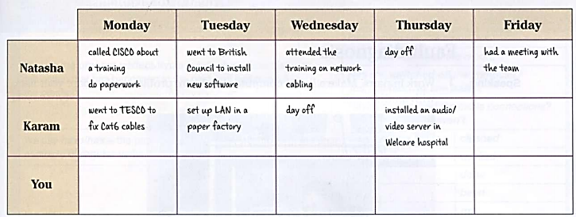
3. Karam and Natasha work for ComHelp, a company that provides IT services to customers. Read their notes and write affirmative and negative sentences about their work last week.
Call CISCO about a training.
Do paperwork.
Go to the British Council to install new software.
Attend the training on network cabling.
Day off
Have a meeting with the team.
Go to TESCO to fix CAT 6 cables.
Set up LAN in a paper factory.
Day off
Attend a workshop.
Install a video server.

3. Now, complete the chart with your activities last week, at work or college and write about it.
 | Monday | Tuesday | Wednesday | Thursday | Friday
You |  | Attend an English class
Example: On Monday I... and...
5. Ask and answer questions about what you did last week
Example:
Student A: What did you do last week?
Student B: On Monday morning I attended a training course and in the afternoon I went to the doctor.

