TALKING ABOUT THE PAST
1. How much do you know about the history of networking and social media? Can you match these events 1-5 to the dates a-e?


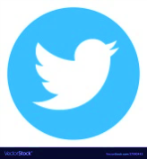


1 Tim Berners Lee created the World Wide Web  2 Facebook started in…  3 They launched Twitter in…  4 MySpace started in …  5 Ray Tomlinson sent the first e-mail in | a) 2006  b) 1989  c) 1971  d) 2004  e) 2003

You can find the answers here

  - Tim Berners Lee created the World Wide Web in 1989.
  - Facebook started in 2004.
  - They launched Twitter in 2006.
  - MySpace started in 2003.
  - Ray Tomlinson sent the first email in 1971.

2. Now, find out

a. Who launched Instagram ……………………………………………………….…….…………….
b. When they launched it ……………………….…………………………….……………………………..
c. Who created TikTok ……………………………………………………….…………….…….………..
d. When they launched TikTok ………………………………………………..…….……………….…
e. The year Google started………………………………………………………………………………….
f. The year Steve Jobs created the iPhone ………………………………………………………….

You can find the answers here
- Kevin Systrom and Mike Krieger were the cofounder of Instagram and they launched it in 2010.
- Zhang Yiming founded ByteDance, a social media group that created TikTok. They launched the app in September 2017.
- Google started in 1998.
- Steve Jobs created the iPhone in 2007.

3. Now look at the verbs in blue. Do they have anything in common? Is there a verb which does not share that thing in common? (Ahora mirá los verbos en celeste. ¿Tiene algo en común? ¿Hay algún verbo que no comparta eso?)

NO VEO QUE TENGAN NADA EN COMÚN | VEO QUE CASI TODOS TIENE EN COMÚN… | CREO QUE EL VERBO QUE NO COMPARTE ESO ES…

Mi conclusión: ……………………………………………………………………………………………………………………………………………..
……………………………………………………………………………………………………………………………………………………………………….

4. Read and listen to this text about a tech conference last month and complete the text with the verbs in the box.

were – gave – joined - was (x2) – attended – talked

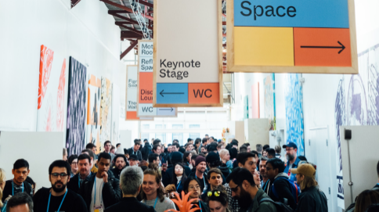

Last month, we ………………..……..a big tech conference in San Francisco. The new gadgets……………………. incredible! The keynote speaker………..…………..Tim Cook, the CEO of Apple. He …………………………..a presentation on the future of technology. After the presentation, we ……………………. other developers and……………………. about new projects. It ………………….. a great experience.
5. Read the text again and mark the sentences T (true) or F (false) and correct the false ones.
- They were in San Francisco last month.
- They attended a conference on new gadgets.
- Tim Cook gave a presentation on the future of Apple.
- The developers talked about the new projects.
- It was a terrible experience.

GRAMMAR: the past simple

Look at all the verbs in blue. All these verbs refer to actions that happened in the past: 1971; 1998; 2003; 2007; 2010…, last month, so they are in the past simple tense.
In English, we use the past simple tense to talk about actions or states that happened and finished in the past. For example: "I worked for Arm from 2010 to 2022"

Mirá todos los verbos en celeste. Todos se refieren a acciones que sucedieron en el pasado: 1971; 1998; 2003; 2007; 2010…, el mes pasado y por lo tanto están en el tiempo pasado simple.
En inglés, usamos el pasado simple para hablar de acciones o estados que sucedieron y terminaron en el pasado
Por ejemplo: “I worked for Arm from 2010 to 2022" (“Trabajé para Arm desde 2010 hasta 2022”). Ya no trabajo más para ellos

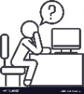
Ahora, mirá los verbos en el texto que acabás de completar en el listening. De los 7 verbos usados, ¿cuántos comparten la misma terminación y cuántos no lo hacen?

………. VERBOS SÍ COMPARTEN EL FINAL | ……….. VERBOS NO LO COMPARTEN

Los verbos que comparten la terminación -ed, como attended y joined pertenecen al grupo de verbos regulares. Se llaman verbos regulares porque siguen la regla de la -ed; es decir son los verbos que forman el pasado agregando -ed al final

En el siguiente cuadro, podés ver las reglas para agregar -ed según la terminación de los verbos:
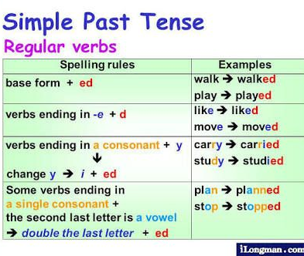

Los verbos que no terminan en -ed, como gave se llaman irregulares porque no siguen ninguna regla para formar el pasado. Algunos de ellos sufren algún cambio: give – gave; send – sent; otros no cambian: set – set, y otros cambian totalmente: be – was/were. Es necesario memorizarlos para poder trabajar con ellos.
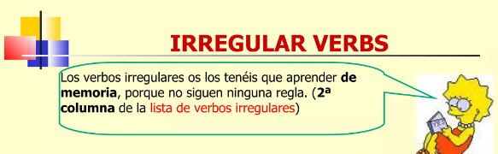

De acuerdo a estas reglas, ¿cuál sería el pasado de los siguientes verbos?

- copy  - edit  - delete  - fix  - install  - create | - develop  - design  - classify  - plan  - work  - stay


Volvé a mirar todos los verbos, pero esta vez, enfocate en los sujetos que los acompañan y decidí si en el pasado simple los verbos tienen distintas conjugaciones según las personas, o tienen una única conjugación en el pasado simple: ………………………………………………………………………………………………………………….

ATENCIÓN! Hay una excepción: el verbo be, que tiene 2 conjugaciones en pasado, was y were. Was es el pasado de is y am, y were, el de are.

Para sintetizar, podemos decir que el pasado simple, en oraciones afirmativas, se forma de la siguiente manera:

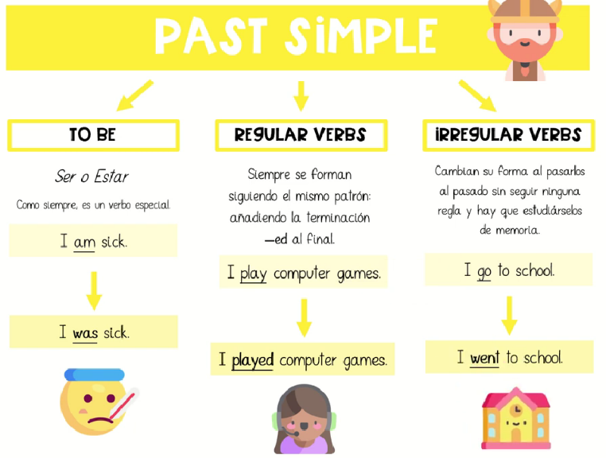

I was sick
They were sick

Como el pasado simple se refiere a eventos que comenzaron y terminaron en un momento definido del pasado, es común la presencia de indicadores temporales en este tiempo verbal:
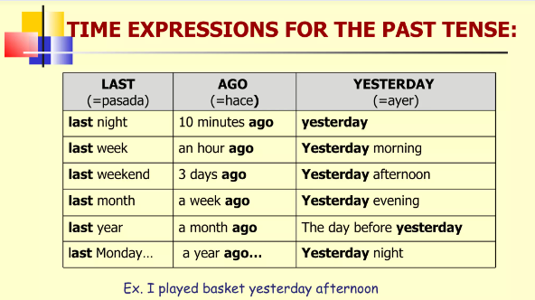

PRACTICE:
1. Complete with the correct past tense form:

- Last year, we ___ (be) at an international IT conference.
- It ___ (be) in Silicon Valley.
- The keynote speaker ___ (be) Sheryl Sandberg, a Facebook CEO.
- She ___ (give) a presentation on women in technology.
- Apple ___ (present) its new accessories for iPhone.
- They ___ (be) amazing!
- We ___ (meet) other developers and ___ (talk) about the new gadgets.

2. Rewrite the sentences in the past simple tense using the time expressions in brackets as in the example.
The course starts on Monday. (last Monday) → The course started last Monday.
1 We play tennis with Nick and Sarah every week. (last week / Tom and Sue)
………………………………………………………………………………………………………………………………………………………….
2 Joe and Dan are usually at home in the evening . (yesterday / at work)
………………………………………………………………………………………………………………………………………………………….
3 My father usually finishes work at half past five. (today / half past seven)
………………………………………………………………………………………………………………………………………………………….
4 Andrea always has a cup of tea for breakfast. (this morning / cup of coffee)
………………………………………………………………………………………………………………………………………………………….
5 Peter celebrates his 16th birthday on Wednesday. (last Wednesday)
………………………………………………………………………………………………………………………………………………………….
6 Jennifer is a computer engineer now. (last year / a university student)
………………………………………………………………………………………………………………………………………………………….
7 My grandparents spend their holidays in France every summer. (last summer / Portugal)
………………………………………………………………………………………………………………………………………………………….
8 We watch a film on TV every Sunday. (last Saturday)
………………………………………………………………………………………………………………………………………………………….
9 I usually cycle to school. (this morning / walk)
………………………………………………………………………………………………………………………………………………………….
10 Sandra lives in Manchester. (three years ago / Paris)
………………………………………………………………………………………………………………………………………………………….
3. Read about Nicole and complete the text.
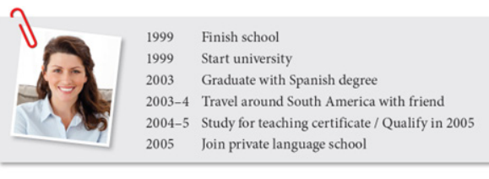
I ………………………………… (1) school in 1999 and I ………………………………… (2) university in the same year. After I ……………………………… (3) from university with a degree in Spanish, I ………………………………… (4) around South America with a friend for nearly a year. After that I ………………………………… (5) for a certificate in teaching and ………………………………… (6) in 2005. Finally, I ………………………………… (7) a private language school where I still teach Spanish today.

4. Write about you day yesterday. You can use the past tense of the following verbs:
sleep late - get up – have breakfast – go to college – eat lunch – study for a test – go to the gym – play online games – watch TV – have a Zoom class
Remember to use some time references: yesterday morning; in the afternoon, etc.

