TALKING ABOUT THE PAST
What social networks do you use? How much time do you spend on them?
Examples: I don’t use social networks but I spend a lot of time on the computer.
I use Instagram and I spend two or three hours on them every day.

1. How much do you know about the history of networking? Can you match these events 1-5 to the dates a-e?
1 Tim Berners Lee invented the World Wide Web  2 Facebook started in…  3 Jack Dorsey, Evan Williams, Biz Stone  and Noah Glass launched Twitter in…  4 MySpace began in …  5 Ray Tomlinson sent the first e-mail in | a) 2006  b) 1989  c) 1971  d) 2004  e) 2003

Find the answers here:
https://drive.google.com/file/d/1JvJxVo2Blppz-EXv8QDA44P9mq63efUT/view?usp=sharing

2. Instagram is a photo and video-sharing social media application. Find out:
a. Who launched it …………………………………………………….…………….
b. When he launched it ……………………….…………………………………..

3. What about Discord?

4. Read this text about Karl's IT career up until now
'I left school in 2015 when I was 17 and went straight to the University of Bristol to study computing. I was 21 when I graduated but I didn’t look for a job immediately because I wanted to travel around the world for a year. Was it a good idea? Oh yes, it was great!
In 2020 I got a job with the software company Arm. They were the best-known company in England but I wasn’t very happy with them. Finally, I went to work for Microsoft in Seattle in the USA. This is where I am now and I love it!'

GRAMMAR: the past simple
We use the past simple tense to talk about finished actions in the past. | Karl left school in 2015  He was 17 years old.  He didn’t look for a job when he finished school.
Time expressions | My sister graduated two years ago.  I downloaded two videos yesterday.  She used that system last week/year/month.  They started that user group on Monday/in June/in 2001.

THE VERB ‘BE’ IN THE SIMPLE PAST
1. Complete the sentences in the table. Use the text as a guide.

Affirmative
I left school when I …………..17.
They ………… the best known company in England.
Negative
I …………. very happy with them.
They weren’t the best known software company in the USA
Yes-No Questions | Short answers
………… it a good idea?  Were they the best known software company in England? | Yes, it ………. / No, it ……………  Yes, they …………. / No, they………..
Wh- questions
How old ……… Karl in 2000?

2. De esta tabla deducimos que:
- Was es el pasado de ……….. y ………….
- Were es el pasado de …………….
- Al igual que ‘is’, ‘am’ y ‘are’, was y were pueden …………………….. y ……………………………… SIN AYUDA DE NINGÚN AUXILIAR.
- Was y were no tienen formas cortas, pero was not y were not sí las tienen: ………………… y ………………..

OTHER VERBS
1. Complete the sentences in the table. Use the text as a guide.

Affirmative
I ………… school in 2000.
Negative
I ……… …………….. for a job immediately
Yes-No Questions | Short answers
………… Karl …………….. for a job immediately | Yes, he …………. / No, he ……………
Wh- questions
Where ………… he …………………. to work?

2. De esta table deducimos que:
- Oraciones afirmativas:

- Oraciones negativas:

- Preguntas:

3. Read and listen about Karl again and say true (T) or false (F)

1 Karl started university when he was 19.
2 He graduated in 2019.
3 He didn’t get a job immediately after his graduation.
4 He travelled around the word for 2 years
5 In 2020 he got a job in the USA.
6 Arm was a hardware company.
7 Karl wasn’t happy with his job.
8 Now he’s working for Microsoft.

4. Can you match the verbs on the right with their past tense form?
REGULAR VERBS | connect | looked for
 | decide | used
 | graduate | installed
 | install | started
 | look for  play | worked  connected
 | start | graduated
 | stay | stayed
 | study  use | decided  studied
 | work | played
IRREGULAR VERBS | be (is – am - are) | stet up
 | buy | went
 | do | saw
 | get | did
 | go | bought
 | have | was - were
 | leave | left
 | see | got
 | send | had
 | set up | sent

5. What did you do yesterday? (¿Qué hiciste ayer?) Tratá de usar algún verbo de la lista para decir lo que hiciste ayer.
Yesterday I studied English and played online games with my friends.

READING
Karam and Natasha work for ComHelp, a company that provides IT services to customers. Karam and Natasha work in different areas of the city. Every week they write a report for their boss. Read their notes.

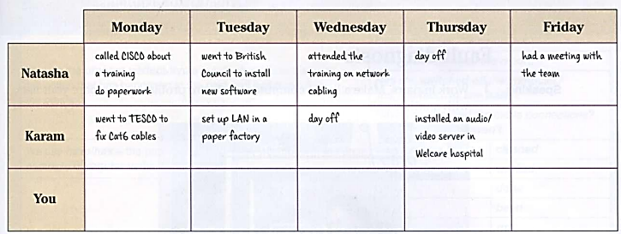

11. Complete the table in 1 with notes about what you did last week at work or college.
12. Write a report about what you did last week.
Example: Last week I... . On Monday I... and...

