DESCRIBING SOFTWARE AND HARDWARE

In computing, hardware refers to the physical components of a computer system, like the CPU, RAM, and monitor. Software, on the other hand, encompasses the programs and instructions that enable the hardware to perform tasks, such as operating systems, applications, and games.

**1. Put the following examples of hardware and software under the correct columns**

operating systems - keyboard – mouse – word processors – scanner– motherboard –computer programs – printer – speakers –search engines – hard disk drive (HDD) – language processors – USB drives – monitor

|  |  |
| --- | --- |
| HARDWARE | SOFTWARE |
| INTERNAL COMPONENTS: | SYSTEM SOFTWARE |
| INPUT AND OUTPUT DEVICES: | APPLICATION SOFTWARE |

**2. Match these elements of hardware and software with their pictures and definitions:**

**mouse – operating systems – monitor – printer – computer program**

1. A computer program is a set of instructions that a computer follows to do a task. It is a type of software which people write in programming languages like Python or Java. A computer program tells the computer what to do step by step.
2. Operating systems are programs that control the computer's hardware and software. They are the software which manage files, memory, and other programs. Examples of operating systems are Windows, Linux, and macOS.
3. A monitor is a hardware device which shows the images and text from the computer. Some monitors are small, and others are very large and nowadays most of them are flat. It is a screen where you cans see information, graphics, pictures, etc.
4. A mouse is an input device that people use to move the pointer on the screen. It is a small object that usually has two buttons and a scroll wheel. Users move the mouse with their hand to give instructions to the computer.
5. A printer is a machine which is connected to a computer that prints computer information. It is usually a rectangular box with a paper tray. Some printers only print, and others also scan and copy.

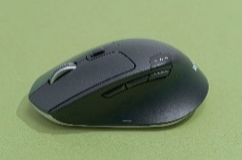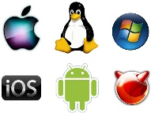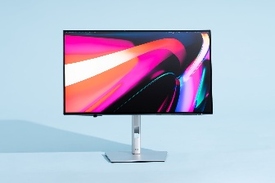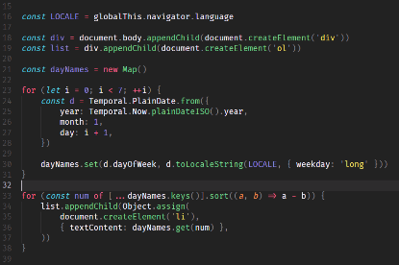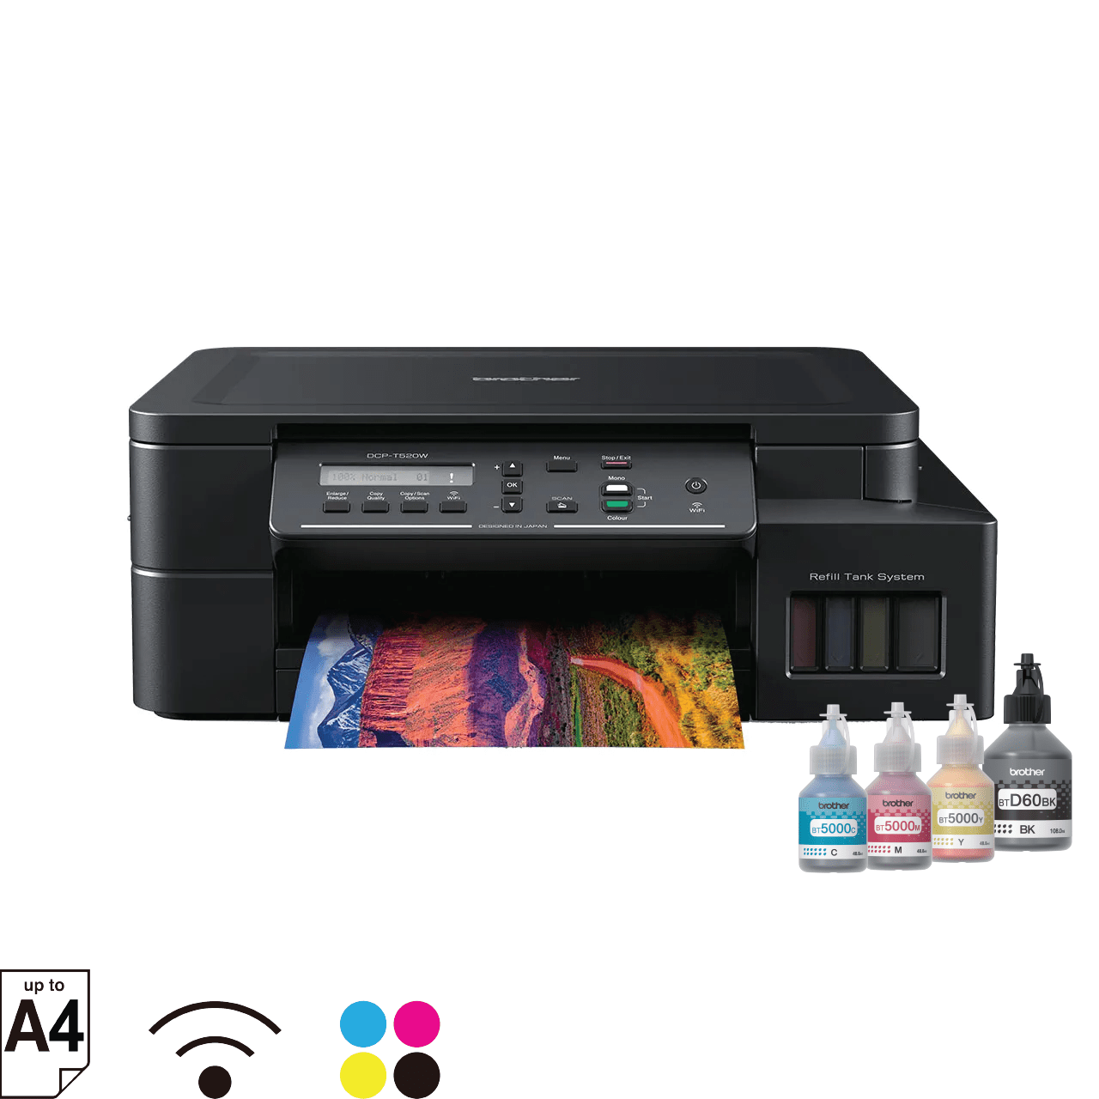

1. 2. 3. 4. 5.

3. Detengámonos ahora en los textos.¿Consideran que son:

1. publicidad?
2. definiciones?
3. descripciones?
4. noticias?

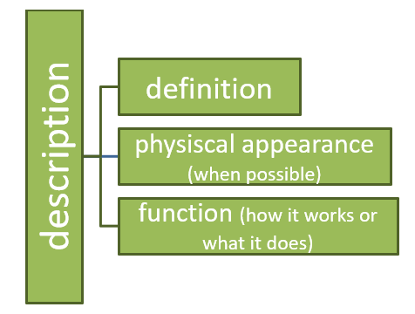Los textos son **descripciones** de elementos de hardware y software y en general tienen la siguiente estructura:

4. ¿Podés identificar y resaltar en los textos estas partes?

En general, las **definiciones** tienen la siguiente estructura:

**A(n) + [nombre del objeto] + is + a(n) + [device] + that / which / + [acción o función]**

**object**

**element**

* A mouse is a device **that** people use to control the pointer.
* A program is a set of instructions **which** tells the computer what to do.

Cuando nos referimos al aspecto físico, podemos usar estructuras como estas:

**It + is / can be + a(n) + adjetivo (small/big/flat/round) + …**

* It is a small object that ….
* It can be small or very large…

**It + has + (a / an) + noun +…**

* It has two buttons and a scroll wheel

Para hablar de las funciones o para qué sirve algo, podemos usar:

**People/ Users + use + it + to + infinit.**

* **People use it to give instructions to the computer**

5. Use the information below to write the description of a GPU, a keyboard and a PSU

|  |  |  |  |
| --- | --- | --- | --- |
| Computer parts | Main ideas | connectors | Connected ideas |
| A GPU or Graphics Processing Unit | * is an electronic circuit * it helps | * that/which * --- * and | * people use to display high quality images and graphics. * to process 2D data * to render and decode 3D data such as animations and videos. |

|  |  |  |  |
| --- | --- | --- | --- |
| Computer parts | Main ideas | connectors | Connected ideas |
| A keyboard | * is a primary input device * it is a panel with keys * a standard keyboard has | * that/which * --- | * helps users to interact with the computer system. * users press to generate numbers, letters and symbols on the screen. * alphabetical keys, character keys, function keys, number keys, arrow keys and control keys. |
| A Power Supply Unit or PSU | * Is a hardware component of a computer * The power supply | * that/which * --- | * supplies all other components with power. * converts [AC](https://www.computerhope.com/jargon/a/ac.htm) (Alternating Current) into [DC](https://www.computerhope.com/jargon/d/dc.htm) (direct current) which is usable by the computer. |