COMPUTER COMPONENTS

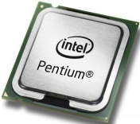
1 A. Listen, read, and number the label of each component.
2
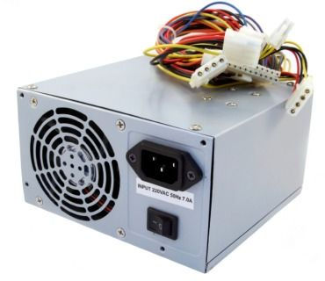
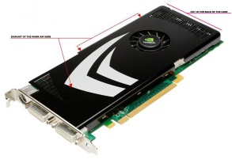
- the dedicated video card.
4
- Optical drive, this is the CD, or DVD, or Blu-ray drive. 3
- RAM, that’s Random Access Memory.
- motherboard
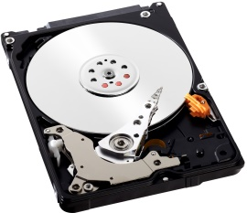
- CPU or processor.
- the power supply 5
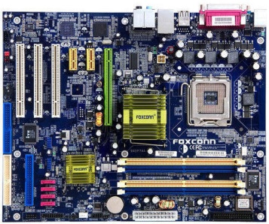
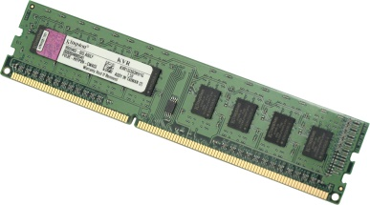
- … and of course, the hard drive

6

7
TEXT 1:
The main components of a computer are the power supply, the CPU or processor, RAM or Random-Access memory, the optical drive, (this is the CD, DVD or Blu-ray drive), the mother board, the dedicated video card and the hard-drive.
B. Listen and match the halves to complete the ideas
1. The CPU or processor | a. is a magnetic storage device which contains the operating system (OS), installed software and other computer files.
2. RAM | b. is the main printed circuit board in a computer. It allows communication between the CPU, RAM and the other hardware components.
3. The hard drive or hard disk drive | c. is the main brain of the computer. It reads the list of instructions and runs each one in order
4. The motherboard | d. is a temporary memory bank where computers store data that they need to retrieve quickly.

C. Make and answer questions about the text above.
1. What are the main components of a computer?
2. What is the work of the CPU?
3.
4.
5.
TEXT 2.
D. Listen and complete the text with some of the words in the box

place – electronic machine – computer – registers – data
computers – CPU chip – instructions – computer program

The central processing unit or CPU is an important part of every ________________. It controls the other parts of the computer. The CPU is an ________________ ________________ that works on a list of instructions. It reads the list of ________________ and executes each one in order. This list of instructions is called a ________________ ________________. When the CPU runs a computer program, it needs a place to store the ________________ it reads and writes. This storage is called a register. A CPU usually has many registers which are part of the ________________ ________________.

- Match the elements with the correct phrases. Then, use the correct verb to make complete sentences.

- The CPU  - A computer program  - Registers | - places to store data  - an electronic machine that Works on a list of instructions  - part of the CPU chip  - the other parts of the computer  - a list of instructions.

The CPU controls the other parts of the computer.

F. Reread the text about the CPU and answer:
1. What does the CPU do?
The CPU sends……………………………………….……………………………………………………..…………
2. What does the CPU work on?
…………………………………………………………………………………………………………………………………
3. What does it read?
….……………………………………………………………………………………………………………………………..
4. How does it execute the instructions?
…………………………………………………………………………………………………………………………………….
5. Where does the CPU store data?
……………………………………………………………………………………………………………………………….…..
6. What does a CPU usually have?
……………………………………………………………………………………………………………………………………

TEXT 3
The motherboard is the main printed circuit board of a computer and other smart devices. It contains the principal components of a computer system. It also has connectors for other circuit boards. A motherboard is the heart of a computer because it connects its main electronic components and allows communication between them. However, it does not have any computing power. It needs the CPU to send a and receive messages to the other systems.
G. Reread the text and make and answer questions about the motherboard.

DESCRIBING COMPUTER SYSTEMS COMPONENTS
A. Reread texts 1; 2 and 3. What kind of texts are they? Why?
- News
- Adverts
- Descriptions
- Instructions
Podemos ver que estos textos son descripciones y que en general tienen la siguiente estructura:

Las definiciones por lo general tienen la siguiente estructura:
S + be + complemento + pron. relativo + cláusula relativa
↓ ↓ ↓ ↓ ↓
The mouse is a pointing device that we use to manipulate the cursor on the screen.
La función o la forma en la que un componente trabaja, no tiene una estructura tan definida, pero es común encontrar el mismo orden de palabras que en una oración afirmativa: S + V + …
B. Can you put the sentences of this OS description in the correct order?
It manages computer hardware and software resources, and provides common services for computer programs ª. An operating system is the program that controls everything on the computer ^{b}. Two very popular operating systems are Windows and iOS. Another common operating system is Linux ^{c}.

C. Can you write two descriptions using the information on the table and the previous texts as models?
Computer parts | Main ideas | connectors | Connected ideas
GPU or Graphics Processing Unit | - is an electronic circuit  - it helps | - that/which  - ---  - and | - people use to display high quality images and graphics.  - to process 2D data  - to render and decode 3D data such as animations and videos.
Keyboard | - is a primary input device  - it is a panel with keys  - a standard keyboard has | - that/which  - --- | - helps users to interact with the computer system.  - users press to generate numbers, letters and symbols on the screen.  - alphabetical keys, character keys, function keys, number keys, arrow keys and control keys.
Power supply or PSU | - Is a hardware component of a computer  - The power supply | - that/which  - --- | - supplies all other components with power.  - converts AC (Alternating Current) into DC (direct current) which is usable by the computer.

Nombre o etiqueta de algo

