REVISION EXERCISES
1 Work with a partner and
- Read the 2 paragraphs.
- Ask and answer questions to get the information.
Graciela Brizuela is from San Salvador de Jujuy, Jujuy. She’s a teacher. She works at Facultad de Ingeniería. She doesn’t play video games.
José Fernández is from Tilcara, Jujuy. He studies game development at Facultad de Ingeniería. He plays video games in the afternoon.
First name | (What)
Surname | (What)
City/province | (Where)
Activity / career | (What)
College/ work | (Where)
Play games | (When)
Example: What’s her first name?

2. Correct the sentences as in the example
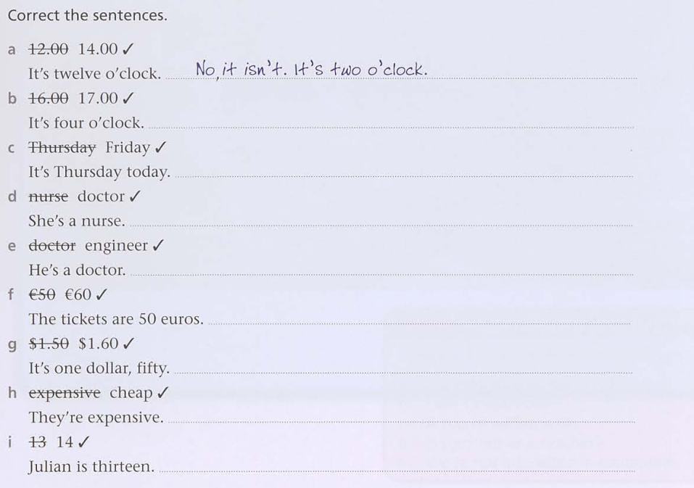

3. Write the he /she / it form of the following verbs.

4. Put the words in order to make a sentence
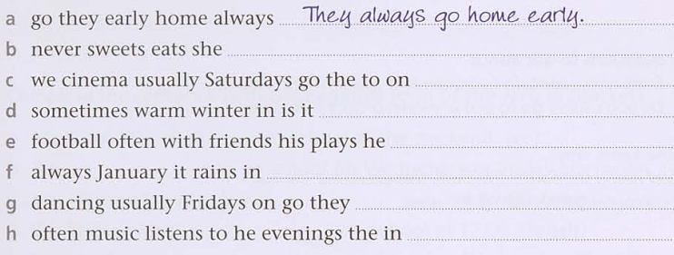
5. Look at Mark’s timetable. Complete the sentences with the affirmative form of the verb in brackets
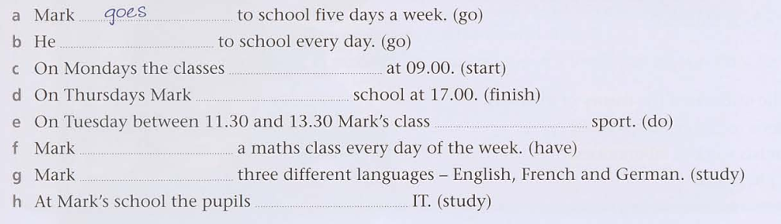
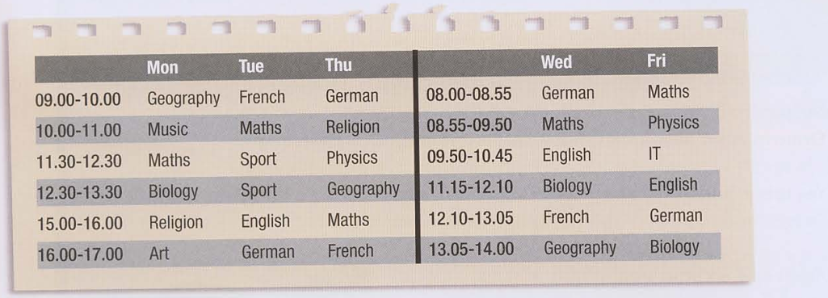

6. Complete the sentences about Mark with the negative form of the verbs in brackets.

7. Complete the questions with do or does and answer them.
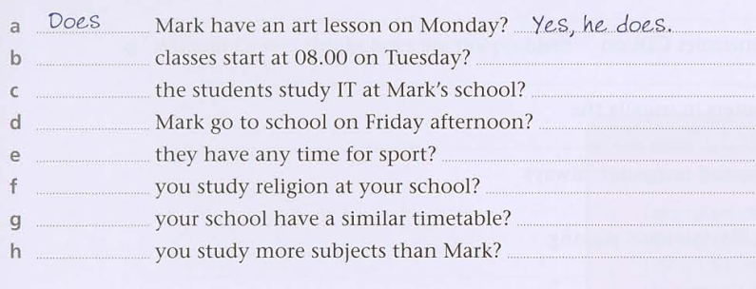

Online activities:
https://wordwall.net/es/resource/13246233/verb-to-be-where-are-you-from
https://elt.oup.com/student/englishfile/beginner3/grammar/file01/grammar01_a02?cc=ar&selLanguage=en
https://elt.oup.com/student/englishfile/beginner3/grammar/file06/grammar06_a01?cc=ar&selLanguage=en

