AN INTERVIEW

Hi! My name’s Sylvia. I’m the IT team leader, and this is Isabelle, Andrew, Carla and Tom. We’ re all IT professionals. Isabelle’s a database administrator and she’s in the data analysis area. Andrew’s an IT support officer and his area is technical support. Carla and Tom are data analysts, their area is data processing. We work for an IT services company in Northern Ireland. Our offices are in Belfast.

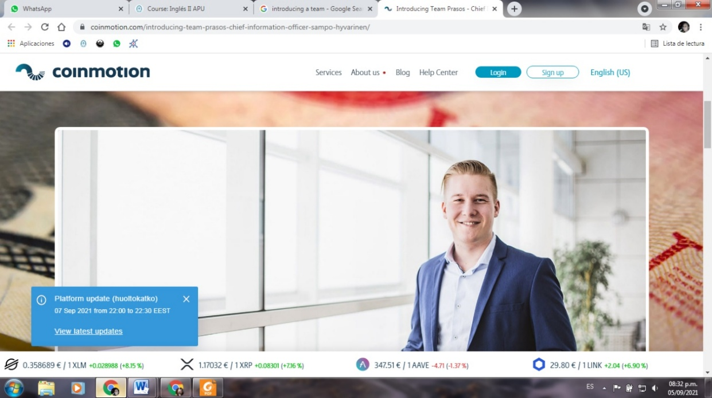
1. Read the interview:

My name’s Sylvia.
I’m an IT professional for an IT services company.
It’s in Ireland.
No, I’m not. I’m the team leader.
Carla and Tom are.

What’s your name?
What’s your job?
Oh, I see… Where is Your company?
Great. Are you in the data processing area?
Who are the data analysts?

Sam Sylvia
2. Look at the interview, then look at table and complete it:
 | WH-questions | Yes/No questions
Estructuras  Ejemplos | WH + be + S + …? | Be + S + …?
Respuestas
Ya fuimos trabajando con algunas preguntas en las clases anteriores y notamos que cuando preguntamos invertimos el orden sujeto-verbo de las oraciones afirmativas o negativas. De acuerdo a la información de la tabla podemos decir que:
- Hay dos tipos de preguntas: las WH questions (preguntas WH) y las Yes-No questions (preguntas SI-NO)
- Las WH se llaman así porque comienzan con una palabra que generalmente tiene una w y una h al principio:
WH words or question words:
Who asking about a person = ¿quién?
What asking about a thing or an idea = ¿qué / cuál?
When asking about a time = ¿cuándo?
Where asking about a place = ¿dónde?
Why asking about a reason = ¿por qué?
How asking about the way you feel or the way you do something = ¿cómo?
Estas preguntas solicitan un tipo de información específica: ¿quién? ¿dónde? ¿cuándo?, etc., y requieren como respuesta una oración completa, (S + V +información).

- Las Yes-No solicitan confirmación de algo, por lo tanto tienen un tipo de respuesta especial que se llama short answer y que básicamente responde con sí o no a lo que se preguntó (Yes, + S + BE / No, + S + BE + not)

3. Review: complete the table

 | Affirmative sentences | Negative sentences | Questions
I | I’m the IT team leader | I’m not a data analyst. | Where am I ?  Am I in room 5?
He  She  It | He is Andrew. | He is not Tom. | Who is he?  Is he in the technical support area?
You
We
They

4.a Look at the team introduction again and put the words in the correct order to make questions.
4.b Complete the answers:
Hi! My name’s Sylvia. I’m the IT team leader, and this is Isabelle, Andrew, Carla and Tom. We’ re all IT professionals. Isabelle’s a database administrator and she’s in the data analysis area. Andrew’s an IT support officer and his area is technical support. Carla and Tom are data analysts, their area is data processing. We work for an IT services company in Ireland. Our offices are in Belfast.

- Sylvia/is/an IT team leader?
Is Sylvia the IT team leader?
Yes, she is.
- Carla and Tom /team leaders/are?
______________________
No, ________.

- The company /is/in Ireland?
______________________
Yes, ________.
- Are/where/their offices?
______________________
Their offices ________________
- Database administrator/is/who?
______________________
Isabelle __________________

2. a. Look at the photos of people at Heathrow Airport, London.
2.b. Choose the correct wh-word to complete the questions: who; what; when, where; why; how.
2. c. Complete the answers.
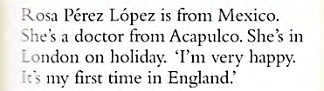
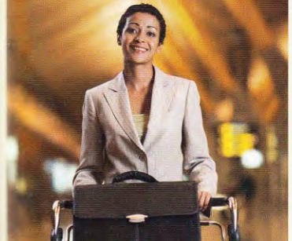
1.

- ..… is she? ……………………. Rosa Pérez López.
- ..… her job? ………………………. doctor.

- ……… she from? …………………………………………………..
- ….. is she very happy? ……………………………………..on holiday.
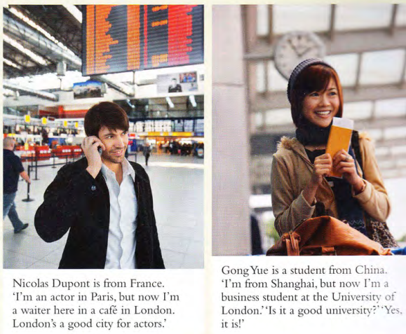
2.

- …… are they? ……………………………….. Nicolas Dupont and Gong Yue.
- …… are they? ……………………………………….at Heathrow Airport, London.
- ………. are their jobs? ……………………….. a waiter in London and ………………………………………..a business student.
- ……. are they feeling? ……………………………….. happy.
3. Now complete the yes/no questions about Nicolas and Gong with is/are and write the answers.
a. …… at Heathrow? ……………………………………………………………………….
b. ……. they tourists? …………………………………………………………………………
c. …… it their first time in London? ……………………………………………………………………….
d. ……. London a good city for actors? ………………………………………………………………………

4. Read the game art team introduction below and make questions for the underlined information. (Leé la presentación del equipo de arte de más abajo y formulá preguntas para la información subrayada.

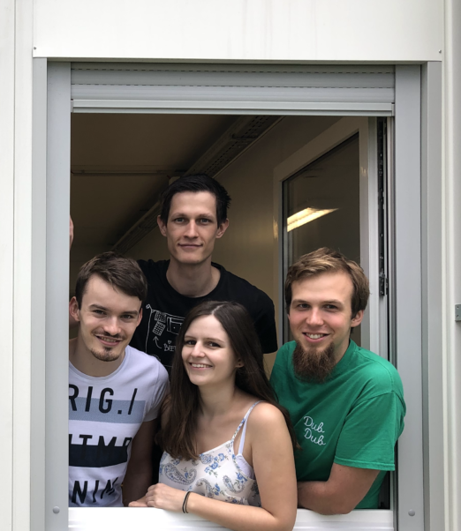
Hi! I’m Marco¹, the sound art team leader² and this is John, María and Juan. We are all sound artists. John and María³ are sound engineers and they are in the FX area⁴. Juan is a music expert⁵ and his area is music.
We work for E-Games Studio, a small game development company⁶ in Melbourne, Australia⁷.

- Who ……………………………………………………………?
- What …………………………………………………………?
- Who ……………………………………………………………?
- What……………………………………………………………?
- Is ………………………………………………………….…………?
- Is ……………………………………………………………….……?
- Where …………………………………………….………………?

