**AN INTERVIEW**



Hi! **My** name**’s** Sylvia. **I’m** the IT team leader, and this is Isabelle, Andrew, Carla and Tom. **We’ re** all IT professionals. Isabelle**’s** a database administrator and **she’s** in the data analysis area. Andrew**’s** an IT support officer and **his** area is technical support. Carla and Tom **are** data analysts, **their** area is data processing. **We** work for an IT services company in Northern Ireland. **Our** offices **are** in Belfast.

**1. Read the interview:**

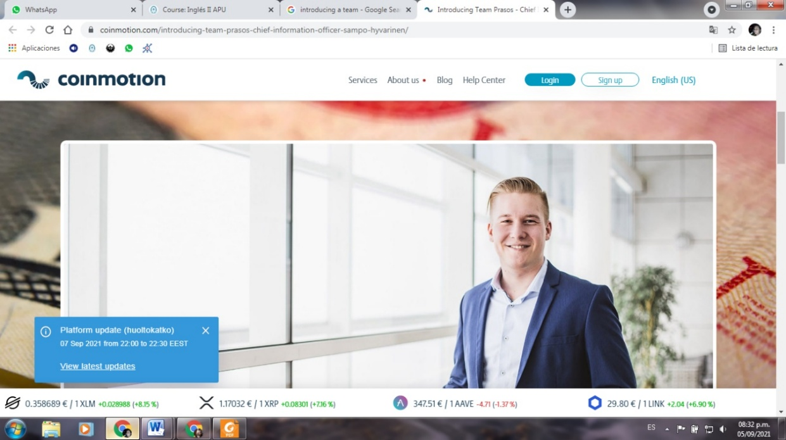

My name’s Sylvia.

I’m an IT professional for an IT services company.

It’s in Ireland.

No, I’m not. I’m the team leader.

Carla and Tom are.

***What****’s* your name?

***What****’s* your job?

Oh, I see… ***Where*** is Your company?

Great. ***Are*** you in the data processing area?

***Who*** are the data analysts?

Sam Sylvia

**2. Look at the interview, then look at table and complete it:**

|  |  |  |
| --- | --- | --- |
|  | **WH-questions** | **Yes/No questions** |
| Estructuras  Ejemplos | WH + be + S + …? | Be + S + …? |
| Respuestas |  |  |

Ya fuimos trabajando con algunas preguntas en las clases anteriores y notamos que **cuando preguntamos invertimos el orden sujeto-verbo** de las oraciones afirmativas o negativas. De acuerdo a la información de la tabla podemos decir que:

* Hay dos tipos de preguntas: las WH questions (preguntas WH) y las Yes-No questions (preguntas SI-NO)
* Las WH se llaman así porque comienzan con una palabra que generalmente tiene una w y una h al principio:

**WH words or question words:**

**Who** asking about **a person = ¿quién?**

**What** asking about **a thing or an idea = ¿qué / cuál?**

**When** asking about a **time = ¿cuándo?**

**Where** asking about a **place = ¿dónde?**

**Why** asking about **a reason = ¿por qué?**

**How** asking about the **way you feel or the way you do something = ¿cómo?**

Estas preguntas **solicitan un tipo de información específica**: ¿quién? ¿dónde? ¿cuándo?, etc., y requieren como respuesta una oración completa, (S + V +información).

* Las Yes-No solicitan **confirmación de algo**, por lo tanto tienen un tipo de respuesta especial que se llama **short answer** y que **básicamente responde con sí o no a lo que se preguntó** (Yes, + S + BE / No, + S + BE + not)

**3. Review: complete the table**

|  |  |  |  |
| --- | --- | --- | --- |
|  | **Affirmative sentences** | **Negative sentences** | **Questions** |
| I | I’m the IT team leader | I’m not a data analyst. | What’s your job?  Are you an IT professional? |
| He  She  It | He is Andrew. | He is not Tom. | Who is he? / Is he in the technical support area? |
| You  We  They |  |  |  |

**4.a Look at the team introduction again and put the words in the correct order to make questions.**

**4.b Complete the answers:**

Hi! **My** name**’s** Sylvia. **I’m** the IT team leader, and this is Isabelle, Andrew, Carla and Tom. **We’ re** all IT professionals. Isabelle**’s** a database administrator and **she’s** in the data analysis area. Andrew**’s** an IT support officer and **his** area is technical support. Carla and Tom **are** data analysts, **their** area is data processing. **We** work for an IT services company in Ireland. **Our** offices **are** in Belfast.

1. Sylvia/is/an IT team leader?

*Is Sylvia the IT team leader?*

Yes, *she is*.

1. Carla and Tom /team leaders/are?

______________________

No, ________.

1. The company /is/in Ireland?

______________________

Yes, ________.

1. Are/where/their offices?

______________________

Their offices ________________

1. Database administrator/is/who?

______________________

Isabelle __________________

2. a. Look at the photos of people at Heathrow Airport, London.

2.b. Choose the correct wh-word to complete the questions: **who; what; when, where; why; how.**

2. c. Complete the answers.

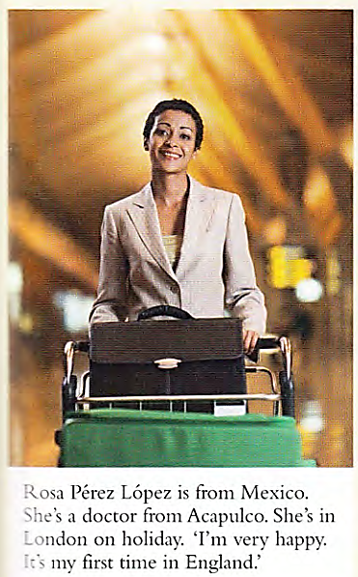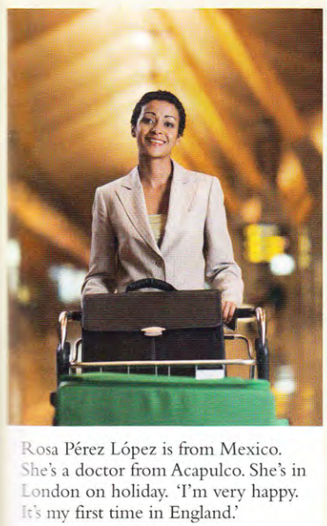 1.

1. ..… is she? ……………………. Rosa Pérez López.
2. ..… her job? ………………………. doctor.
3. ……… she from? …………………………………………………..
4. ….. is she very happy? ……………………………………..on holiday.

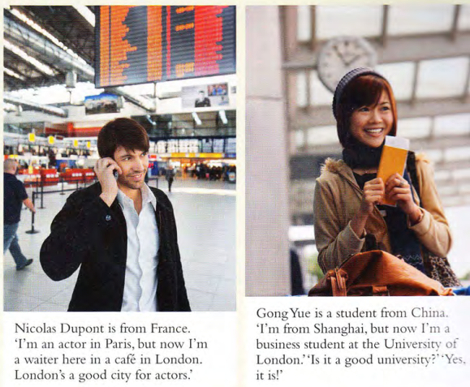2.



1. …… are they? ……………………………….. Nicolas Dupont and Gong Yue.
2. …… are they? ……………………………………….at Heathrow Airport, London.
3. ………. are their jobs? ……………………….. a waiter in London and ………………………………………..a business student.
4. ……. are they feeling? ……………………………….. happy.

3. Now complete the yes/no questions about Nicolas and Gong with **is/are** and write the answers.

a. …… at Heathrow? ……………………………………………………………………….

b. ……. they tourists? …………………………………………………………………………

c. …… it their first time in London? ……………………………………………………………………….

d. ……. London a good city for actors? ………………………………………………………………………

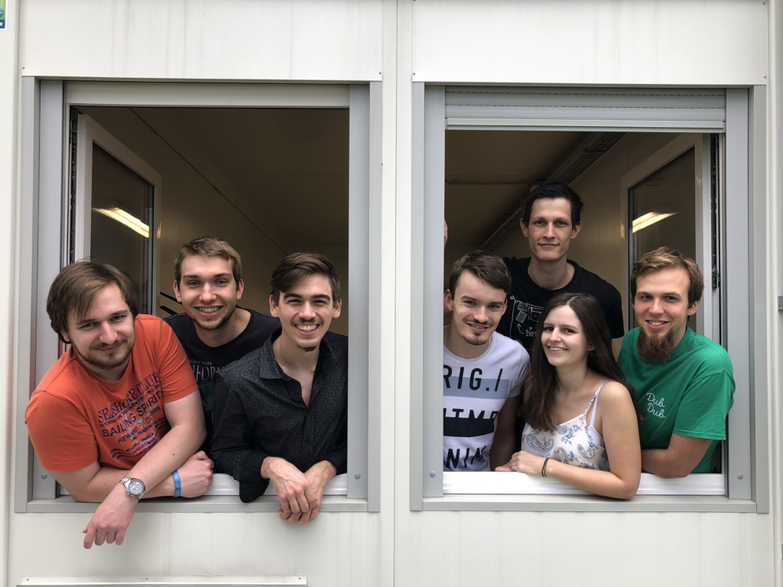4. Read the game art team introduction and make questions for the underlined information.

Hi! I’m Marco1, the sound art team leader2 and this is John, María and Juan. We are all sound artists. John and María3 are sound engineers and they are in the FX area4. Juan is a music expert5 and his area is music.

We work for E-Games Studio, a small game development company6 in Melbourne, Australia7.

1. Who ……………………………………………………………?
2. What …………………………………………………………?
3. Who ……………………………………………………………?
4. What……………………………………………………………?
5. Is ……………………………………………………………?
6. Is ……………………………………………………………?
7. Where ……………………………………………………………?