AN INTERVIEW
Hi! I’m Daniel, the game art team leader and this is Julia, Pat and Mike. We are all game artists. Julia is a 3D model expert and she is in the animation area. Pat and Mike are 2D artists and their area is concept art.
We work for E-Games Studio, a small game development company in Australia and our offices are in Melbourne.

Read the interview:

What’s your name? My name’s Daniel.
What’s your job? I’m a game artist at E-Games Studio.
E-Game Studio… Where is the company? It’s in Australia.
Oh! Great. Are you a 2D artist? No, I’m not.
Are you the game art team leader? Yes, I am.
Who are the 2D artists? The 2D artists are Pat and Mike.

Sam Daniel
Look at the interview, then look at table and complete it:
 | WH-questions | Yes/No questions
Estructuras | What /Where/who + is/am/are + S +…? | Is/Am/are + S + …?
Respuestas

Review:
 | Affirmative sentences | Negative sentences | Questions
I
He
She
It
You
We
They

Wh words or question words:
Who asking about a person.
What asking about a thing or an idea.
When asking about a time.
Where asking about a place.
Why asking about a reason.
How asking about the way you feel or the way you do something.

1.a Look at the text again and put the words in the correct order to make questions.
Hi! I’m Daniel, the game art team leader and this is Julia, Pat and Mike. We are all game artists. Julia is a 3D model expert and she is in the animation area. Pat and Mike are 2D artists and their area is concept art.
We work for E-Games Studio, a small game development company in Australia and our offices are in Melbourne.
1.b Complete the answers:

- Julia/is/a game artist?
Is Julia a game artist?
Yes, she is.
- Julia, Pat and Mike/team leaders/are?
______________________
No, ________.
- E-Game Studio/is/in Australia?
______________________
Yes, ________.
- Are/where/their offices?
______________________
Their offices ________________
- 3D model expert/is/who?
______________________
Julia __________________

2. a. Look at the photos of people at Heathrow Airport, London.
2.b. Choose the correct wh-word to complete the questions: who; what; when, where; why; how.
2. c. Complete the answers.
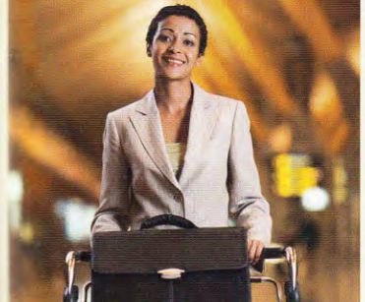
1.

- ..… is she? ……………………. Rosa Pérez López.
- ..… her job? ………………………. doctor.

- ……… she from? …………………………………………………..
- ….. is she very happy? ……………………………………..on holiday.
2.

- …… are they? ……………………………….. Nicolas Dupont and Gong Yue.
- …… are they? ……………………………………….at Heathrow Airport, London.
- ………. are their jobs? ……………………….. a waiter in London and ………………………………………..a business student.
- ……. are they feeling? ……………………………….. happy.
3. Now complete the yes/no questions about Nicolas and Gong with is/are and write the answers.
a. …… at Heathrow? ……………………………………………………………………….
b. ……. they tourists? …………………………………………………………………………
c. …… it their first time in London? ……………………………………………………………………….
d. ……. London a good city for actors? ………………………………………………………………………
4. Read the text and make questions for the underlined information.
Hi! I’m Marco¹, the sound art team leader² and this is John, María and Juan. We are all sound artists. John and María³ are sound engineers and they are in the FX area⁴. Juan is a music expert⁵ and his area is music.
We work for E-Games Studio, a small game development company⁶ in Melbourne, Australia⁷.

- Who
- What
- Who

- What
- Is
- Is
- Where

