WHERE ARE YOU FROM?
En la clase anterior, además de estudiar los personal pronouns I y you, y las formas am (‘m) y are (‘re) del verbo be, aprendimos a preguntar con where: Where are you from? y también a preguntar con Are you: Are you from Sidney?
Así, vimos que:
- I am = I’m = soy: I’m Graciela. I’m a teacher. You are = You’re = vos sos / usted es: You’re Leo Messi. You’re a football player.
- Where are you from? = es la pregunta que usamos para averiguar sobre el lugar de procedencia de alguien.
- Are you from…? = sirve para preguntar si alguien es de un lugar. Esta pregunta tiene por respuesta si o no: Yes, I am. / No I’m not.
Let’s practice:
- Compete the dialogue with ‘m, are or where
S: Hi, I… Sue.
T: Hello, I… Tom.
S: Nice to meet you.
T: Nice to meet you too.
S: … … you from?
T: I… from Australia.
S: Oh! … you from Sidney?
T: No, I… not. I… from Melbourne.
¿Qué están haciendo Sue y Tom en este diálogo?
¿Hay fórmulas o expresiones de cortesía? ¿Cuáles son?
- Now, practice with your classmates and guess the city
Where are you from?

I’m from Argentina.

Oh, are you from Buenos Aires?

No, I’m not.

Are you from …?

No, … . I’m …

Veamos ahora nuevos pronombres y una nueva forma de ‘be’:
- Look at the photos of people at Heathrow Airport, London.
A. Who is a tourist?
B. Read the texts and check your answer.
C. Complete the table with the correct information.
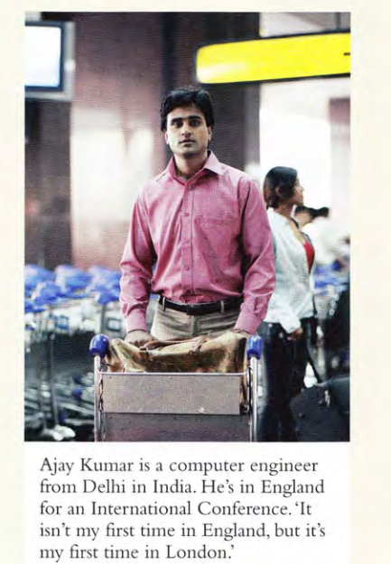
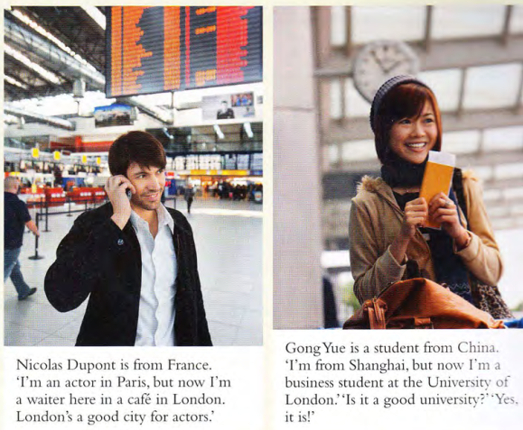

Name | Ajay
Job |  | Actor/waiter
Where from? |  |  | Mexico
First time in London? |  |  |  | no

- Leé los textos de nuevo. ¿Podés encontrar nuevos pronombres? ¿Cuáles?

Ajay Kumar is a computer engineer from Delhi in India. He’s in England for an international Conference. ‘It isn’t my first time in England, but it’s my first time in London.
Rosa Pérez López is from Mexico. She’s a doctor from Acapulco. She’s in London on holiday. ‘I’m very happy. It’s my first time in England.
Nicolas Dupont is from France. ‘I’m an actor in Paris, but now I’m a waiter here in a café in London. London is a good city for actors.’
Gong Yue is a student from China. ‘I’m from Shanghai, but now I’m a business student at the University of London’. ‘Is it a good university?’ ‘Yes, it is!’

3. Underline the verb be in the sentences.
1. Ajay Kumar is a computer engineer.
2. She's a doctor from Acapulco.
3. It isn't my first time in England.
4. Is it a good university? Yes, it is.
4. Complete the tables
He  She  It | is  ‘s | Form France.
is not
………..
…………………. | he  she  it | From India?  a doctor?  Your first time here?
Yes, | he /she / it | is.
No, |  | ……… .
Where | ……………… | he | From?

5. Add 's (is) in ten places.
Ellie Turner's from Montreal, Canada. She a teacher at
McGill. It a big university in Montreal. She in London for a
conference.
Yong-Joon from Korea. He a taxi driver in Seoul, the capital.
He in London on holiday. He happy to be here.
Pat a businesswoman from Auckland, New Zealand. She in
London on business.

