I WILL BE A PROGRAMMER – EL FUTURO CON WILL

Ya estudiamos algunos verbos modales para hablar de obligaciones, prohibiciones, sugerencias y habilidad y posibilidad (must, mustn’t, should, shouldn’t, can y can’t).



Ahora vamos a estudiar un nuevo **verbo modal que sirve para hablar del futuro**: WILL, que, como todo modal, tiene que estar seguido de un verbo principal para tener sentido.

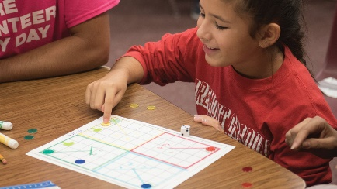1. Cuando will acompaña a un verbo le da la forma futura. Veamos dos ejemplos:

will +be = seré, serás, será, seremos, serán

will + work = trabajaré, trabajarás, trabajará, trabajaremos, trabajarán

I will be a game designer. I will work for Nintendo

Como los demás verbos modales, **will** conserva la misma forma para todas las personas:

**I will, you will, he will, she will, it will, we will, they will**

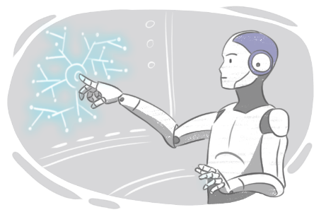y va acompañado del verbo principal en infinitivo:

**I / You / He / She / It / We / They will + infinitive**

**I will study English with Chat GPT or BARD.**

**It will rain tomorrow.**

**They will live in Italy in 10 years’ time.**

**We will learn with robot teachers.**

2. WILL también tiene una forma contraída: ‘**ll** que es la que se usa más comúnmente

|  |  |  |  |
| --- | --- | --- | --- |
| I | **’ll** | be | a programmer analyst |
| You | **’ll** | be | a programmer analyst |
| He | **’ll** | be | a programmer analyst |
| She | **’ll** | be | a programmer analyst |
| It | **’ll** | be | a great job. |
| We | **’ll** | be | programmer analysts |
| they | **’ll** | be | programmer analysts |

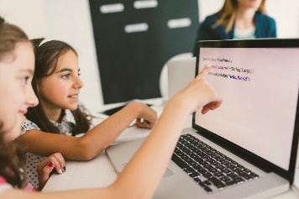

3. Al igual que los otros modales, **will** forma el negativo con la partícula **not**. El negativo **will not** también tiene su forma contraída, **won’t:** **S + won’t (will not) + V (inf) + ….**

|  |  |  |  |
| --- | --- | --- | --- |
| I | **will not / won’t** | be | a software developer |
| You | **will not / won’t** | be | a software developer |
| He | **will not / won’t** | be | a software developer |
| She | **will not / won’t** | be | a software developer |
| It | **will not / won’t** | be | a nice job |
| We | **will not / won’t** | be | software developers |
| They | **will not / won’t** | be | software developers |



4. Para hacer preguntas yes/no: **Will + S + V (inf) + …?→ SHORT ANSWER: Yes, + S + will / No, + S + won’t**

|  |  |  |  |  |
| --- | --- | --- | --- | --- |
| **Will** | I | work | in the USA? | Yes, I will / No, I won’t |
| **Will** | you | work | in the USA? | Yes, you will / No, you won’t |
| **Will** | he | work | in the USA? | Yes, he will / No, he won’t |
| **Will** | she | work | in the USA? | Yes, she will / No, she won’t |
| **Will** | it | work | faster | Yes, it will / No, it won’t |
| **Will** | we | work | in the USA? | Yes, we will / No, we won’t |
| **Will** | they | work | in the USA? | Yes, they will / No, they won’t |

|  |  |  |  |  |
| --- | --- | --- | --- | --- |
| **Where** | **will** | I | work? | I will work in the USA |
| **Where** | **will** | you | work? | You will work in the USA |
| **Where** | **will** | he | work? | He will work in the USA |
| **Where** | **will** | she | work? | She will work in the USA |
| **How** | **will** | it | Work? | It will work faster. |
| **Where** | **will** | we | work? | We will work in the USA |
| **Where** | **will** | they | work? | You will work in the USA |

5. Para hacer preguntas Wh: **WH + will + S + V (inf) + …?**

6. **Para qué usamos will?**

A. **expresar una decisión espontánea**, tomada en el momento en que se está hablando, es decir para una decisión tomada en ese mismo instante. Veamos estos ejemplos:



a) A: Tomorrow’s cyber-Monday!

B: That’s great! I’ll buy new trainers!

b) The computer is running slow. I’ll clean it with C cleaner.

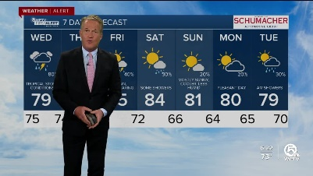B. **predecir lo que sucederá en el futuro**:

a) Futurologists predict that many homes will have robots in the future.

b) Children won’t go to school; they’ll have a robot teacher who teaches them at home.

d) It will rain tomorrow.



PRÁCTICA

1. Leé el texto y decí si los enunciados de más abajo son verdaderos o falsos. Si son falsos, corregilos:

The Future of Computer Programming

In the future, computer programming will be even more important than it is today. Developers will write code much faster, and AI will help programmers solve complex problems. Programming languages will become easier to learn, and more people will be able to create their own software.

Bugs won’t be a problem, because new tools will help find and fix code errors automatically. Programmers won’t spend hours writing code manually. Instead, they will use voice commands to code, and AI will finish the rest of the work.

Soon, we will see new programming languages that will help us work on projects faster and with fewer mistakes.

1. Computer programming won’t be more important in the future than it is now.
2. Writing code will be much faster.
3. Programmers will solve complex problems with the help of AI.
4. It won’t be very easy to learn programming languages.
5. Bugs will be a serious problem.
6. Voice commands will help programmers to code faster.
7. We won’t have new programming languages.

2. What do you think? Write sentences with will to make predictions about the future.

a. people - drive normal cars / flying cars

b. robots – do the household jobs / not do the household jobs

c. people – live on the moon / on Mars

d. we - download information on our computers / into our heads

e. your microwave - talk to you / not talk to you.

f. people – speak only English / three or four languages.

**3. Escuchá el diálogo entre Sarah y Peter:**

**A. Listen and mark true (T), false (F) or doesn’t say. (DS)**

What do they think will happen in the future?

1. Cars won’t fly. …………
2. People will study at school. …………
3. People will live on the Moon. …………
4. We won't have many diseases. …………
5. Doctors will visit you in your home. …………
6. We will have robots to cook and clean the house. …………

**B. Correct the false sentences.**

**4. Ahora leé el diálogo y verificá tus respuestas en el ejercicio anterior:**

Sarah: What do you think the future will be like?

Peter: I think cars will fly.

Sarah: Really? What do you think the school will be like?

Peter: I think people will study in their houses via the Internet.

Sarah: What will hospitals be like?

Peter: I think medicine will be totally different. We won’t have many of the diseases that we have today.

Sarah: How will houses be different?

Peter: May be we’ll have robots that clean our house and cook.

Sara: That will be nice.

Cuando hablamos de cómo creemos que serán las cosas en el futuro generalmente usamos la expresión: “I THINK + will + V inf” /”I DON’T THINK + will + V inf” que quiere decir CREO QUE…, PIENSO QUE…, o bien, NO CREO QUE… o PIENSO QUE NO…, seguida de una oración con WILL.

I think cars will fly.

I think people will study in their houses via the Internet.

I don’t think people will live on Mars.

I don’t think medicine will change much.

También es común emplear las palabras PROBABLY / DEFINITELY, que quiere decir probablemente / definitivamente y se ubica:

* entre WILL y el VERBO PRINCIPAL, si la oración es afirmativa.
* antes de WON’T si la oración es negativa.

We will probably download information into our heads.

People will definitely speak three or four languages.

NEGATIVE SENTENCES WITH PROBABLY / DEFINITELY:

We probably won’t learn French at university.

We definitely won’t travel to Jupiter in 50 years’ time.

1. What do you think life will be like in 20 years’ time? Write sentences using I THINK or PROBABLY and the ideas below. Escribí oraciones usando I THINK o PROBABLY y las ideas de abajo.

EJEMPLO:

Artificial intelligence – transform society

I THINK artificial intelligence will transform society.

Artificial intelligence will PROBABLY change society.

1. People – live in other planets
2. Computers – talk to their users
3. I – be a successful programmer
4. My screen reader – read many languages perfectly well.
5. Programmers - have lots of work.

Las predicciones con will no necesariamente tienen que referirse a un futuro lejano, tampoco tienen que ser siempre afirmativas:

It WILL rain TOMORROW.

The English exam WON’T be difficult.

WILL Microsoft offer open source software?

2. Complete the sentences with WILL or WON’T

a. Houses…be smart

b. Robots…govern the world.

c. People… have robot teachers.

d. I… have a big computer shop.

f. My best friend… be a psychologist.

g. I… develop software for hospitals.

h. My teachers…work in Canada next year.

i. I… design RFID chips for kitchen cabinets.

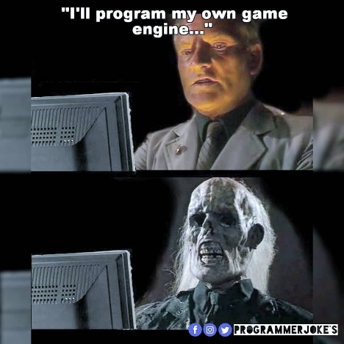3. Make predictions or ask about the future. Use the questions as a guide.

a. Who will win the next Boca-River match?

b. Who will be the next president in Argentina?

c. How much will a standard laptop cost in 2022?

d.) Will you pass all your exams this year?

e. What subjects will you study next year?

f. What will you do in 5 years’ time? (work for a big programming company/ have my own business/be a teacher/ be a successful programmer