CLASS 1: HELLO! - PRACTICE
1. audio 1.3 Listen and number the jobs in the order you hear them .
a. writer …5……

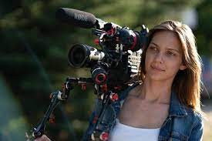
b.

filmmaker ………

c. explorer ………

d. scientist ……….

e. What job is missing? …………………………………
2. audio 1.6 Listen and complete:
A: ……………….
B: Hello. I’m …………………………
A: Oh, you’………. ……….. filmmaker!
B: ………., for National Geographic.
3. Mark the sentences Correct (C), or correct them.
- I’m Mireya and I’m an scientist.
- You’re an explorer.
- Hi, my name’s Robert and I’m a explorer.
- I’m an doctor.
- You’re Leo Messi and you’re an footballer.
- My name’s Juan. I’m a system analyst.

a.- e e l o p r r x ..explorer..  b.- c e i i n s s t t ……………………………….…  c.- d e i r r v …………………………………..  d.- a c e e h r t …………………………………  e.- c d o o r t ……………………………………  f.- a e f k i l m m r ………………………………  g.- g r e e n i e n ………………………………… | an explorer  …………………………….  ………………………………  ………………………………  ………………………………  ………………………………  ………………………………
1. Put the letters in order and write the jobs. 2. Add a or an to the jobs in 1

Escuchá y numerá las profesiones en el orden en el que las escuchás.
¿Qué trabajo / profesión falta?
Marcá las oraciones como Correctas (C), o corregilas, según corresponda.
Put the letters in order: pone las letras en orden
Write the jobs: escribí los trabajos
Add: agregá.

