THE TEAM WAS WORKING ON A NEW APP

THE PAST CONTINUOUS



Last week, the software development team **was working** on a new app for a client. While John **was coding** the login system, Sarah and Jake **were testing** the user interface. At the same time, Emily and Pete **were writing** the new code, and Mike **was debugging** the database.

At 7.30 this morning, everyone **was preparing** for a meeting with the client. The project manager **was explaining** the latest updates, and the team members **were reviewing** their tasks. They **were** all **trying** to finish the project before the deadline. However, Sara and Jake **weren’t working** on the project at that moment—they **were making** coffee for the meeting.

1. VOCABULARY: What are the words that you don’t understand?

2. CHECK YOUR UNDERSTANDING:

**Choose the best answer for the questions.**

I) When was the team working on a new app for a client?

a. at 7.30 this morning. – b. last week. – c. in the kitchen.

II) What were Emily and Pete doing?

a. They were writing the new code. – b. They were testing the interface. – c. They were coding the login system.

III) Was Pete debugging the database?

a. No, they weren’t. – b. No, he wasn’t. – c. Yes, he was.

IV) What was the team manager doing at 7.30 am?

a. He was preparing for the meeting. – b. He was reviewing his tasks. – c. He was explaining the latest updates.

v) Where Sara and Jake working on the project?

a. Yes, they were. – No, she wasn’t. – No, they weren’t.

3. STUDY THE GRAMMAR:

Look at the verbs in bold and find what they have in common:

All these verbs are in the [Past Continuous](https://drive.google.com/file/d/1d9DhqP7ZZcovSD-OLDbbHWV3NCixr33M/view?usp=sharing) tense. We use the past continuous tense to describe **an action in progress in the past**. The action **was not finished, it was happening** **at a specific moment in the past**. (Usamos el **past continuous** para describir una acción en progreso en el pasado. La acción **no estaba terminada**, **estaba sucediendo** en un **momento definido en el pasado**)

The team was working on app  
 MON FRI

last week

Everyone was preparing for a meeting

7.30 this morning

Vemos en las líneas del tiempo que las acciones no habían terminado, sino que estaban sucediendo, estaban en progreso. Es decir, durante la semana pasada, la tarea de desarrollar la app, no estaba terminada. El equipo **estaba trabajando** en la app. Del mismo modo, los preparativos para la reunión con el cliente a las 7 de la mañana, no estaban terminados. El gerente del proyecto **estaba explicando**…, los integrantes del equipo **estaban revisando**…, etc.

Ejemplos típicos de este tiempo verbal son acciones como estudiar, trabajar, leer, hacer un examen, mirar televisión, ducharse, etc., que necesitan un tiempo para desarrollarse:

Yesterday, at 10.00 pm, I **was working** on the new project.

This morning, at half past nine, he **was troubleshooting** the software

We **were designing** the user interface last Tuesday at 11.00.

Podemos ver en los ejemplos de más arriba, que al igual que el **present continuous**, el **past continuous** se forma con **be + V + -ing**, pero en lugar de usar **is, am** y **are,** usamos **was** y **were.**

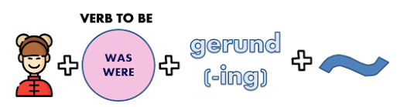

**Complete the table with the correct past form of be.**

|  |  |  |  |
| --- | --- | --- | --- |
| I | *was* | sending an email | at 8.00 pm. |
| You |  | writing the game script |
| He |  | coding in C++ |
| She |  | printing documents |
| It |  | designing 3D characters |
| We |  | testing the game sound. |
| They |  | downloading music |

Para las **negaciones** usamos **was/were** + **not**, o la forma contraída **weren’t** y el verbo terminado en -ing.



|  |  |  |  |
| --- | --- | --- | --- |
| I | *was not (weren’t)* | sending an email | at 10.00 this morning. |
| You |  | writing the game script |
| He |  | coding in C++ |
| She |  | printing documents |
| It |  | designing 3D characters |
| We |  | testing the game sound. |
| They |  | downloading music |

**Now, complete the table with** **the correct negative form of was or were**.

Para formular preguntas usamos was o were al inicicio de la oración, seguido del sujeto y el verbo terminado en -ing.



**Complete the table with the correct form of be, and the personal pronouns**.

|  |  |  |  |
| --- | --- | --- | --- |
| Was | *I* | sending an email? | at 10.00 this morning? |
|  |  | writing the game script? |
|  |  | coding in C++? |
|  |  | printing documents? |
|  |  | designing 3D characters? |
|  |  | testing the game sound? |
|  |  | downloading music? |

**REMEMBER!**

**Yes/No questions have short answers →Yes, I was. – No, I wasn’t.**

**→Yes, they were. – No, they weren’t.**

Para las “WH questions” usamos la misma estructura de las YES/NO, pero ubicamos las WH words (who, what, when, where, etc.) al inicio de las preguntas.

**¿Cómo formularías WH questions sobre las oraciones de la primera tabla?**

**When** were you sending an email?

**What** were you writing at 8.00 pm?

SUMMARIZING

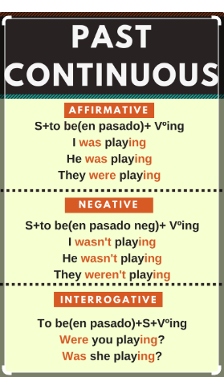

4. PRACTICE

A) What was happening at 8.00 am yesterday? Read the table. Then write affirmative or negative sentences in the past continuous tense.

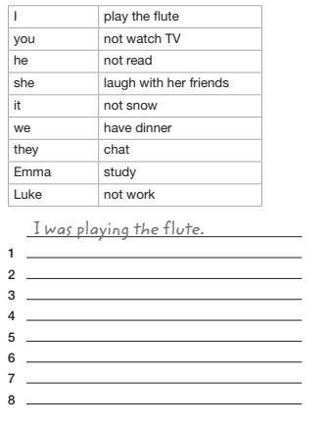

B) Read the table. Then correct the sentences. Write one negative and one affirmative sentence

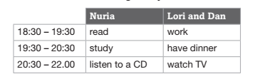

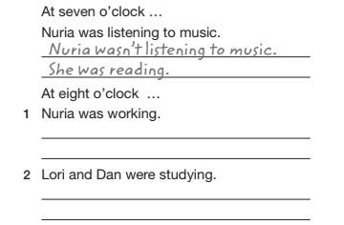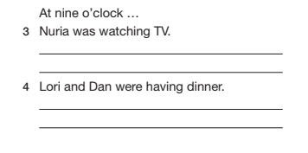

C) Complete the sentences with the correct form of the verbs in brackets.

1 What ___________ (Elaine and Caroline / do) in that shop?

2 I ___________ (drive) home at seven o’clock in the evening.

3 Where ___________ (you / go) yesterday afternoon?

4 Mary and Lionel ___________ (live) in Washington at the time.

5 The teacher got angry because I ___________ (not listen) to her

6 Steven ___________ (sleep) at 10.30 pm.

7 The lift ___________ (not work) this morning.

8 Why ___________ (your father / complain) to the police officer?

D) Make questions using the prompts. Then, answer them as in the example.

*A: you / watch TV / 8.00 p.m.?*

*Were you watching TV at eight o’clock?*

*B: No / have dinner*

*No, I wasn’t. I was having dinner.*

*A: Sally / do / homework / 8.00 a.m.?*

*Was Sally doing her homework at 8.00 am?*

*B Yes*

*Yes, she was.*

**1** A your friends / play tennis / 4.30 p.m.?

B No / study / English

**2** A Jennifer / work / 10.30?

B Yes

**3** A Donald and Eddie / have breakfast / seven o’clock?

B No / sleep

**4** A Robert / drive / work / 8.15?

B Yes

**5** A it / rain / yesterday morning?

B Yes

**6** A your father / watch / TV / 9.30 p.m.?

B No / read / book

**7** A Steven and Chris / walk / school / 8.30 a.m.?

B Yes

**8** A Simon / eat / sandwich / 12.15?

B No / drink / coffee

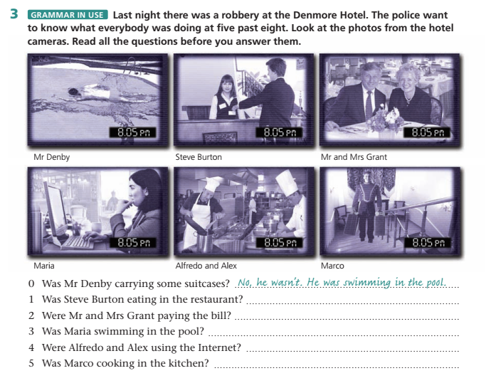

E)

**Now answer these WH questions about the robbery**

1. *Who was paying the Bill? Steve Burton was paying the bill.*
2. What were Mr. and Mrs. Grant doing at 8.05 pm?
3. Who was swimming in the pool?
4. What was María doing?
5. What was Marco doing at 8.05?
6. Who were cooking in the kitchen?
7. Why wasn’t Mr Denby eating in the restaurant?

**Extra practice here:** [**https://www.ego4u.com/en/cram-up/tests/past-progressive-1**](https://www.ego4u.com/en/cram-up/tests/past-progressive-1)