A VISUAL ARTIST IS A PERSON WHO CREATES VISUAL ART

DEFINING RELATIVE CLAUSES



|  |  |
| --- | --- |
| **Tim:**  **Elly:**  **Tim:**  **Sonia:**  **Tim:**  **Elly:**  **Tim**: | Look! This is the street **where** I live now.  The houses look very nice! Which one is yours?  The house **that** has black tiles and a big tree at the font.  And is this the new boy **who** comes to college with you?  Yes, he is. His name’s Julian and he lives next door.  And who are the two girls next to him?  The one **whose** hair is red is Kim, my sister, and the one whose hair is black is her friend Lea. |

**Vocabulary**:

**1. Read the conversation and decide if the following sentences are true or false.**

1. Tim has a photo of a big cat. T / F
2. His house doesn’t have a tree at the front. T /F
3. There are two girls and a boy in the picture. T / F
4. Julian is Tim’s brother. T/F
5. The girl with black hair is Kim . T / F

**2. Let’s study the grammar:**

**This is the street where I live now.**

Una cláusula relativa definida es un **grupo de palabras que no llegan a ser una oración, pero agregan información** sobre lo que se está hablando **o definen** eso de lo que se está hablando.

¿Podés identificar en la oración tomada de la conversación:

* de qué o quién se está hablando? …
* cuál es la cláusula relativa definida? …
* el elemento que une lo que se habla con lo que agrega información o define?...



La parte principal de la oración es la **cláusula principal o main clause** y allíse encuentra el sujeto (eso de lo que se habla): **This is the street**

**↓**

**De lo que se habla**

El elemento que une la cláusula principal con la cláusula relativa definida se llama **pronombre relativo o relative pronoun** y es el sujeto de la cláusula relativa: **where**

**↓**

**Relative pronoun**

**La cláusula relativa definida o defining relative clause** viene inmediatamente después del pronombre relativo: **I live now**

**↓**

**Cláusula relativa definida**

En el ejemplo estudiado, la cláusula relativa, agrega información. Veamos ahora un ejemplo donde la cláusula define:

**A visual artist is a person who creates visual art.**

**↓ ↓ ↓**

**Main clause relative relative clause**

**pronoun**

Podemos ver que la estructura es la misma, pero la defining relative clause en vez de explicar o describir algo, lo define.

Detengámonos ahora en los **relative pronouns**. Estudiemos los dos ejemplos:

**This is the street where I live now.**

**A visual artist is a person who creates visual art.**

A simple vista podemos notar que los relative pronouns (ponombres relativos) en las dos oraciones son: a) los mismos b) diferentes

¿Por qué?

¿Qué podemos decir de estos pronombres (en qué casos o acompañando a qué sujetos usamos cada uno de ellos)?

Los relative pronouns o pronombres relativos varían de acuerdo a de qué o de quién hablamos:

Cuando nos referimos a **personas**, podemos usar **who** o **that**.

Cuando nos referimos a objetos, animales, plantas, etc. podemos usar **that** o **which.**

Cuando nos referimos a lugares, usamos **where.**

Si hablamos de posesión, es decir de quién es algo, usamos **whose.**

¿Podés completar la tabla?

|  |  |
| --- | --- |
|  | Relative pronouns |
| People  Things , animals, plants, ideas  Places  Possession |  |

EXERCISES:

1. Choose the correct relative pronoun.

1. That’s the office **which / where** the 3D artists work.
2. Development teams usually have a lead designer **whose /who** coordinates the work of other designers.
3. Mario is an Italian plumber **which / that** lives in the Mushroom Kingdom.
4. Game developers are people **who / whose** job is to develop games.
5. A game level is an area of the game **which / where** has specific challenges and characters or creatures.
6. A platform game is a game **that /where** characters run and jump on platforms.

2. Complete with the correct relative pronoun:

1. 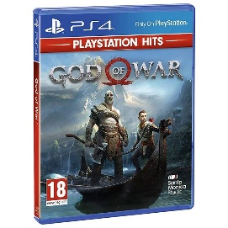A game programmer is a software engineer… job is to write video games software.
2. A video game is an electronic game… involves interaction with a user interface or a joystick.
3. A joystick is an upright handle… you use to control a computer game.
4. Sound engineers are technical professionals… are responsible for sound effects.
5. The Mushroom Kingdom is a place… Mario has a house.
6. God of War is a video game series… Sony creates and distributes.
7. Deemo II takes place in a world… rain never stops.
8. Mario is a character… powers are temporary.

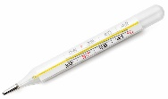3. Match **a** to **h** with **1** to **8** and complete with **who, that, where** or **which.**

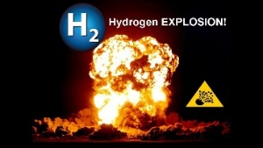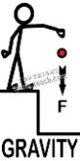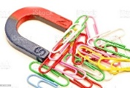

|  |  |
| --- | --- |
| 1. Photosynthesis is a process | 1. … attracts bodies with mass. |
| 1. Magnetism is a force | 1. … we use to look at very small things. |
| 1. Gravity is a force | 1. **that / which** plants use to make food. |
| 1. An astronomer is a person | 1. … we use to measure temperature. |
| 1. Hydrogen is a gas | 1. Levenhuk 2L NG Lime School microscope… studies space. |
| 1. A thermometer is an instrument | 1. … we do scientific experiments. |
| 1. A laboratory is a place | 1. ... explodes easily |
| 1. A microscope is an element | 1. … attracts objects containing iron. |

4. Read the definitions and guess the objects:

Twine – Mario – the printing press – the microchip - Prices Zelda - joystick - hospital -

1. This is the device that you use to play video games.
2. This is a machine that makes books, magazines and newspapers.
3. It is a small piece of silicon that makes computer work.
4. This is the place where doctors and nurses work.
5. It is one of the top ten video game design and software 2021.
6. The name of the video game character whose magical powers are teleportation, telepathy and precognition.
7. The name of the video game character whose main power is superhuman strength.