A VISUAL ARTIST IS A PERSON WHO CREATES VISUAL ART
DEFINING RELATIVE CLAUSES
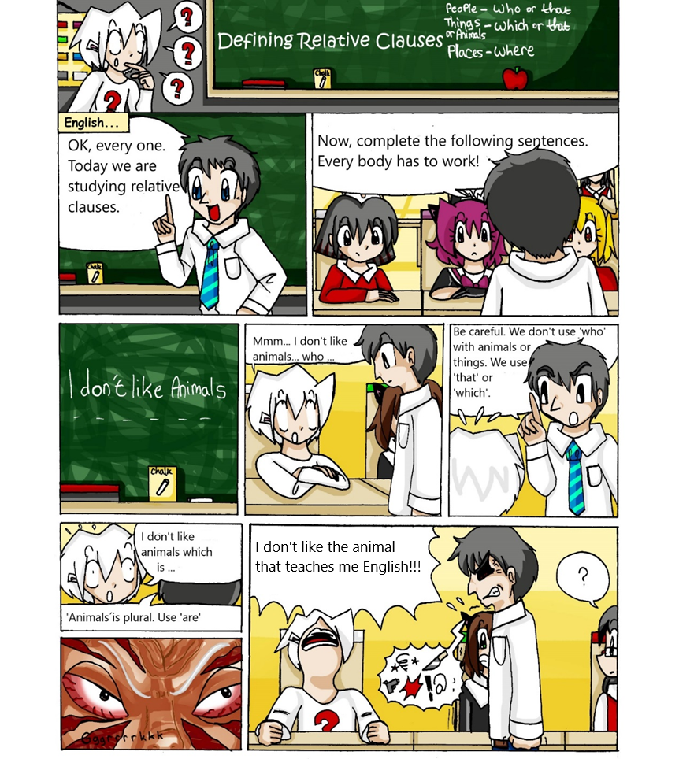

Vocabulary:
We are studying: en este contexto, quiere decir estudiaremos
Relative clauses: cláusulas relativas. Más abajo encontrarás la definición
Teaches: enseña
1. Look at the comic strip and decide if the following sentences are true or false.
- They are studying animals. T / F
- The students have to complete sentences. T /F
- The girl uses the correct form of ‘be’. T / F
- The teacher does not correct her mistakes. T/F
- The girl likes the teacher. T / F
2. Study the grammar:
I don’t like the animal that teaches me English.
Una cláusula relativa definida es un grupo de palabras que no llegan a ser una oración, pero agregan información sobre lo que se está hablando o definen eso de lo que se está hablando.
¿Podés identificar en la oración tomada del comic:
- de qué o quién se está hablando? …
- cuál es la cláusula relativa definida? …
- el elemento que une lo que se habla con lo que agrega información o define?...

La parte principal de la oración es la cláusula principal o main clause y allí se encuentra el sujeto (eso de lo que se habla): I don’t like the animal
↓
De lo que se habla

El elemento que une la cláusula principal con la cláusula relativa definida se llama pronombre relativo o relative pronoun y es el sujeto de la cláusula relativa: that
↓
Relative pronoun

La cláusula relativa definida o defining relative clause viene inmediatamente después del pronombre relativo:
teaches me English
↓
Cláusula relativa definida

En el ejemplo estudiado, la cláusula relativa, agrega información. Veamos ahora un ejemplo donde la cláusula define:
A visual artist is a person who creates visual art.
↓ ↓ ↓
Main clause relative relative clause
pronoun
Podemos ver que la estructura es la misma, pero la defining relative clause en vez de explicar o describir algo, lo define.

Detengámonos ahora en los relative pronouns. Estudiemos los dos ejemplos:
I don’t like the animal that teaches me English.
A visual artist is a person who creates visual art.

A simple vista podemos notar que los relative pronouns (ponombres relativos) en las dos oraciones son
- los mismos b) diferentes
¿Por qué? (Tip: mirá la primera y la sexta viñeta del comic)
¿Qué podemos decir de estos pronombres (en qué casos o acompañando a qué sujetos usamos cada uno de ellos)?

¿Podés completar la tabla?
Relative pronouns
People

Things , animals, plants, ideas

Places

Possession

EXERCISES:
1. Choose the correct relative pronoun.

- That’s the office which / where the 3D artists work.
- Development teams usually have a lead designer whose /who coordinates the work of other designers.
- Mario is an Italian plumber which / who lives in the Mushroom Kingdom.
- Game developers are people who / whose job is to develop games.
- A game level is an area of the game that / where has specific challenges and characters or creatures.
- A platform game is a game that /where characters run and jump on platforms.

2. Complete with the correct relative pronoun:

- A game programmer is a software engineer… job is to write video games software.
- A video game is an electronic game… involves interaction with a user interface or a joystick.
- A joystick is an upright handle… you use to control a computer game.
- Sound engineers are technical professionals… are responsible for sound effects.
- The Mushroom Kingdom is a place… Mario has a house.
- God of War is a video game series… Sony creates and distributes.
- Deemo II takes place in a world… rain never stops.
- Mario is a character… powers are only temporary.

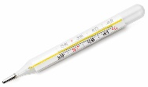
3. Match a to h with 1 to 8 and complete with who, that, where or which.
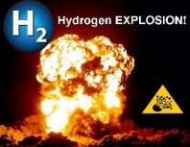
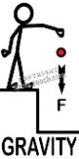
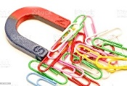
- Photosynthesis is a process | - … attracts bodies with mass.
- Magnetism is a force | - … we use to look at very small things.
- Gravity is a force | - that / which plants use to make food.
- An astronomer is a person | - … we use to measure temperature.
- Hydrogen is a gas | 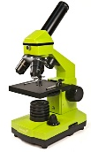  - … studies space.
- A thermometer is an instrument | - … we do scientific experiments.
- A laboratory is a place | - ... explodes easily
- A microscope is an element | - … attracts objects containing iron.

4. Read the definitions and guess the objects:
Twine – Mario – the printing press – the microchip - Prices Zelda - joystick - hospital -

- This is the device that you use to play video games.
- This is a machine that makes books, magazines and newspapers.
- It is a small piece of silicon that makes computer work.
- This is the place where doctors and nurses work.
- It is one of the top ten video game design and software 2021.
- The name of the video game character whose magical powers are teleportation, telepathy and precognition.
- The name of the video game character whose main power is superhuman strength.

