A DAY IN THE LIFE OF A COMPUTER PROGRAMMER

1. ▶ Read and listen to the text about Carla’s day and

1. Underline the words that you don’t understand.
2. Use the online dictionary to find their meanings: <https://dictionary.cambridge.org/>



Carla is a computer programmer. She works for a software publisher company, but she **does not work** in California, she works in New York. She and her colleagues have a very busy schedule. From 8 am to 9 am they have team meetings and after that, their workday begins.

They **do not do** the same thing every day. Sometimes, they write code and sometimes they test code or meet clients. They **do not work** all the time. They usually have 2 breaks for lunch and coffee. Their work **does not end** until 7 pm.

After work, Carla often goes for a walk, has dinner and watches TV, but she **does not go to bed** late because she’s always too tired.

VOCABULARY:

2. Read the text again and match Carla and her team’s activities and the correct time

|  |  |
| --- | --- |
| 1. they have team meetings  2. their work day begins  3. they have 2 breaks  4. they finish work  5. Carla goes for a walk  6. Carla goes to bed | a. at 7 pm  b. after their team meetings  c. after she watches TV  d. for lunch and coffee  e. from 8am to 9 am  f. after work |

**3. Discover** the grammar in this lesson.  
**A.** Look at the words in **bold. What do they have in common?**

**B** Find these sentences in the article and write the missing words.

1. She **does not** in California.  
2. They **do not**  the same thing every day.  
3. They **do not** all the time.

4.Their work **does not**  until 7 pm.

5. she **does not** late

**C.** Complete the sentence below with the correct word from the box

|  |
| --- |
| **nouns – articles – verbs – adjectives --- conjugated – base** |

**The missing words are and they are in their form of the present simple**

**D.** Look at the sentences from exercise A. Then circle T for *true* or F for *false* for each statement  
below. Discuss your answers with your classmates and teacher.

1. Use the base form of the verb after *don’t*. **T - F**2. Add an -*s* to the base form of the verb after *doesn’t*. **T - F**

**E.** Simple Present Negative statements: Complete with the correct **long negative form**

|  |  |  |  |  |  |
| --- | --- | --- | --- | --- | --- |
| Subject | negative | Base Form of Verb | Subject | negative | Base Form of Verb |
| I You We You They | … **don’t** | Work all the time. | He She It | … **doesn’t** | work all the time. |

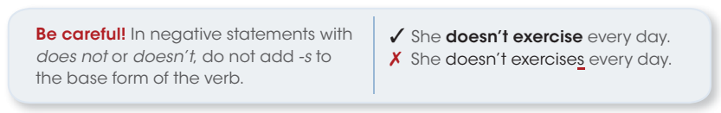

¿Qué regla podés enunciar sobre la formación de oraciones negativas en el presente simple?

**4 Underline *doesn’t* or *don’t* to complete each sentence.**  
1. Carla **doesn’t** / **don’t** have a lot of free time.  
2. Carla and her team **doesn’t** / **don’t** work after 7 pm.  
3. They **doesn’t** / **don’t** do the same things every day.  
4. We **doesn’t** / **don’t** work on weekends.  
5. I **doesn’t** / **don’t** work for IBM.  
6. My office **doesn’t** / **don’t** have a printer.  
7. She **doesn’t** / **don’t** travel for her job.  
8. You **doesn’t** / **don’t** have a busy schedule.

**5 Change each affirmative statement to a negative statement.**  
1. My brother has a job. **My brother doesn’t have a job.**  
2. I drive to work.  
3. They debug programs.  
4. Our teacher does homework.  
5. I go to the gym in the morning.  
6. She has an English class on Sunday.  
7. It works with solar power.  
8. We have an exam on Saturday night.