Life on the Space Station
The present simple, negative forms and questions

VOCABULARY:
Before reading, find the meaning of these words and phrases
Busy schedule:  Wake up:  Wash:  Call:  Talk:  Workday:  Do:  The same thing:  Change:  All the time: | For an hour:  Free time:  Go to sleep:  Isn’t easy:  The sun rises and sets:  16 times each day:  End:  A half day:  On Saturday:  On Sunday:
1. Read the article about life on the International Space Station. Notice the words in bold.

Astronauts on the International Space Station have a busy schedule. Every day they wake up at 7:00 GMT¹. From 7:00 to 8:00, they wash up and have breakfast. At 8:00 in the morning, they call Ground Control² in their countries. After they talk to Ground Control, their workday begins.

The astronauts don’t do the same thing every day. Their schedules change every week.
The astronauts don’t work all the time. Each day they exercise for an hour in the
morning and an hour in the afternoon. After dinner, they have free time. Then, it’s time
to go to sleep. Sometimes this isn’t easy because the sun rises and sets 16 times each day on the space station.
The work of the astronauts doesn’t end on Friday. They work a half day on Saturday and all day on Sunday. Astronauts are very busy people.
1 GMT: tiempo medio de Greenwich (la hora en Londres usada como estándar internacional de medición de tiempo).
2 Ground Control: El equipo en la Tierra que trabaja con los astronautas en el espacio.

2. Match each of the astronauts’ activities with the correct time.

1. They wash up and have breakfast.  2. They talk to Ground Control.  3. They exercise.  4. They have some free time.  5. They need to work a half day. | e. for an hour in the morning and an hour in the afternoon  a. at 8:00 in the morning  b. after dinner  c. on Saturday  d. from 7:00 to 8:00 in the morning

3. DISCOVER. Complete the exercises to learn about the grammar in this lesson.
A Find these sentences in the article and write the missing words.
1. The astronauts don’t… the same thing every day.
2. Astronauts don’t… all the time.
3. The work of the astronauts doesn’t … on Friday.
B Look at the sentences from exercise A. Then circle T for true or F for false for each statement
below. Discuss your answers with your classmates and teacher.

1. Use the base form of the verb after don’t. T - F
2. Add an -s to the base form of the verb after doesn’t. T - F
C. Simple Present: Negative statements: Complete with the correct short or long negative form
Subject | Do Not/  … | Base Form  of Verb | Subject | Does Not/  … | Base Form of Verb
I  You  We  You  They | …  don’t | work. | He  She  It | …  doesn’t | work.
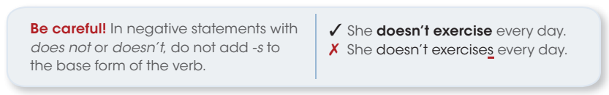

¿Qué regla podés enunciar sobre la formación de oraciones negativas en el presente simple?
4 Underline doesn’t or don’t to complete each sentence.
1. An astronaut on the International Space Station doesn’t / don’t have a lot of free time.
2. Astronauts doesn’t / don’t work all day on Saturday.
3. An astronaut doesn’t / don’t have the same schedule every day.
4. We doesn’t / don’t work on weekends.
5. I doesn’t / don’t work in an office.
6. My office doesn’t / don’t have a window.
7. She doesn’t / don’t travel for her job.
8. You doesn’t / don’t have a busy schedule.
5 Change each affirmative statement to a negative statement.
1. My brother has a job. My brother doesn’t have a job.
2. I drive to work.
3. Pilots fix planes.
4. Our teacher does homework.
5. I go to the gym in the morning.
6. We have class on Sunday.
7. You teach biology.
8. We have an exam on Saturday night.
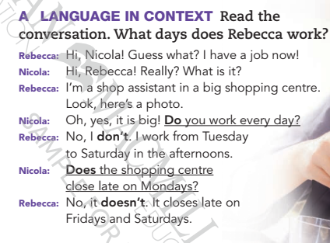
Veamos ahora la formación de preguntas.

B Analyse
Read the conversation in Exercise A again. Look at Yes / No questions form: Complete the table.
do/does + subject + base form

Yes/No questions |  |  | Short answers
(1) … | I/you/we/they | work every day? | Yes, I/you/we/they do. | No, I/you/we/they  3 …
(2) … | he/she  it | finish late?  close late? | Yes, he/she/it does. | No, he/she/it  4 …
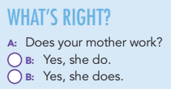

C Practise
Write the words in the correct order to make questions.
1 have / your mother / a job / does /?
2 late / your English class / end / does / ?
3 you / a job / do / have / ?
4 at the weekend / do / study / you / ?
5 your friends / do / English / like / ?
6 does / work / your father / in an office / ?
7 you / have / do / children / ?
8 your best friend / does / alone / live / ?

D Class practise:
Ask and answer the questions in exercise C

Estudiemos ahora la formación de wh questions.
Como primer paso, consideremos las wh words o palabras para preguntar:

Volvamos ahora a la conversación entre Rebecca y Nicola

Rebecca: ¡Hi, Nicola! Guess what? I have a job now! (1)
Nicola: Hi, Rebecca! Really? What is it?
Rebecca: I’m a shop assistant in a big shopping centre (2). Look, here’s a photo.
Nicola: Oh, yes, it is big! Do you work every day?
Rebecca: No, I don’t. I work from Tuesday to Saturday in the afternoons.
Nicola: Does the shopping centre close late on Mondays?
Rebecca: No, it doesn’t. It closes late on Fridays and Saturdays (3).

Si quisiéramos pedir información sobre qué, dónde cuándo, etc., deberíamos formular preguntas con estructuras como la de la consigna que figura en la presentación del diálogo:

What days does Rebecca work?

Wh auxiliary verb
verb
Podemos decir que la estructura es la misma de las Yes/No, pero con una Wh Word adelante:
Por ejemplo, sobre la oración (1) podemos formular preguntas con:
‘what’ + you (2° persona): What do you have?
o ‘what’ + she (3° persona): What …

a. En relación a la oración (2), preguntemos con
- ‘where’ + you + work …
- ‘where’ + she + work …

b. Estudiemos ahora la oración (3). ¿Es posible formular preguntas con ‘you’ en este caso? ¿Por qué sí o por qué no?
¿Qué pregunta/s podés formular sobre esta oración?
…

c. Read the text 'A day in the life of a professional game developer’ again and…
1. Put the words in the correct order to make questions.
- Answer the questions.

John’s a game developer. He gets up at 6.00 am. He usually makes a strong coffee and checks his email. Then he reads the news and has breakfast. After that, he answers the questions from his social media followers. They always ask lots of questions about videogames software.
Twice a week he usually has online meetings with his team and they discuss their active projects. They sometimes work long hours. Then, he plans and organizes the day. From 10.00 pm to 1.00 pm he designs, codes and tests new games. Sometimes he talks to clients on Skype and learns new tools.
In the afternoon he writes articles for his blog, and finishes the morning work. In the evening, he relaxes, has dinner and plays some Xbox with friends. Then, he goes to bed.
- get up / what time / he / does / ?
- he / read / does/ what/?
- do / does / after breakfast/ what / he /?
- how often / online meetings / he / does / have/?

- Make two more questions with ‘when’

