Mining Valuation Lesson: Cut-Off Grade Theory and Practice
Posted On 04 Dec 2011
Comment: 0
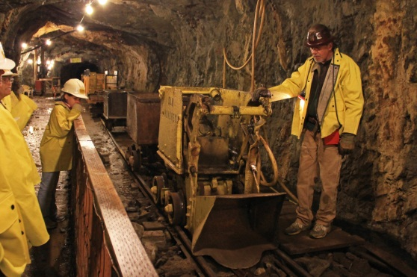The world’s central banks have come together to help with the severity of Europe’s problems. Unemployment in the US fell to 8.6% – the lowest level in more than two and a half years. Markets soared with the biggest 3-day gain since 2009. Things are looking good. Or are they?
It’s getting closer to the Christmas holidays and that means 2011 is coming to an end. At the end of the day, the market will react to positive news just as it does to negative. And over this past year, we have been struggling to find solid ground.
As Canadians, we are lucky to have a strong banking system and natural resources that can easily support our small population. However, that does not shield our economy and our investments from the American and European policies that have created a near-impossible mess to clean up.
The outlook is simple: The US and Europe will have no choice but to print more money. As I have mentioned many times over, more QE will happen. More money will be printed. There is no way out of this mess but to inflate the world with more un-backed currency. Heck, that’s why the Federal Reserve was created in the first place, right? To prevent economic and financial disaster?
Trying to time the market in its current state is extremely difficult. Politics and economic blunders have taken full control of our investments. But predicting the short term market should no longer be the primary drive for investments.
Money will be printed endlessly. It’s inevitable. Even as the US economy is struggling to deal with a housing crisis, inflation will eventually happen. It will take time and we may deflate before it happens, but it will happen. When it does it won’t be a slow and gradual rise – it will be explosive. If you’re smart with your money over the next year or two and invest in gold and gold-related investments, as well as real estate and other tangible assets, you’ll look at our current situation as the opportunity of a lifetime five years from now. In the short term, hang onto cash for fire sales.
A few weeks ago, I wrote a piece on the basics of mining valuations titled, “It’s Not that Simple: Mining 101.” This week I am going more in-depth on this subject as part of a mini-series of letters that will focus on evaluating mining and resource stocks. This week’s topic will be “cut-off” grade – a term you have heard many times before, but is often overlooked or misrepresented. Yet, it is an extremely important factor in mining valuations.
Cut-off Grade Theory and Practice
Consider a block of ore that weighs 1 tonne and contains 3 grams of gold. At a gold price of US$1000 per ounce the value of the gold in the block of ore is just under $96 ($1000/31 X 3 or $1000 per ounce/ 31 grams (troy ounce) X 3 grams of gold)
Simply put, if it were to cost more than $96 to mine, treat, and extract the gold from that tonne of ore, it would be uneconomic to mine. Conversely , if the cost were less than $96, it could be economic to mine.
But it’s not that simple.
If all the tonnes of ore in a deposit contained the exact same grade of gold, it would be easy to calculate. But not all the tonnes of ore that make an orebody contain the same grade of gold. As a matter of fact, gold deposits may vary the most in terms of consistency due to its “nuggetty” nature.
Take a look at this chart:
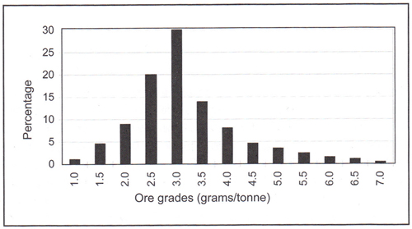
Figure 1
As you can see in Figure 1, in this particular orebody, roughly 30 per cent of the total tonnage has an average grade of 3 grams per tonne, 20 per cent has 2.5 grams per tonne, and so on.
Making the Initial Estimate
Let’s assume that a preliminary feasibility study provides the costs for recovering gold:
 | US$/tonne of ore treated
Overburden removal | 12.0
Mining Cost | 4.0
Treatment Charge | 21.0
Administration and Refining | 9.0
Total Cost | 46.0
Metallurgical tests also show that only 95 per cent of the gold can be recovered from the ore.
So the question is, what is the minimum amount of gold the project needs in one tonne of ore to make it economically recoverable?
As the table shows, there has to be enough gold to provide US$46 of revenue to cover the costs. In other words, the grade that provides the US$46 is the cut-off grade. Let’s once again assume that the gold price is $1000 per ounce, which is equal to $32 per gram (US$1000/31.1 grams)
The formula is simple:
total cost/recovery/price per unit of metal = Cut-off grade
Therefore, in our example:
46/0.95/32 = 1.5 grams per tonne
Now, if we go back to the original tonnage grade distribution as shown in our graph, we can see that roughly 6 per cent of our orebody has a grade of less than 1.5 grams per tonne. Obviously when we mine the orebody, we would try and stay away from mining and certainly would not treat the 6 percent of tonnage below the cut-off grade.
That means, for reserve reporting purposes (see It’s Not that Simple: Mining 101), we have reduced the size of our economic ore down to 94% of our original tonnage. While we have reduced the tonnage above the cut-off by removing the uneconomical 6% of ore, the remaining average grade will have increased as the lower grade is no longer included.
That means that increasing the cut-off grade reduces economic tonnage, but increases the overall grade.
Now here is where its gets complicated in assessing the NPV (net present value) of a project. A whole textbook can be dedicated to cut-off grade and assessing the NPV, but I will simplify as much as possible for all intents and purposes.
First of all, we determine the mine life.
Let’s assume that the annual treatment capacity can process 10 percent of the original total reserve. That means, with a zero cut-off grade, the original mine life would be 10 years (100%/10%). If you increase the cut-off grade, you decrease the life of the mine due to diminishing reserves (reserves are ore in a deposit that is economical to extract, see Mining 101: It’s Not that Simple), but you would increase gold production due to the higher grade.
Now if we assume that capital cost is relatively fixed, it is possible to estimate the NPV for each cut-off grade because we know the operating cost, the mine life, the gold price, and therefore revenue.
Take a look:
Ads by GoSaveAd Options
Cut-off Grade | 1.0 | 1.5 | 2.0 | 2.5 | 3.0 | 3.5 | 4.0
Mine Life (yrs) | 9.9 | 9.5 | 8.7 | 6.7 | 3.7 | 2.3 | 1.5
Relative NPV | 1.0 | 1.04 | 1.07 | 1.08 | 0.9 | 0.7 | 0.6
Looking at the table, you can see that as the cut-off grade increases, so does the NPV. This is due to the greater benefit of a higher annual cash flow from the higher annual average grade outweighing the shorter mine life.
However, eventually, the shorter mine life becomes too significant and the NPV declines. Looking at the table, you can clearly see that a cut-off grade of 4.0 reduces the relative NPV down to 0.6. Again, remember that increasing cut-off grade reduces your mine life as you “throw away” the lower grade ore in your calculations. That means that the higher the cut-off grade, there is even a possibility that the NPV would be negative as the mine life and recoverable ore becomes too small.
The important factor is selecting the cut-off grade that yields the highest NPV. In our table, that means selecting the 2.5 grams per tonne cut-off grade. Of course, this is an extremely simplified example using an extremely simplified calculation of NPV we used previously. With the advent of new technology and computing software, the optimum economic recovery of an ore deposit can be fine tuned even further. That means it is quite possible that the optimum cut-off grade in our example is somewhere between 2.0 and 2.5 grams per tonne, before the NPV drops.
In our example, the higher NPV was achieved using a higher cut-off grade, as a result of increased annual revenue outweighing the shorter mine life. However, cut-off grade will vary significantly from one project to another as many factor such as mine capacity, mill capacity, and commodity prices can all affect the NPV.
The next time you hear about a project that is comparable to another successful mine, remember that no deposits are ever the same. A minor gram per tonne variation in cut-off grade can have significant effects on a project’s NPV and calculations in NPV can vary dramatically from one source to another. That’s why larger projects often have to go through numerous calculations from different sources before proceeding.
When calculating NPV, there are obviously conflicting factors. For example, your capital costs will increase when you increase production, but you need to keep it to a minimum for a given production rate. An increase in annual mine production will generate higher revenue, but it’s subject to available reserves and must be enough to satisfy the capital expenditures. The list of conflicting factors go on so its imperative that calculations are correct to optimize the NPV of a project.
There you have it, the basics of cut-off grade

Break Even Analysis - How to Calculate the Cut Off Grade
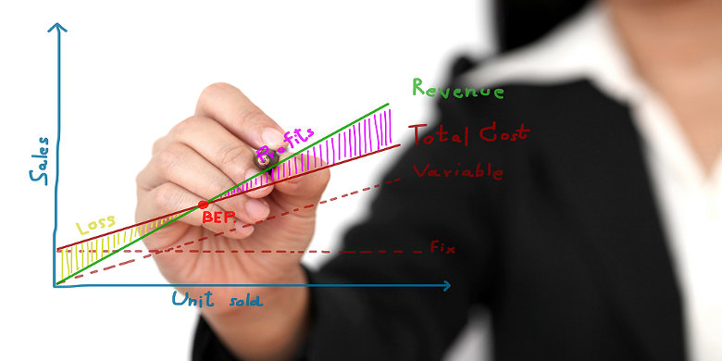
For conducting a mining project's break even analysis, you first need to know about the operational expenses (OPEX). When the OPEX is known, you can calculate the mineral's cut off grade, which is the break even grade, below which it is not economically viable to mine the ore. To find out how I come up with the cost price per tonne (OPEX) if a feasibility study isn't available, I refer you to the note at the bottom of this page.
Before I can calculate the cut off grade, I first need to show a basic equation which converts a troy ounce into grams per ton:
1 troy ounce = 31.1034768 grams per ton = 28.349523125 grams per tonne
As you can see, the difference between a ton and a tonne is approximately 10%.
Then, you need to be aware of the following conversions:
1 ton = 2,000 pounds
1 tonne = 2,204.62262 pounds = 1,000 kilograms
1 kilogram = 2.20462262 pounds
1% of a tonne = 22.0462262 pounds = 22 pounds (rounded)
I believe this last conversion is really convenient, because when I read a mining company's press release in which they announce a drill result of 2% copper, I now quickly know this equals to 44 pounds (lbs), or - assuming a copper price of $ 3 per pound - a mineral value of $ 132 per tonne. To learn more about how you can determine the mineral value per tonne, I recommend you to read the metal value page.
In the following example, you will find the hypothetical cut off grade for an ounce of gold (which is actually the break even analysis for gold mining):
Mining Costs per Tonne (OPEX) | Current Price per Ounce | Cut-Off Grade (ounces per tonne) | Cut-Off Grade (grams per tonne)
$ 150 | $ 1,500 | ($ 150 / $ 1,500 =) 0.10 ounce / tonne | (0.10 x 28.349523125 =) 2.835 grams / tonne
I have also included an example to find the hypothetical cut off grade for a pound of copper (which is actually the break even analysis for copper mining):
Mining Costs per Tonne (OPEX) | Current Price per Pound | Cut-Off Grade (pounds per tonne) | Cut-Off Grade (percentage per tonne)
$ 33 | $ 3 | ($ 33 / $ 3 =) 11 pounds / tonne | ((11 / 22) x 1% =) 0.50 percentage /tonne

If you would like to be the first to be informed when I add new content to UndervaluedEquity.com, please leave your details in the name grab form on the Support page!
You can also support me directly by clicking on the advertisements that appeal to you, or by making a voluntarily donation with Paypal.
Your support helps me to speed up the process of adding great, free content to UndervaluedEquity.com!

Note: When the cost price per tonne can not be found in the mining company's feasibility study, I kindly ask the mining company's management to give me their best estimate. In order to be extra conservative in my calculation, I normally apply a discount rate of 20% on the numbers received.

What Type of Content Can You Expect to Find on UndervaluedEquity.com
Main Section | Description
News (RSS) | Today's News Related to the Global Energy and Mining Stocks. On this page a RSS feed is displayed with stock market news related to the energy and mining sectors. You can subscribe to this free RSS feed too!
My Due Diligence | How I Conduct My Stock's Due Diligence Investigation Process. If you want to know what I learned while I was conducting my due diligence, I recommend you to read all the chapters of the investigation process.
My Stock Watchlist | Are These the Best Stocks to Buy Today. In my stock watchlist you find stocks who offer great potential, but at the time I analysed these stocks they didn't comply with all my guidelines from my due diligence chapters.
My Stock Portfolio | Are These the Best Shares to Buy Now. I will add my stock portfolio to this section of the website shortly, but I prioritise adding content in my due diligence chapters first.

