Demonstrative Pronouns and Adjectives: This, These , That, Those

Look at the following examples


This is a desktop computer.


These are speakers.
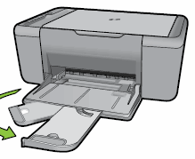
That is an-all-in-one printer.
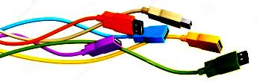
Those are USB cables.

- This, these, that and those are demonstrative pronouns (son pronombres, porque están reemplazando a un sustantivo y actuando como sujetos de la oración).
- We use this and these when the persons or things are near. (here) This is singular. These, is plural.
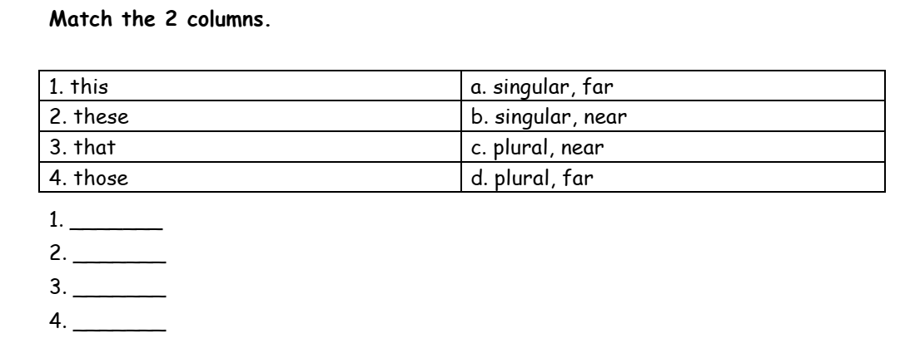
- We use that and those when the persons or things are not near. (there) That is singular. Those, is plural.
1.

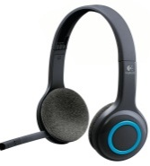
2. Look at these objects. Are they near or are they not? Write sentences with this, these, that and those.
a. wireless headphones
Those are wireless headphones.

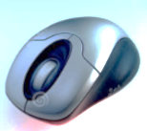
b. an infrared mouse
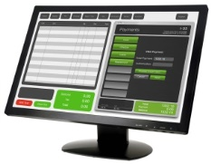
c. an LCD monitor
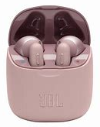
d. ear pods

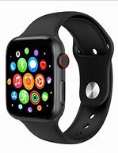

e. a smartwatch

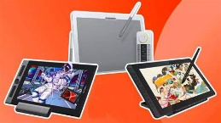

f. drawing tablets

3. Rewrite the sentences in the plural
1.That is my dictionary.
2.That is an African country.
3.This is a wireless keyboard.
4.This is an LCD monitor.
5.That isn’t a USB cable.
6.Is that a box?
7.Is this an English bus?
8.Is that a Chinese mobile?
9.Is this a lion?
10.Is this a monitor?
4. Veamos ahora cómo this –these – that y those también se comportan como adjetivos, es decir que también pueden estar en una oración acompañando a un sustantivo:
This class is very boring!
↓ ↓
dem.adj. noun
- This coffee's cold.
- These cups are dirty.
- That cafe's open.
- Those trees are tall.

Prestemos atención al ejercicio de más abajo
Si observan con atención, verán que después de cada espacio en blanco, (donde deben colocar el demostrativo correcto), hay un sustantivo.

5. Complete with this these that or those. near not near (far)

Jane: How much are ………………………… memory sticks?
Shop assistant: $30
Jane: Thank you. ………………………… a very nice computer!
Lisa: Yes, and the screen is very big. What is ……………………….. thing on the front?
Shop assistant: It’s the webcam. And here’s the mouse.
Jane: Yeah. Is ……………………………..a new model?
Shop assistant: No, ……………………… an old model. That’s why it is on sale. ………………………’s the new model over there.
Lisa: And how much are …………………… headphones over there?
Shop Assistant: They’re on sale, they’re $50
Lisa and Jane: OK. Thanks.

Están cerca
No están cerca
pendrives
Muy linda/muy buena
grande
cosa
Acá/aquí
Over there/there= allá/allí

