
PRESENT SIMPLE OR PRESENT CONTINUOUS ?
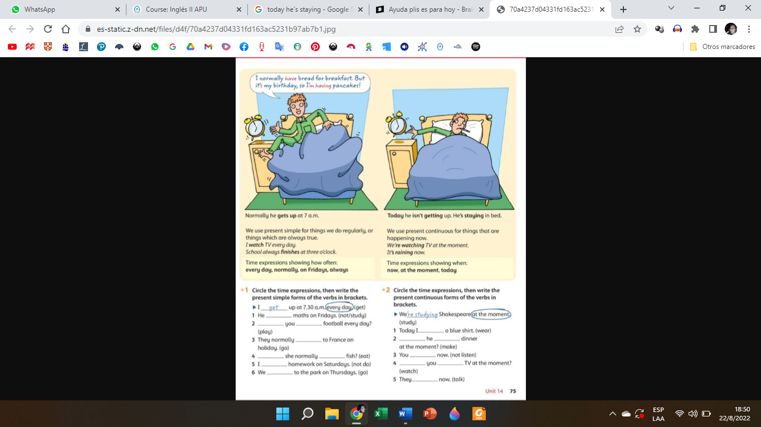
Cuando nos expresamos en español, no siempre lo hacemos en un único tiempo verbal. Muchas veces mezclamos los tiempos, según las situaciones o temas que estemos tratando. Así, puede suceder que estemos pasando por una situación temporal, que rompe nuestra rutina y entonces tengamos que usar dos tiempos verbales, uno para describir la rutina (presente simple) y otro para describir la situación excepcional que salió de la rutina y es temporal (presente continuo).

He usually gets up at 7 a.m. Today he isn’t getting up. He’s staying in bed.
Podemos ver que la actividad rutinaria, (en azul) está expresada en presente simple.
Por otro lado, la situación excepcional y temporal, está expresada en presente continuo.
Es muy importante entonces tener en claro cuáles son las características de cada tiempo verbal, (cómo se forman; para qué se usan; qué adverbios o adverbiales de tiempo los acompañan, etc.) Estudiemos esta tabla:
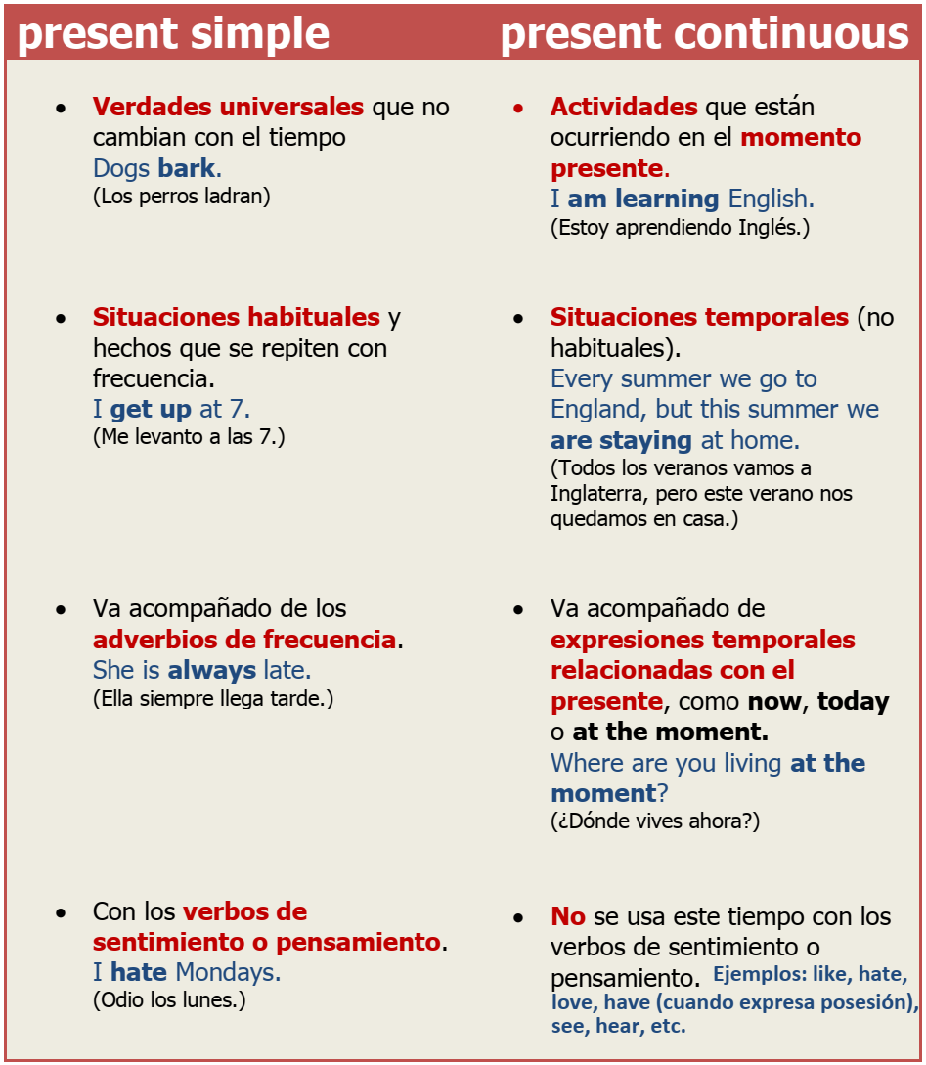

Podemos ver que: el presente continuo suena más temporal mientras que el presente simple suena más permanente. Compará: “I live with my parents” (parents = padres) con “I’m living with my parents.” ¿En qué caso la acción es temporal y en qué caso es permanente?
Vamos a practicar entonces:
1. Look at the pictures and underline the correct option:
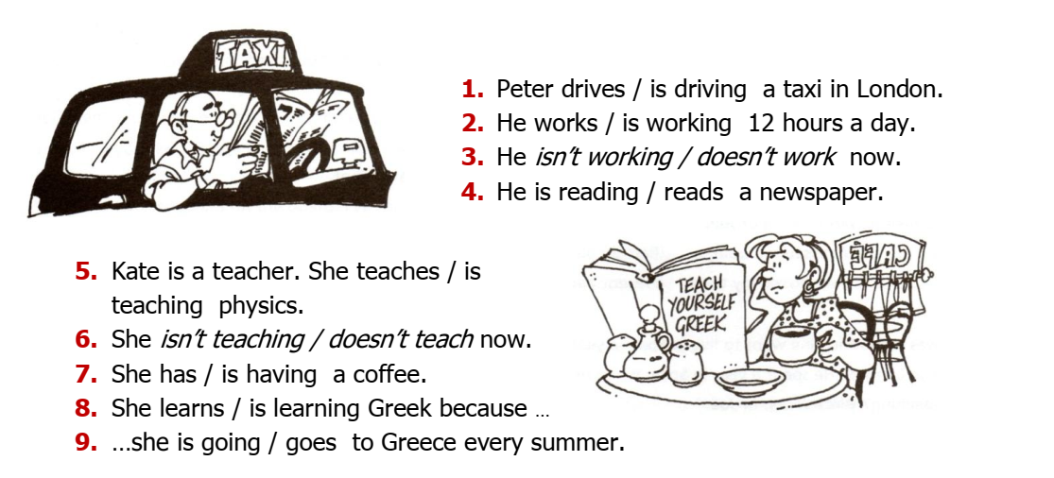
2. Match the questions to the answers:
  - What do you do?  - Are you at University?  - What are you studying?  - Do you have classes every day?  - Are you having classes this afternoon?  - Do you live near the college?  - How do you go to college? |   - I’m studying programming.  - No, I don’t.  - I usually take the bus.  - I’m a student.  - No, I’m not. But I’m having classes on Saturday.  - Yes, I am.  - Yes, I do.

ES IMPRTANTE TENER EN CUENTA QUE:
- Los verbos de sentimiento o pensamiento NO se usan en presente continuo.
She hates Mondays. She is hating Mondays now. X
My brother has* a new computer. My brother is having a new computer. X
I see* you are working hard. I’m seeing you are working hard. X
2) El verbo ‘have’ tiene muchos significados. Cuando tiene el significado de ‘posesión’ NO SE USA EN PRESENTE CONTINUO. Si su significado es ‘have a shower’; ‘have lunch’, ‘have dinner’, si se puede usar en presente continuo.

Veamos los usos:
I have two memory sticks. Nunca: I’m having two memory sticks. X
She has a shower in the morning. She is having a shower at the moment.
They have lunch at home. They are having dinner at work this week.

3) el verbo ´see’, con el significado de ‘ver’ NO SE USA EN PRESENTE CONTINUO. Pero este verbo también tiene el significado de ‘visitar’ o ‘tener una entrevista’ con alguien, con este significado sí se puede usar en presente continuo:

I’m seeing the doctor this afternoon.
Mr. Thomas is seeing a client at 2.30

EXERCISES:
1. Complete the mini-dialogues with the present simple or the present continuous.

A. Hi Louise! Where ………………………………………… (you / go)?
B: Hi! I…………………………………………………. (go) to college.

A: How………………………………………………….(you/go) to college?
B: I always …………………………………………………. (walk) to college.

A: What ………………………………………………….(they /do)?
B: They …………………………………………………. (download) music.


A: What …………………………………………………. (Amy /do)?*
B: She’s an engineer. But she …………………………………………………. (not / work) right now. She’s unemployed.
* atención a esta pregunta que no se refiere a lo que Amy está haciendo, sino a su profesión.
2. Compete the text with the correct form of the verbs in brackets.

This is Mara. She …………………………… (be) a software developer. She ………………………… (design) and ……………………… (develop) computer games. She ……………………………… (be) from China, but she …………………………… (live) in London. She usually …………………………… (go) to work by train.
At the moment, she …………………………… (not develop) software, she …………………………… (fix) malware. She ……………………………… (use) SpyHunter.
This month, Mara……………………….. (take) English classes because she …………………………. (not speak) English very well.
She ………………………… (like) sports, so at weekends, she usually ……………………………(play) football or …………………………… (go) cycling.
2. Make 5 (five) wh questions about Mara
Examples: What does Mara do? (pregunta por su profesión).
What does she design and develop?

4. Find and correct the mistakes in the following sentences
a. Look! The program doesn’t run.
b. We usually are having English in room 11.
c. The teacher not come today because she’s sick.
d. We always coming to college by bus.
e. John isn’t designing computer games. He’s not a software developer.
f. A: What do you learn this week?
B: I’m learn about network security.
g. He’s having a new mobile.
h. What time are you usually going to bed?

5. Look at the picture and write sentences in the present simple and the present continuous. Use the questions as a guide.

Who are the people? Where are they? What do they usually do? What aren’t they doing now? What are they doing now?
buffet – office – conference room – at home
work – talk – have a coffee write software – develop mobile applications

