REVISION EXERCISES
- Read the 2 paragraphs.
- Ask and answer questions to get the information.

- Graciela Brizuela is from San Salvador de Jujuy, Jujuy. She’s a teacher. She works at Facultad de Ingeniería. She doesn’t play video games.

- José Fernández is from Tilcara, Jujuy. He’s a student. He studies game development at Facultad de Ingeniería. He plays video games in the afternoon.
First name | (What)
Surname | (What)
City/province | (Where)
Activity / career | (what
College/ work | (Where)
Play games | (When)
Example: What’s her first name?
Relative clauses:
This is the street where I live now.
Una cláusula relativa definida es un grupo de palabras que no llegan a ser una oración, pero agregan información sobre lo que se está hablando o definen eso de lo que se está hablando.
¿Podés identificar en la oración tomada de la conversación:
- de qué o quién se está hablando? …
- cuál es la cláusula relativa definida? …
- el elemento que une lo que se habla con lo que agrega información o define?...

La parte principal de la oración es la cláusula principal o main clause y allí se encuentra el sujeto (eso de lo que se habla): This is the street
↓
De lo que se habla

El elemento que une la cláusula principal con la cláusula relativa definida se llama pronombre relativo o relative pronoun y es el sujeto de la cláusula relativa: where
↓
Relative pronoun

La cláusula relativa viene inmediatamente después del pronombre relativo: I live now
↓
Cláusula relativa definida
Detengámonos ahora en los relative pronouns:
Cuando nos referimos a personas, podemos usar who o that.
Cuando nos referimos a objetos, animales, plantas, etc. podemos usar that o which.
Cuando nos referimos a lugares, usamos where.
Si hablamos de posesión, es decir de quién es algo, usamos whose.
1. Complete with the correct relative pronoun.

- That’s the office we have team meetings
- Mark Zuckerberg is an American programmer is the co-founder of Facebook.
- Software testers are people job is to test and upgrade software versions.
- Git is a tool helps programmers track changes in their projects.
- Bugs are errors cause a program to work incorrectly.
- This is the lab students learn programming skills.
- Python is a programming language is easy to learn.

2. Match the parts to make complete sentences:
- Data centers are places  - A programmer is a person  - A keyboard is a device  - These are the tools  - Systems analysts are professionals  - GitHub is a platform  - A cybersecurity specialist is a person  - This is the computer | who  which  that  whose  where | - work involves understanding the needs of the users.  - programmers use every day.  - job is to protect computer systems from attacks.  - developers share their projects.  - writes code to develop software.  - always crashes during presentations.  - allows users to type information.  - companies keep their servers.

Descripción de dispositivos:
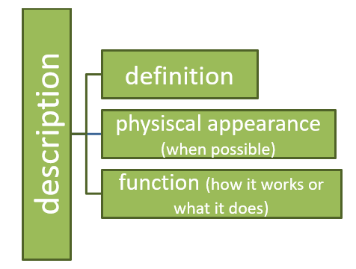
Las descripciones de elementos de hardware y software en general tienen la siguiente estructura:

A mouse is an input device that people use to move the pointer on the screen. It is a small object that usually has two buttons and a scroll wheel. Users move the mouse with their hand to give instructions to the computer.
A printer is a machine which is connected to a computer that prints computer information. It is usually a rectangular box with a paper tray. Some printers only print, and others also scan and copy.
1. Put the following description in the correct order.
A keyboard is used to generate numbers, letters and symbols on the screen. A keyboard is a primary input device that/which helps users to interact with the computer system. It is a rectangular plastic panel with letter, number and symbol keys that are arranged in arrows.

VOCABULARY
1.a. Read the team introduction correct the wrong verbs or possessive adjectives. Be careful, there are two correct words.

Hi! I’m¹ Sylvia, the IT team leader, and this is Isabelle, Andrew, Carla and Tom. I²’re all IT professionals. Isabelle is a database administrator; your³ area’s data analysis. Andrew’s⁴ an IT support officer and our⁵ area is technical support. Carla and Tom’s⁶ system analysts, your⁷ area is IT systems analysis. We’re all in the IT team at university. Their⁸ offices are in building 8.

1….. 2….. 3….. 4….. 5….. 6….. 7….. 8…..

PRACTICE
2. Correct the sentences as in the example
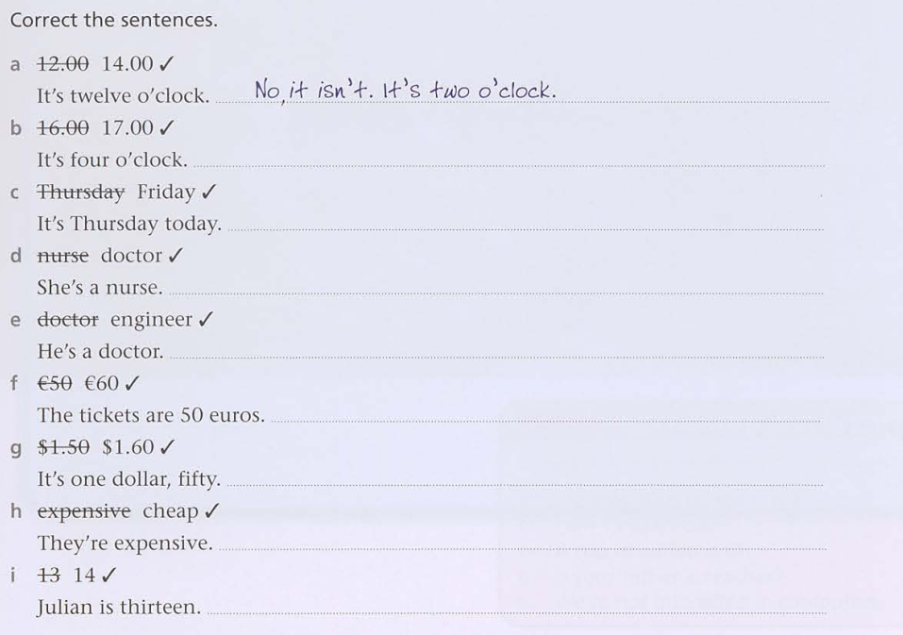

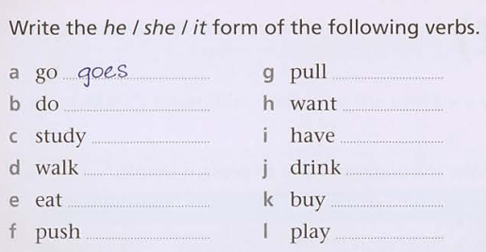
3. Write the he /she / it form of the following verbs.

4. Put the words in order to make a sentence
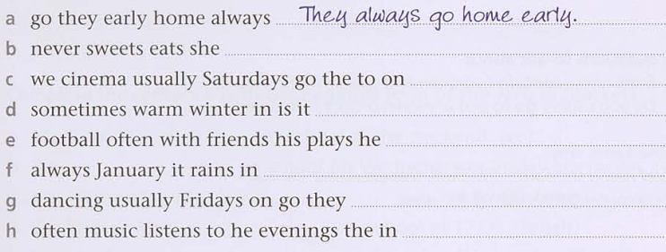
5. Look at Mark’s timetable. Complete the sentences with the affirmative form of the verb in brackets
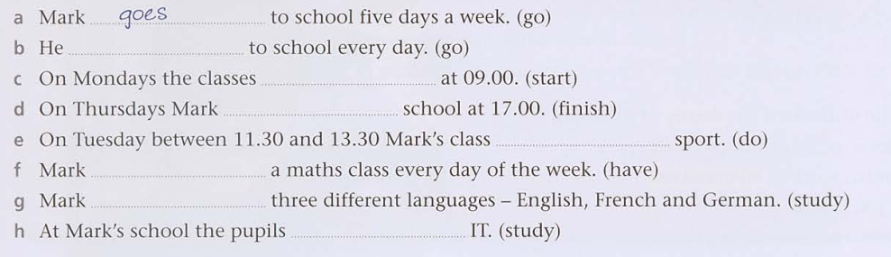
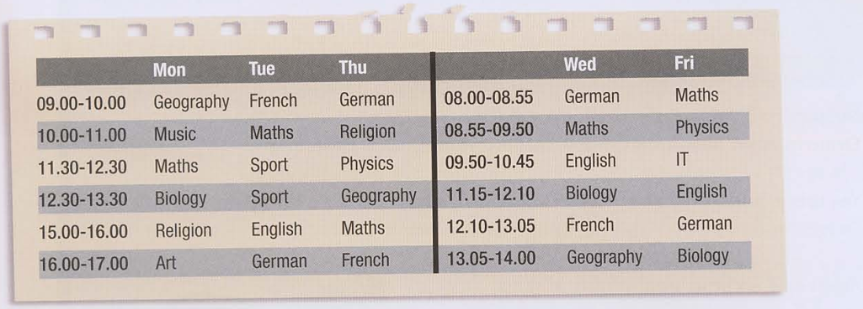

6. Complete the sentences about Mark with the negative form of the verbs in brackets.
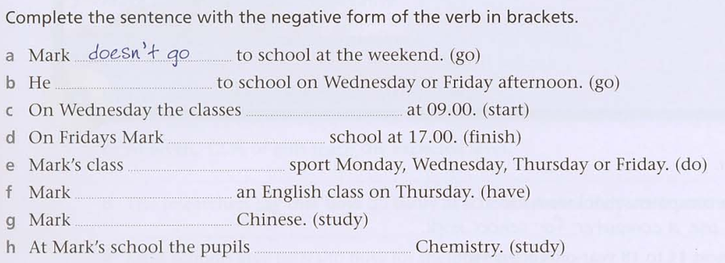

7. Complete the questions with do or does and answer them.
