REVISION
ALPHABET AND SPELLING
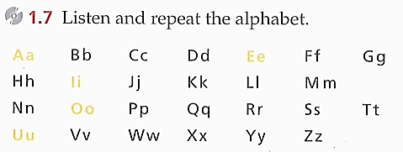
1.

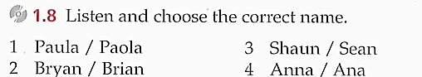
2.

3. 1.9 This is the reception desk of an international conference in Berlin. Listen to the conversation between the receptionist and a photographer and complete it.
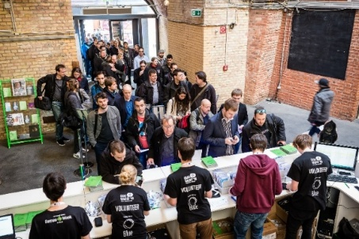

R: Good morning. ……………………………………, please?
L: Hi. My name’s Schultz.
R: Can you spell that?
L: Yes. ………………………………………….. : Shultz.
R:…………………………………………………………………?
L: ………………… ………………………………………….
R: Thank you. ………………………………………………..?
L: …………………………………………… I’m from Today magazine.
R: OK. Sign here, please.
L: OK. Thanks. Bye.
R: Goodbye.
4. Online exercise: listen and write the phone numbers: https://www.liveworksheets.com/worksheet/en/english-second-language-esl/339788
1. 2. 3. 4. 5.

