**Actividad de consolidación**

1**. Para resolver este ejercicio debe usar el texto del último ejercicio del apunte de clase**.

**Write the questions (Escribí las preguntas)**

*1 Ellie / Canada?*

*Is Ellie from Canada?*

2. she / doctor?

3. McGill University / London?

4. Yong-Joon / Japan?

5. he / in London / on holiday?

6. Auckland / New Zealand?

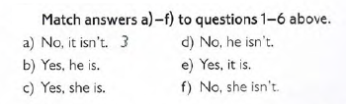2.

3. Look at the texts again and underline the correct option.

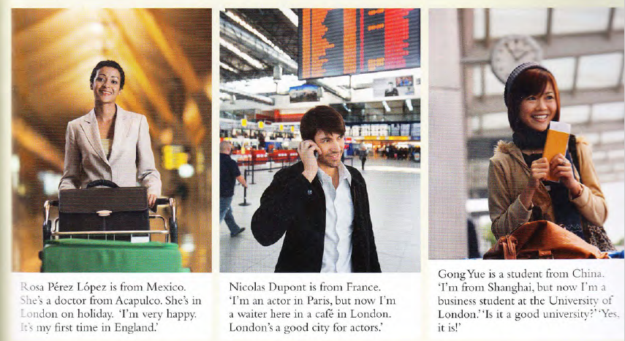

Example:

Rosa Pérez **is** / isn’t from Mexico.

1. Rosa is / are a Doctor.
2. Rosa is / are very happy.
3. Nicolas Dupont are / is from France.
4. Nicolas is / isn’t a doctor.
5. Nicolas is / are a waiter in London.
6. Gon Yue is / isn’t a student from Japan.
7. She are / is from Shanghai.